a
aginjibagwesi
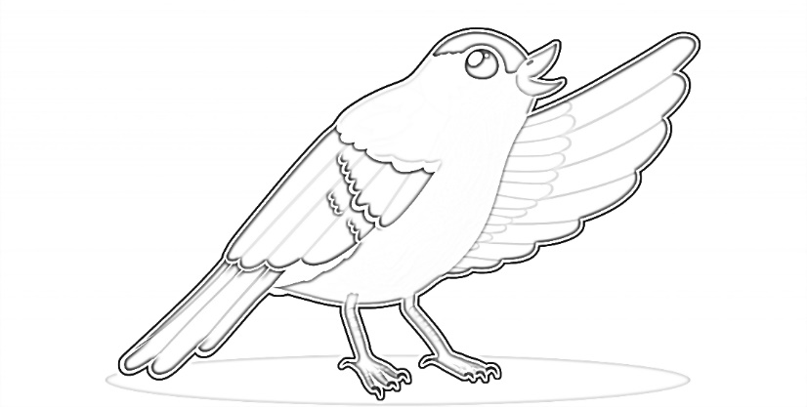

a a a a a a a
aginjibagwesi
aa
aagim

aa aa aa aa
aagim
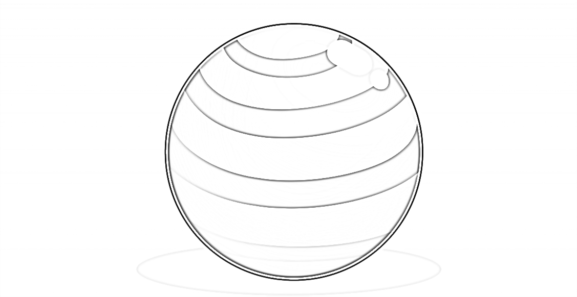
b
biikwaakwad

b b b b b b b
biikwaakwad
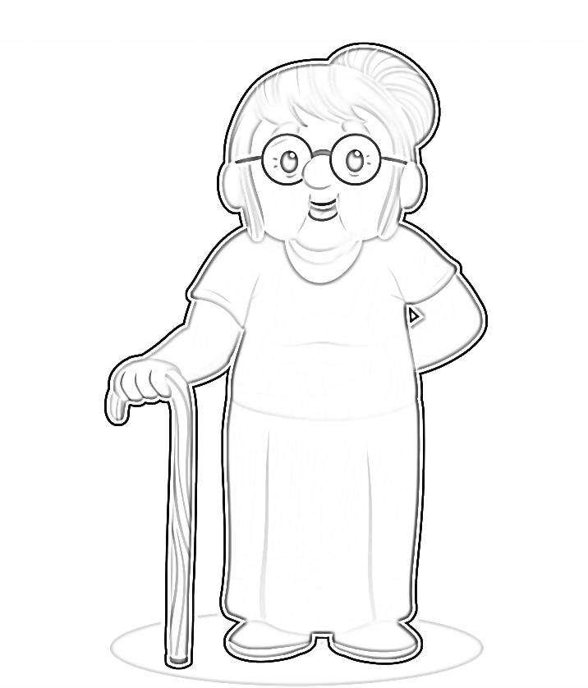
ch
gichi-ayaa’aa

ch ch ch ch
gichi-ayaa’aa
d
dagwaagin

d d d d d d d
dagwaagin
e
esiban

e e e e e e e
esiban
g
gaa-dakaag

g g g g g g g
gaa-dakaag
i
inini

i i i i i i i
inini
ii
niimi

ii ii ii ii ii
niimi
j
jiimaan

j j j j j j
jiimaan
k
akik

k k k k k
akik
m
mooz

m m m m m m
mooz
n
ningwakwad

n n n n n n
ningwakwad

o
oginii-waabigwan

o o o o o o
oginii-waabigwan

oo
oodena

oo oo oo oo
oodena
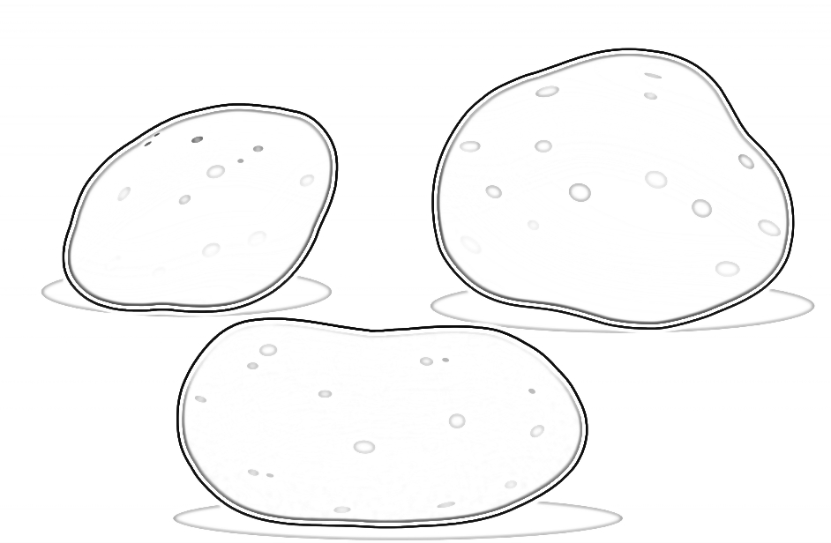
p
opiniin

p p p p p p
opiniin
s
wiisini

s s s s s s s
wiisini
sh
asham

sh sh sh sh sh
asham
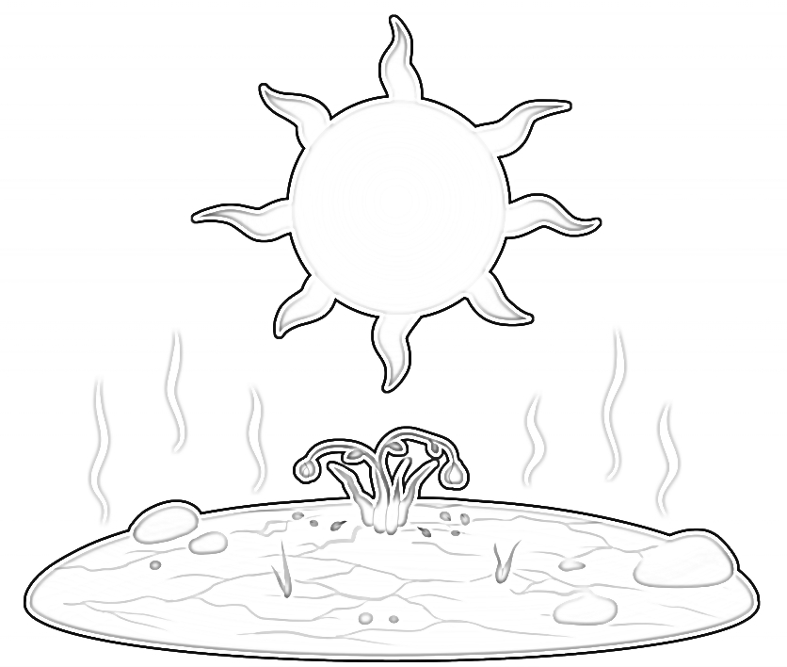
t
giizhaate

t t t t t t
giizhaate
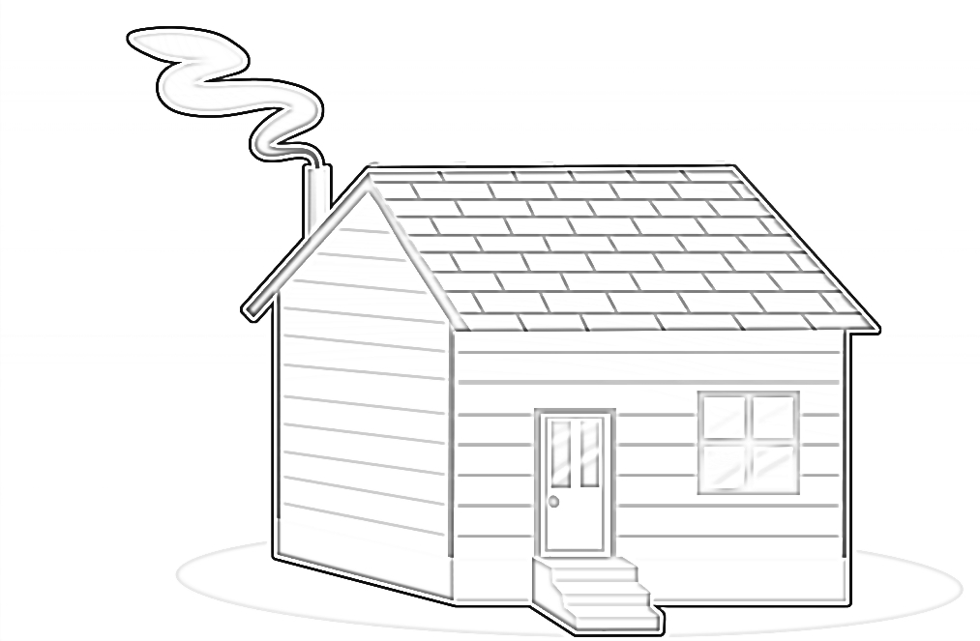
w
waakaa’igan

w w w w w w
waakaa’igan
y
inday

y y y y y y
inday
z
ziinzibaakwadoonsan

z z z z z z z
ziinzibaakwadoonsan
zh
zhoominag

zh zh zh zh zh
zhoominag

