Aaniin Ezhinikaazowin?
What is Your Name?

Written by Brigitte Neganigwane
Illustrated by Tim Smith

Boozhoo!

Aaniin ezhinikaazowin?

Hello! What is your name?

John nindizhinikaaz.
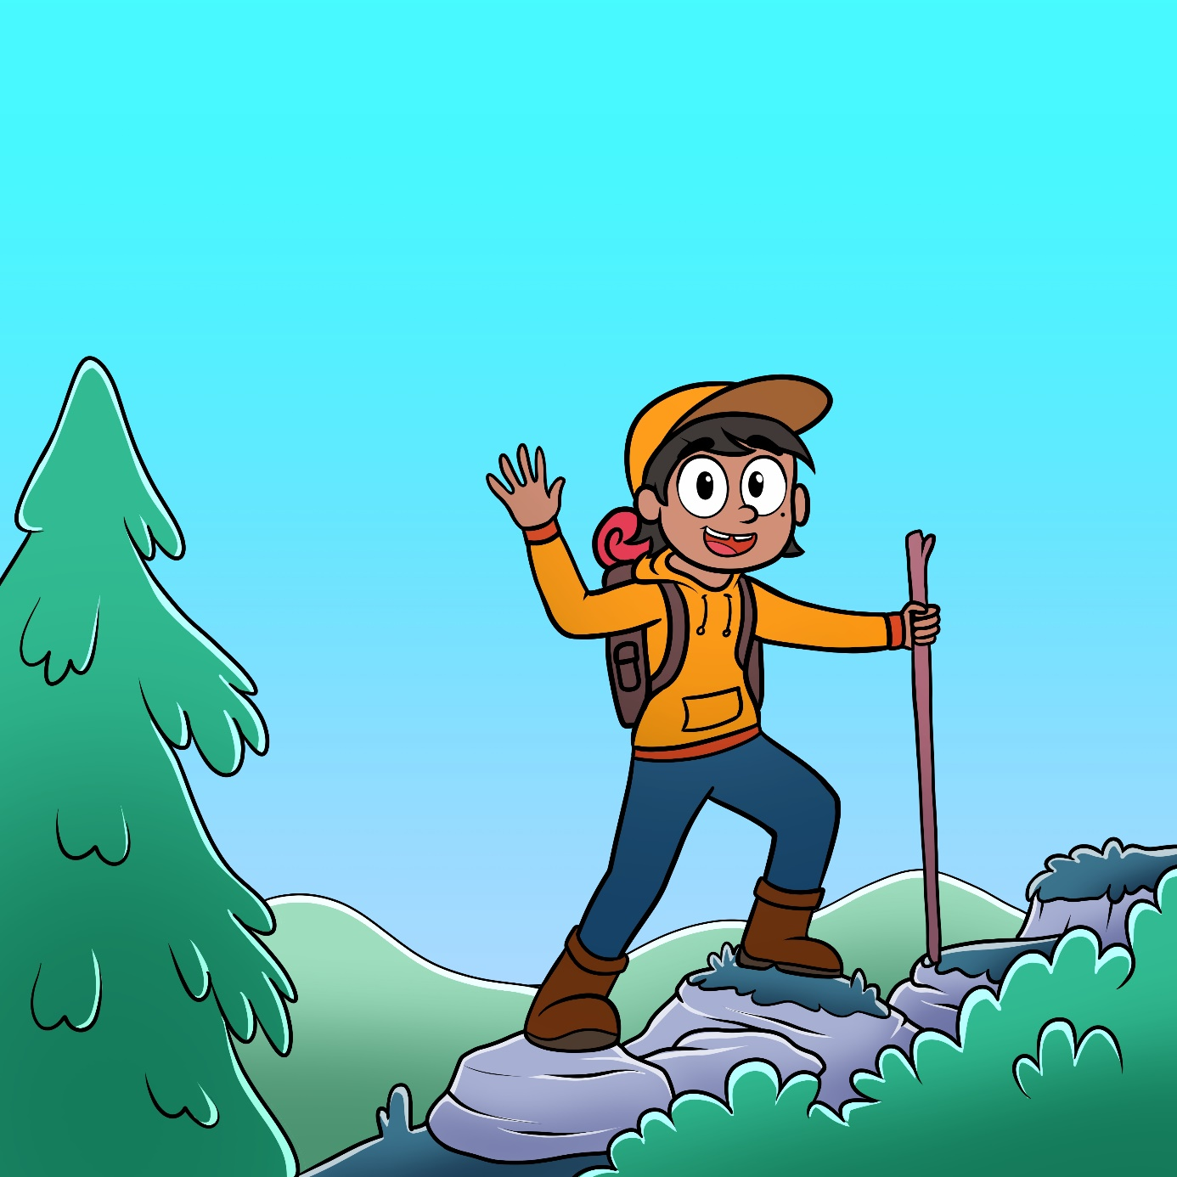

Niminwendaan
wii-pabaamaandaweyaan.

My name is John. I like to climb around.

Jessica nindizhinikaaz.
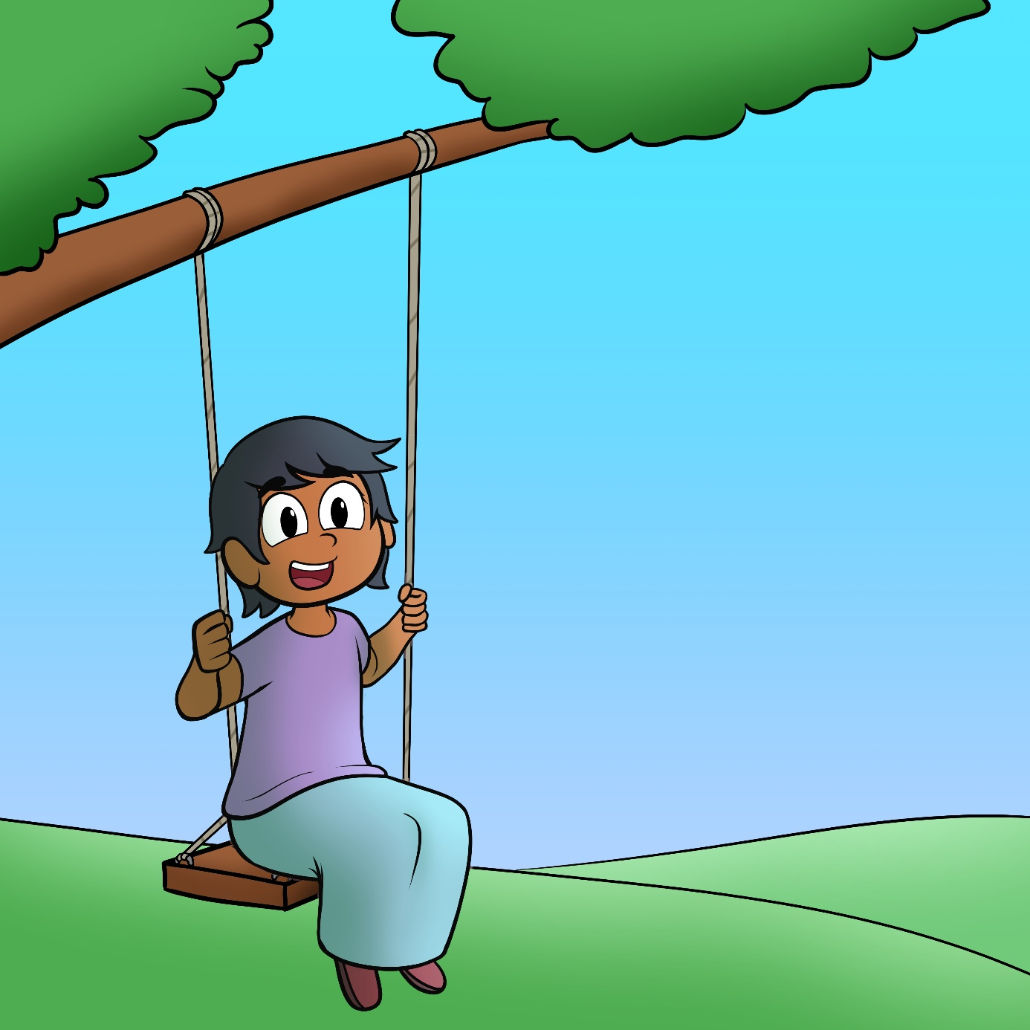

Niminwendaan
wii-wewebizoyaan.

My name is Jessica. I like to swing.

Sam nindizhinikaaz.
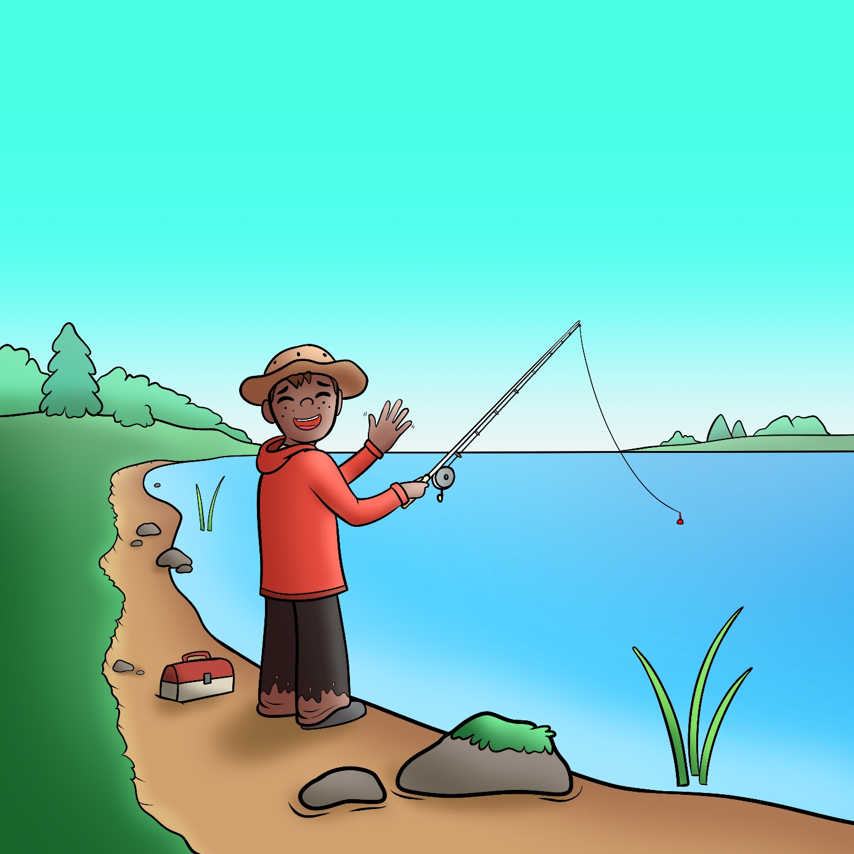

Niminwendaan
wii-wewebinaabiiyaan.

My name is Sam. I like to fish.

Sally nindizhinikaaz.
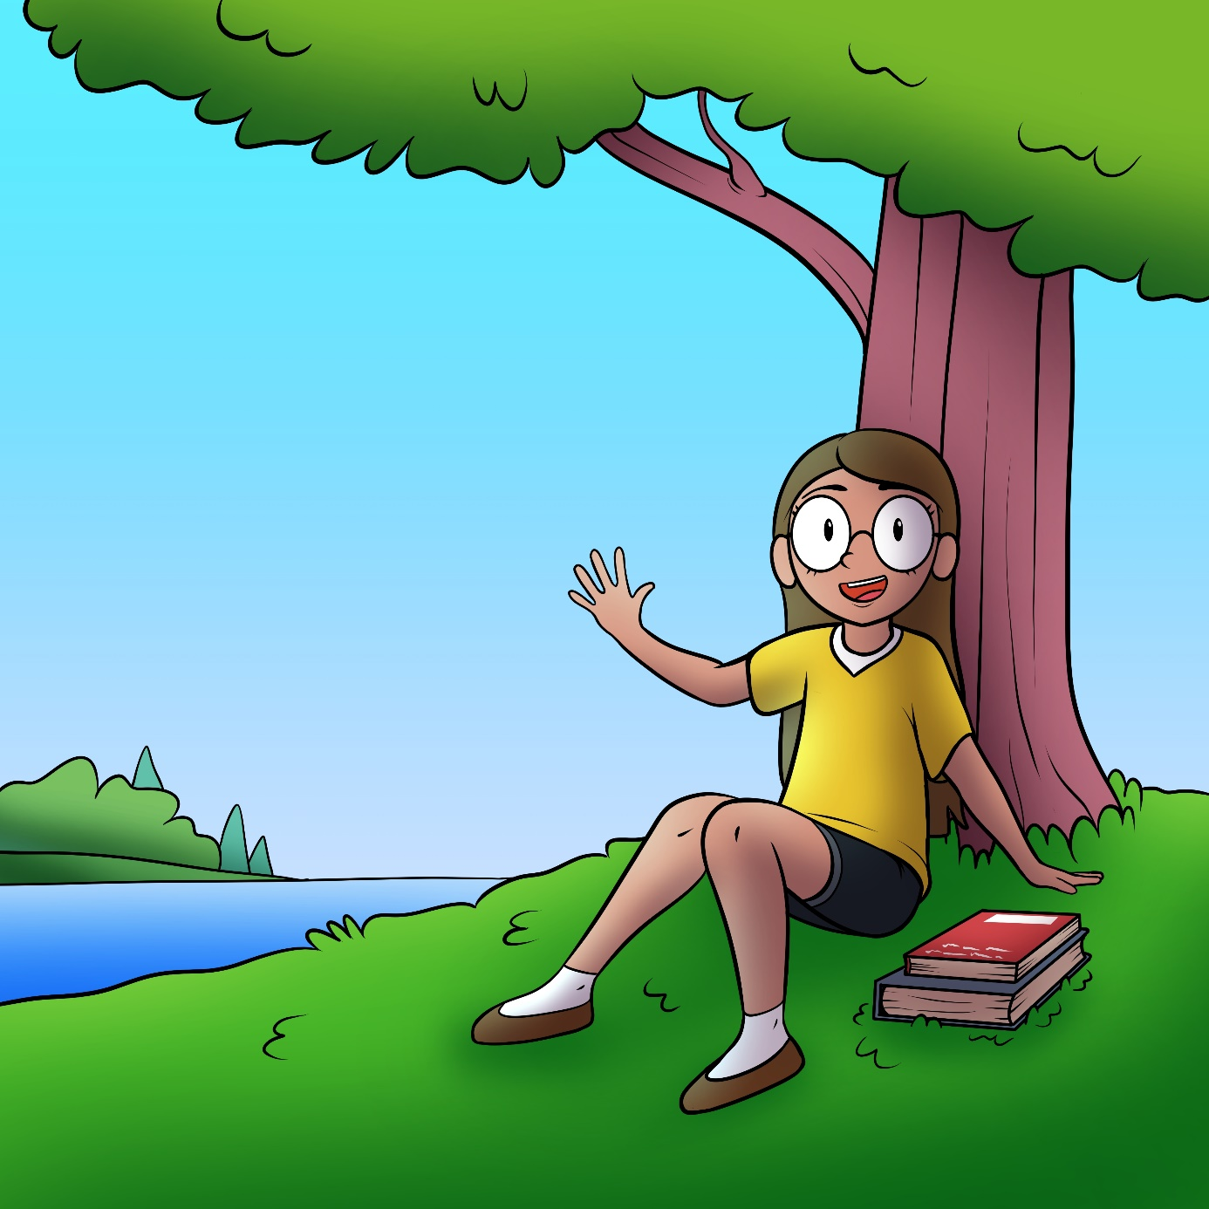

Niminwendaan
wii-agindaasoyaan.

My name is Sally. I like read.

Talia nindizhinikaaz.
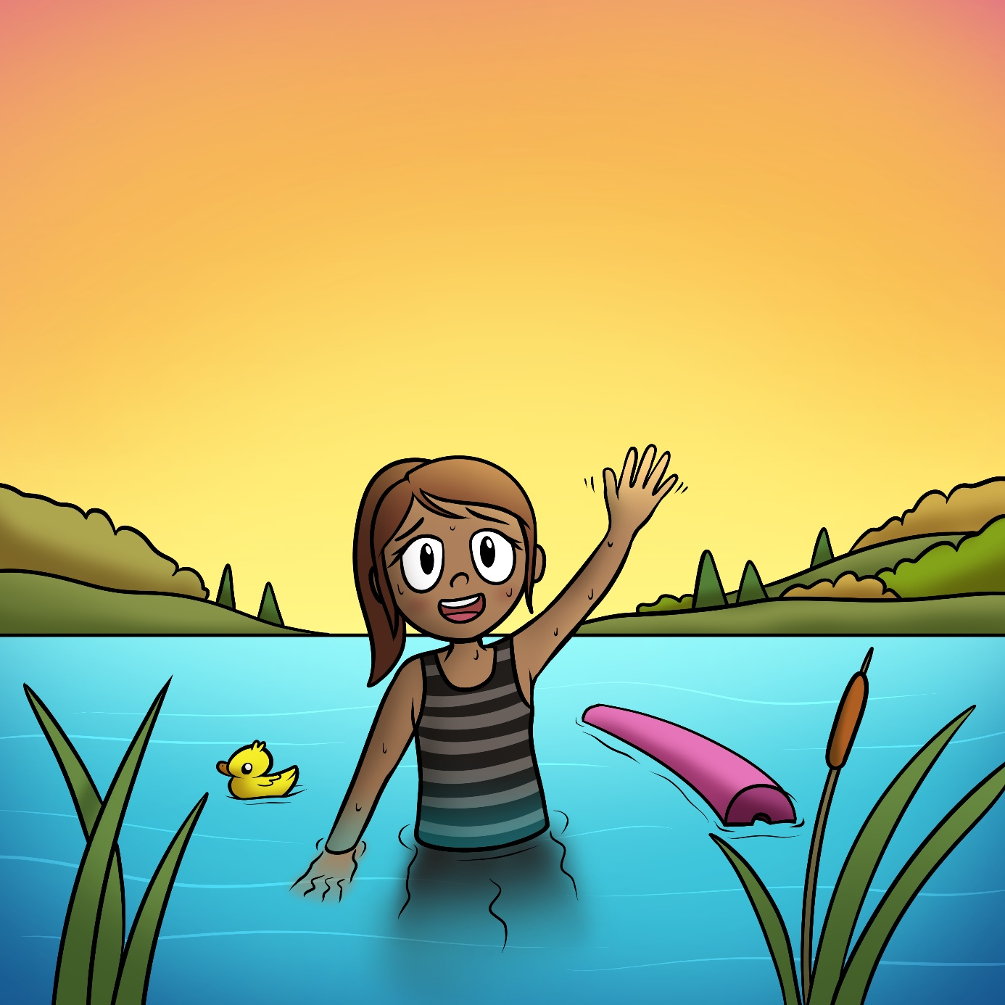

Niminwendaan
wii-bagizoyaan.

My name is Sally. I like to swim.

Tim nindizhinikaaz.
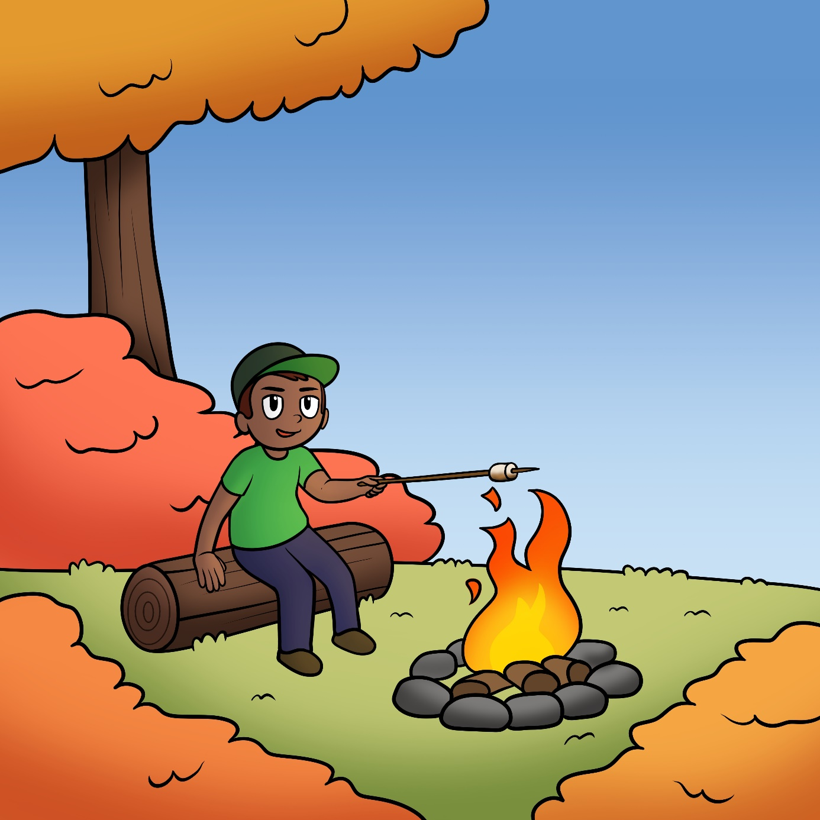

Niminwendaan
wii-namadibiyaan jiigishkodeng.

My name is Tim. I like to sit by the fire.

Angel nindizhinikaaz.
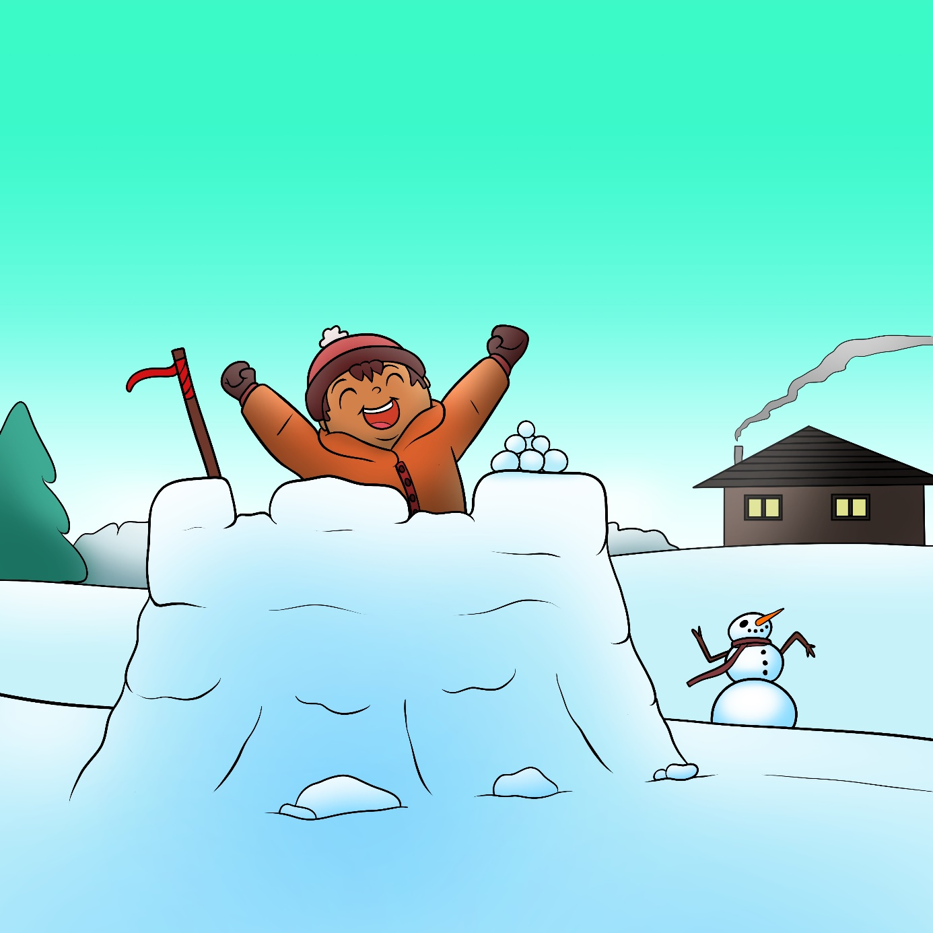

Niminwendaan
wii-odaminoyaan goonikaang.

My name is Angel. I like to play in the snow.

Andy nindizhinikaaz.
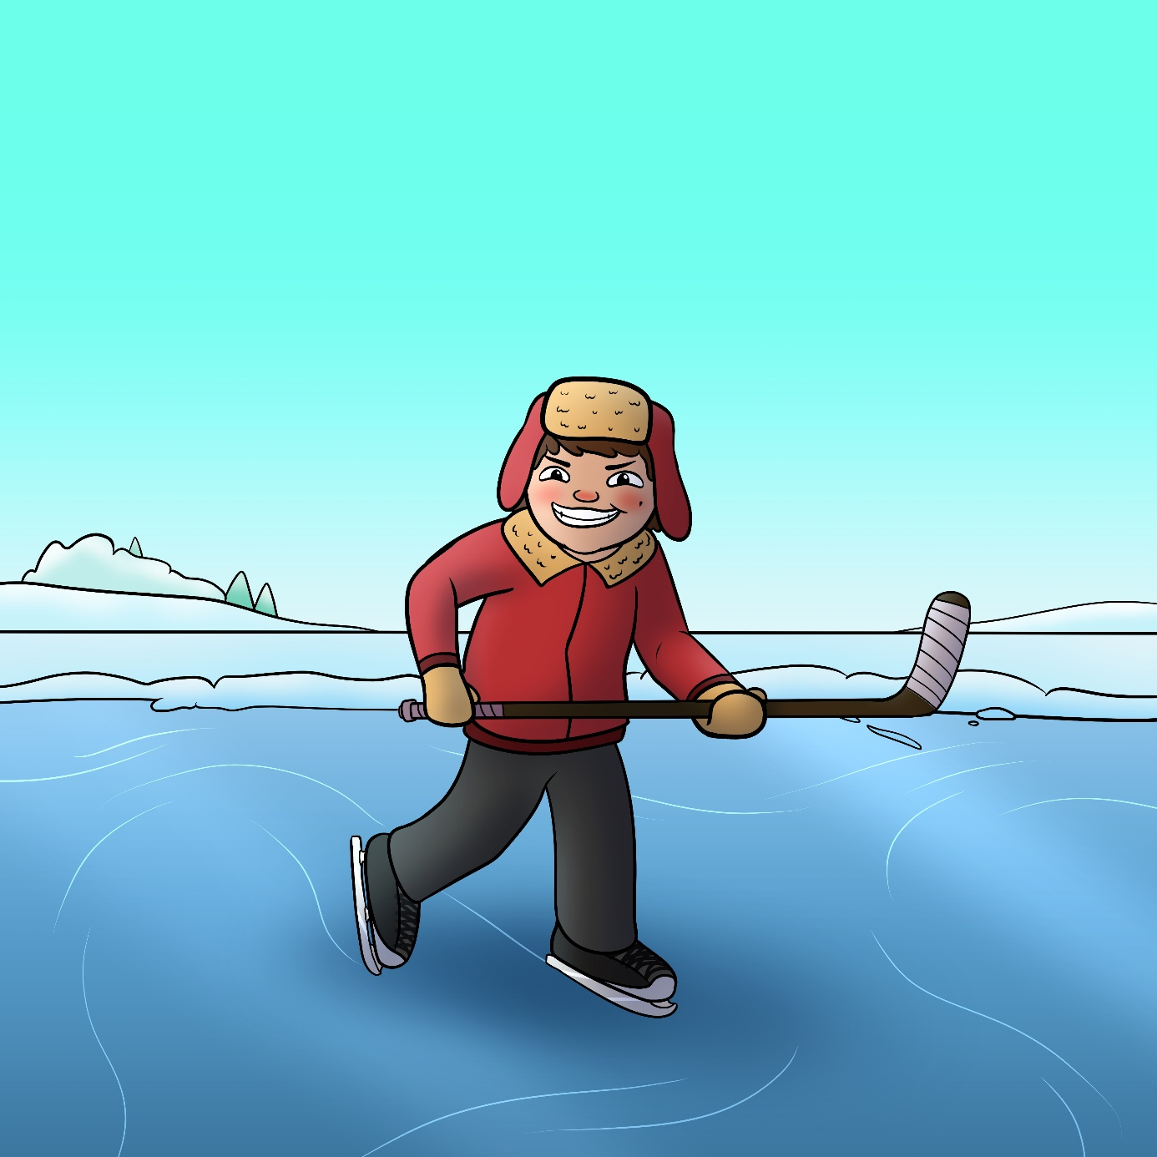

Niminwendaan
wii-zhooshkwaadeyaan.

My name is Andy. I like to ice skate.

Willow nindizhinikaaz.
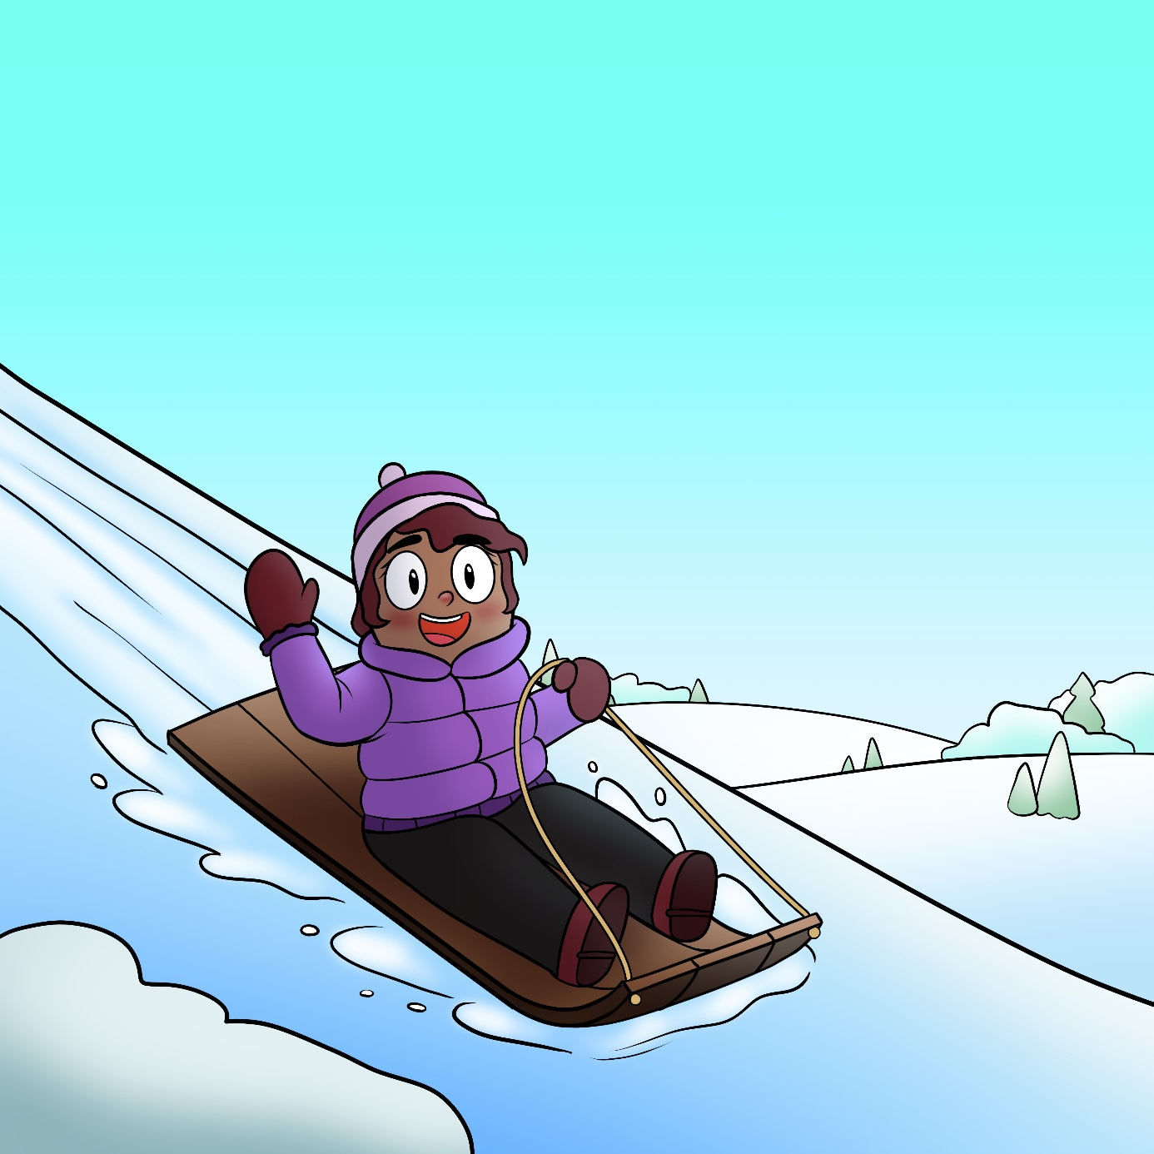

Niminwendaan
wii-zhooshkwajigeyaan.

My name is Willow. I like to go sliding.

Giga-waabamininim miinawaa!

I will see you all again!

