**Wiinimoshenhwi-**

**Giizhigad**

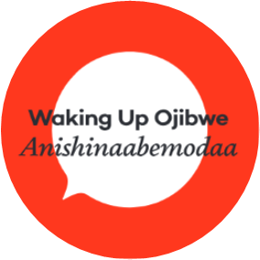

**Wiinimoshenhwi-Giizhigad Phrases**

Gizhawenimin – I love you

Gigikendaas – You are smart

Kakininjiinishin – Hug me

Giwawiyadendaagoz – You are funny

Gigizhewaadiz – You are kind

Gimino-wiijiiw – You are a good friend

Gigichiinendaagoz – You are special

**____________________ indizhinakaaz**

**Gimino-wiijiiw**

**Gigichiinendaagoz**

**Giwawiyadendaagoz**

**Gizhawenimin**

**Gigikendaas**