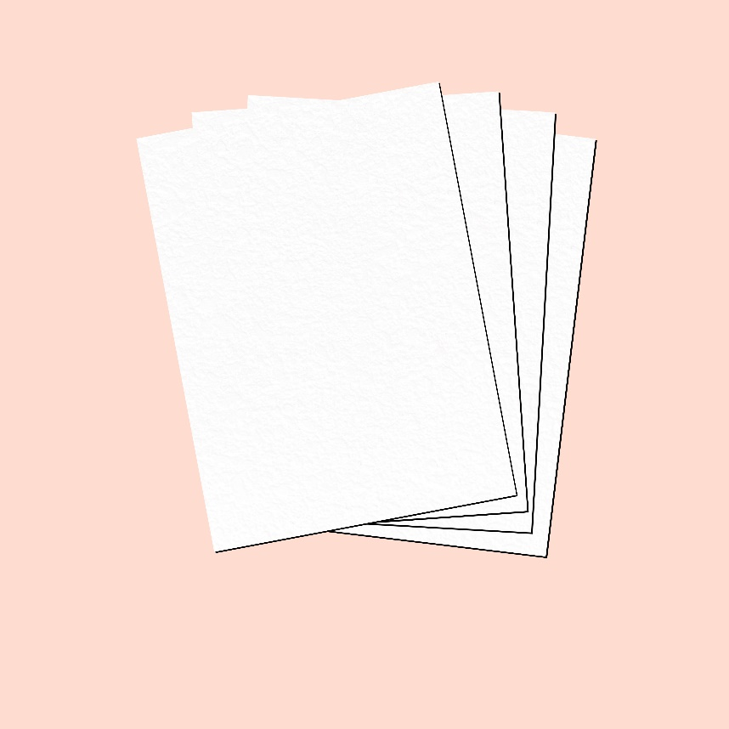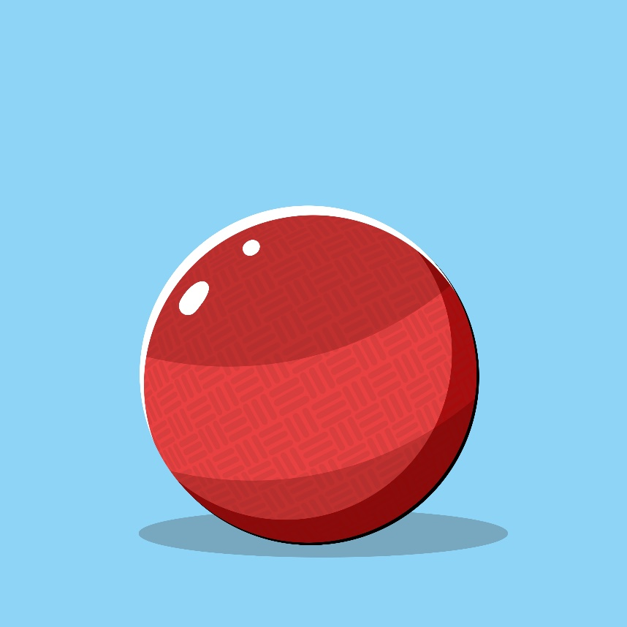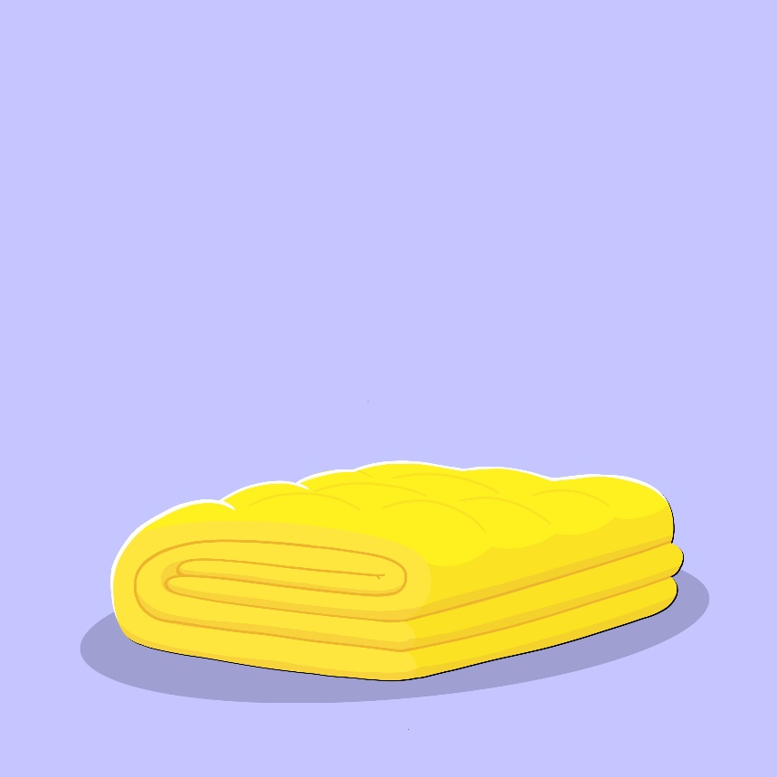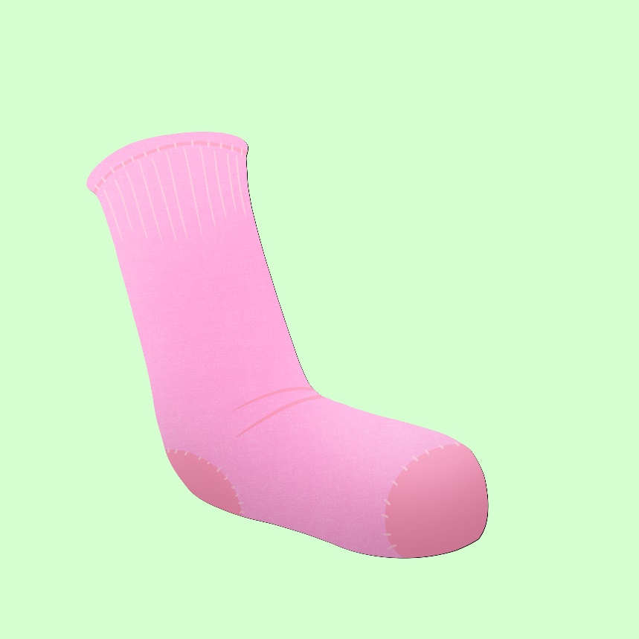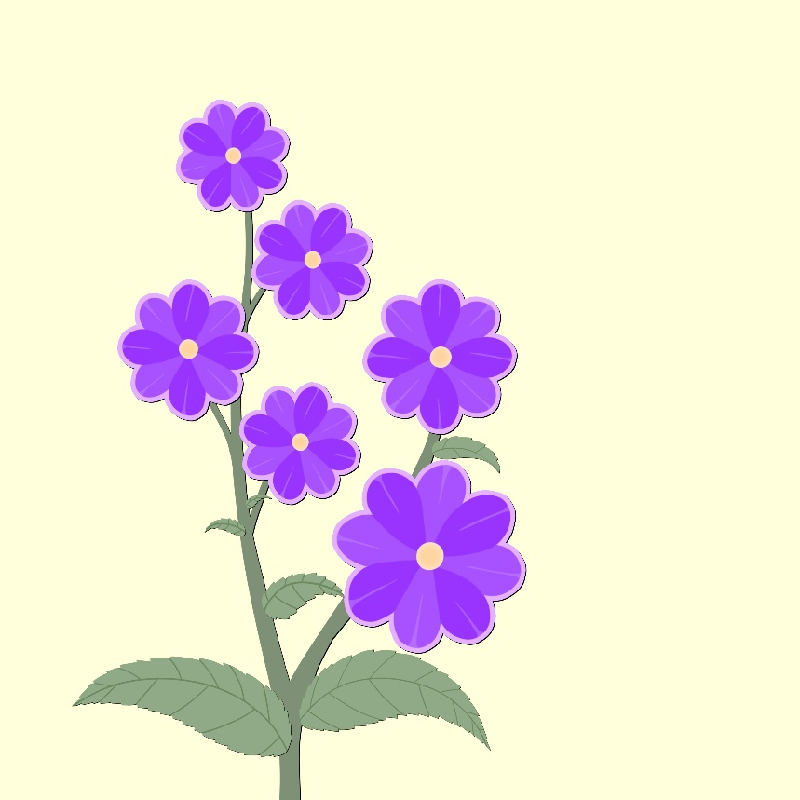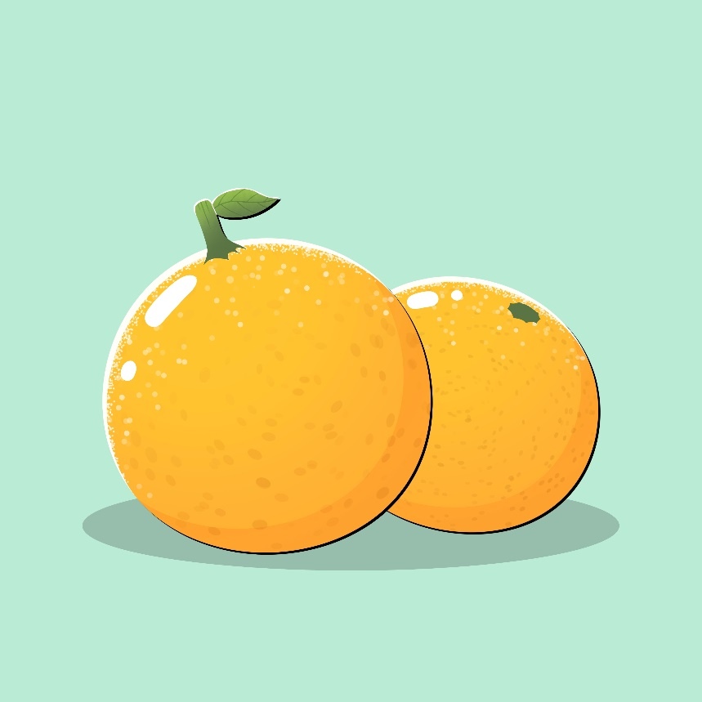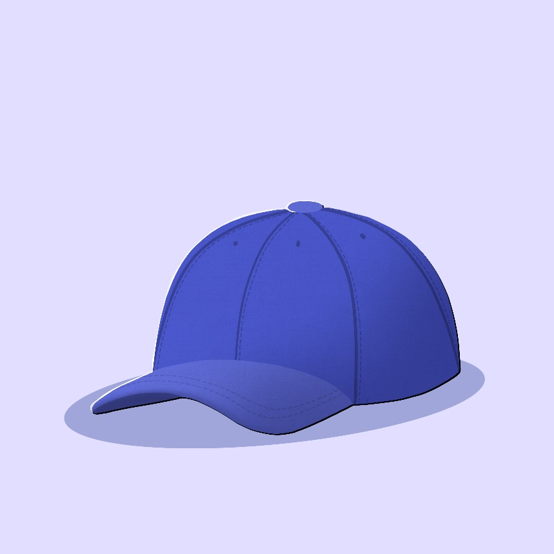

**miskwaa**(miss-kwaah)  
it is red

**waabishkaa**(waah-bish-kaah)  
it is white

**ozaawaa**(oh-zaah-waah)  
it is yellow

**makadewaa**(muh-kuh-day-waah)  
it is black

**miskoonaagwad**(miss-koh-naah-gwud)  
it is pink

**ozhaawashkwaa**(oh-zhaah-wush-shkwaah)  
it is green

**makade-ozaawaa**(muh-kuh-day-oh-zaah-waah)  
it is brown

**ozhaawashkwaa**(oh-zhaah-wush-shkwaah)  
it is purple

**ozaawaa**(oh-zaah-waah)  
it is orange

**ozhaawashkwaa**(oh-zhaah-wush-shkwaah)  
it is blue