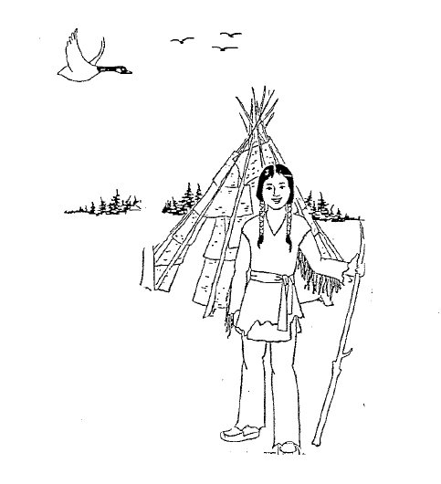Nanaboozhoo
idash
Nikag

Written by Brian Smith

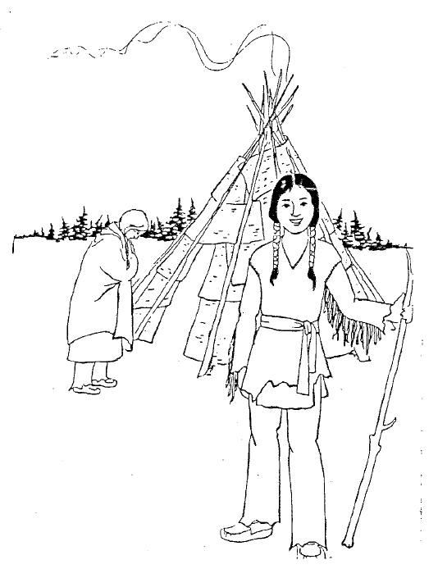

Mewinzha gwiiwizens gii-nitaawigi, Nanaboozhoo izhinikaazo, ogookomisan ogii-nitaawigi’igoon noopoming.

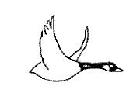

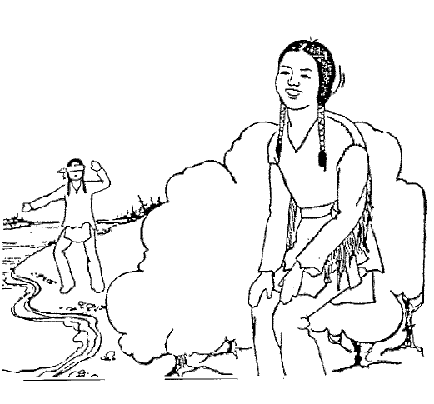

Page 2

Gii-nitaa-miikindizi a’aw Nanaboozhoo, anooj igo gegoo gii-izhichige.

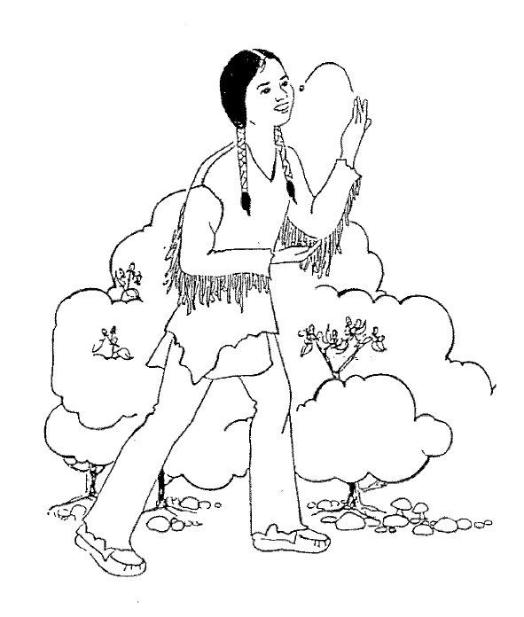

“Ganabaj ninga-babaamose,” inendam. Megwaa babaamosed ezhi-waabamad miskomiinan,
ezhi-mawinzod mii go gaye ani-miijid.

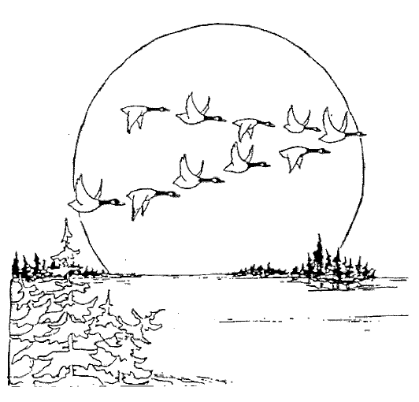

Mii dash noongom wenji-niigaanibizod awe naawayi’ii gaa-ayaad.

Translations
- A long time ago there was a boy named Nanaboozhoo who lived with his grandmother in the bush.
- He always liked to play tricks on other people.
- “I’ll go for a walk,” he thought one day. As he walked he saw some raspberries so he picked and ate them.
- He heard some geese flying in. “What can I do to get all those geese?” he thought. “I am very hungry,” he said.
- He peeled the bark of a spruce, and made it into a rope. “I’ll tie their legs all together,” he thought.
- Then he dove under the water, swam over to the geese, and tied their legs together.
- As he scared them, the one in the middle flew up first.
- That is why the one in the middle flies first.

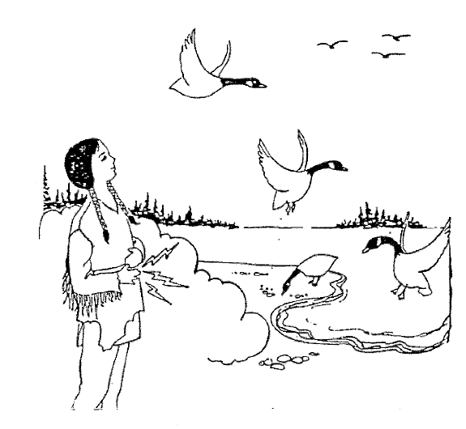

Ogii-noondawaag nikag wii-pooniiwag.
“Aaniin ge-izhichigeyaan gakina ji-dakoobinawaban?” inendam.
“Aapiji ninoondeskade,” gii-ikido.

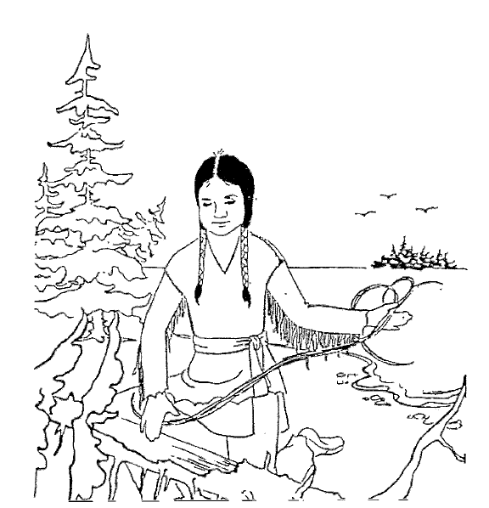

Izhi-bishagibinad gaawaandag, biiminakwaan
ogii-onji-ozhitoon.
“Ninga-dakobidoonan okaadan,” inendam.

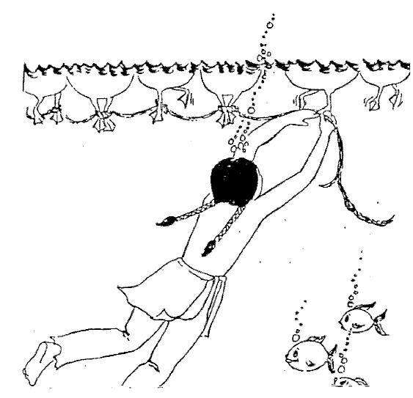

Giimooj gaa-izhi-googiid, wii-anda-dakobidood iniw okaadan gakina igiwe nikag.

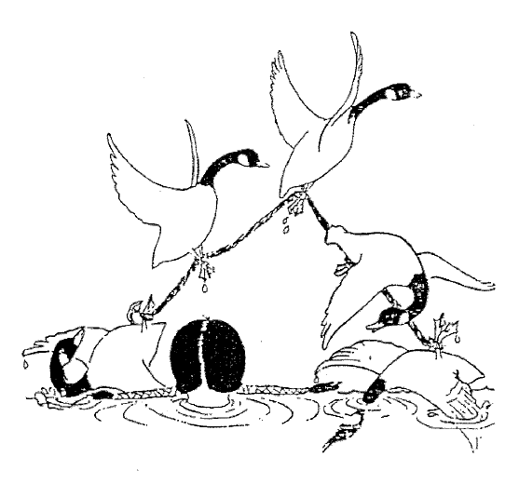

Naawayi’ii nitam gaa-ayaanid ogii-zegi’an
gaa-izhi-maajii-bimised.
.

