Mikan! - Find it!

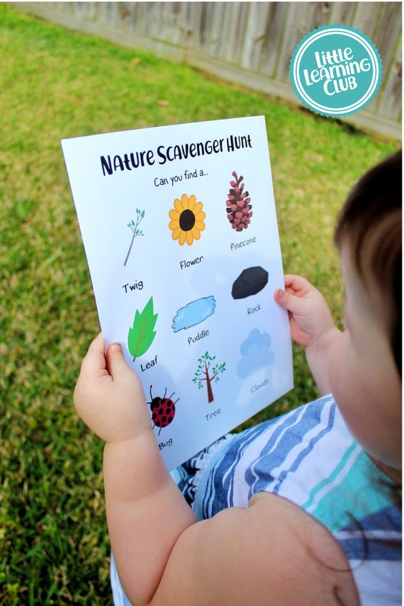
Materials:
- Scavenger hunt worksheet (provided)

Directions:
- Print out worksheets and laminate
- Dress the children according to weather (rain or shine)
- Help guide the children on finding the materials
- Have children gather for circle time to talk about what they discovered

Vocabulary:
Mikan ______ - Find ______ (Inanimate) | Mikaw ______ - Find ______ (Animate)
Waabigwan - Flower | Asin - Rock
Aniibiish - Leaf | Manidoosh - Bug
Mitigwanens - Twig | Mitig - Tree
Waanakwad - Cloud | Bineshiinh - Bird
Gaa-waanibiiyaag - Puddle

Bimosedaa! – Let’s walk!
Aandi ______? – Where is ______?

