Okaadi-Ginebig Odaminowin
Prepping the Game:
- Be sure to use a large enough container that will fit 10 or more large cards in and to make sure the container is clean. A dishwasher tablets container works great!
- Using the tracing pattern on the next page, trace out an crocodile head on a green foam sheet, and trace the eyes with white and black foam sheets. Cut the tracings and glue them together. Glue 2 any colour pompoms where the nose should be on the crocodile.
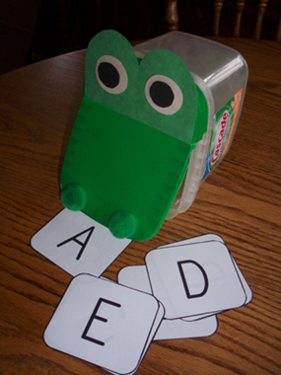
- Glue the head onto the container - be sure to leave a flap for his mouth to open easily. When finished it should look something like this:

- After leaving it to dry, you can add in the Miijim/Wiisiniwin Cards.

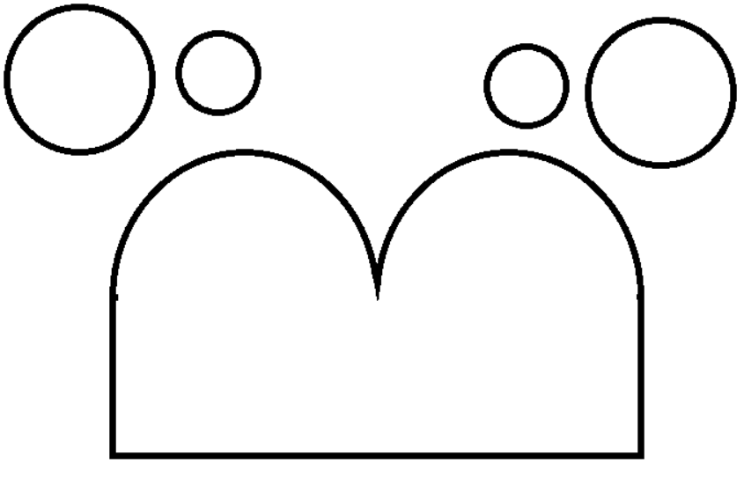

Okaadi-ginebig Nagamowin

Okaadi-ginebig, Okaadi-ginebig,
Wegonen gii-miijiyin?
Okaadi-ginebig, Okaadi-ginebig,
Wegonen gii-miijiyin?
(Reach in a grab a card)
Howa! ________________ gigii-miijin!

Crocodile, Crocodile,
What did you eat?
Crocodile, Crocodile,
What did you eat?
(Reach in and grab a card)
Wow! You ate __________________!

