Niswi Makwag
Three Bears
Gaa-ozhiibii’iged/Gaa-nagamod: Bernice Greene

Onzaam gizhide naabagate’igan, uh-huh, uh-huh.
Onzaam gizhide naabagate’igan, uh-huh, uh-huh.
Onzaam gizhide naabagate’igan, ando-babaamosedaa, uh-huh, uh-huh, uh-huh.
(The porridge is very hot. The porridge is very hot. The porridge is very hot so let’s go walk around.)
Wiiba igo ikwezens bi-ayaa, uh-huh.
Wiiba igo ikwezens bi-ayaa, uh-huh.
Wiiba igo ikwezens bi-ayaa imaa waakaa’igan, uh-huh, uh-huh, uh-huh.
(Soon a girl comes. Soon a girl comes. Soon a girl comes there to the house.)
Ezhi-namadabid ikwezens, uh-huh.
Ezhi-namadabid ikwezens, uh-huh.
Ezhi-namadabid ikwezens apane naa i'i desabiwin, uh-huh, uh-huh, uh-huh.
(The girl sits. The girl sits. The girl sits on the chair *implied: and breaks it*.)
Ezhi-gagwe-gawishimod ikwezens, uh-huh.
Ezhi-gagwe-gawishimod ikwezens, uh-huh.
Ezhi-gagwe-gawishimod onji-nibaased iidog, uh-huh, uh-huh, uh-huh.
(The girls tries to go to bed. The girl tries to go to bed. She tries to go to bed so she might sleep.)
Wiiba igo makwag bi-giiwewag, uh-huh.
Wiiba igo makwag bi-giiwewag, uh-huh.
Wiiba igo makwag bi-giiwewag imaa waakaa’igan, uh-huh, uh-huh, uh-huh.
(Soon the bears come home. Soon the bears come home. Soon the bears come home there to the house.)
Ezhi-amaji’awaad ikwezens, uh-huh.
Ezhi-amaji’awaad ikwezens, uh-huh.
Ezhi-amaji’awaad ikwezens igi makwag, uh-huh, uh-huh, uh-huh.
(They wake the girl. They wake the girl. The bears wake the girl.)
Ambe ge giin bi-wiisinin odinaawaan, uh-huh.
Ambe ge giin bi-wiisinin odinaawaan, uh-huh.
Ambe ge giin bi-wiisinin odinaawaan, aapiji ninoondeskademin! Uh-huh, uh-huh, uh-huh.
(You too come and eat. You too come and eat. You too come and eat, we’re very hungry!)

Niswi Makwag

- Teach counting bezhig, niizh, niswi.
- Use the Niswi Makwag Story Cards to sing along with the Niswi Makwag song.
- Compare and contrast this retelling with the original Goldilocks and the Three Bears. Students should be able to recognize that the Bears invite her to stay for supper and feed her instead of her running away.
Talk about the importance of feeding visitors and how food ties into building relationships.
- Talk about what bears eat in the wild. Black and brown bears mostly eat insects, grasses, roots, berries, and other animals like birds, fish and rodents. Some bears also like honey and termites.

Lesson Ideas
A Resource from the Anishinaabemodaa Initiative & Bernice Greene

Materials:
- Lyrics for Niswi Makwag
- Niswi Makwag Story Cards

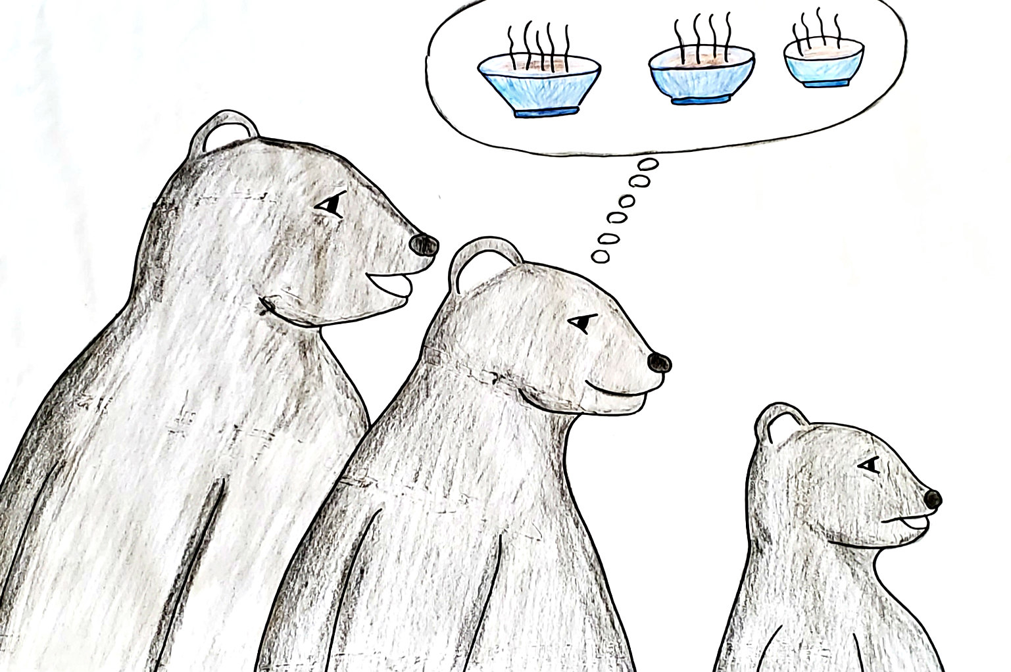

Niswi Makwag - 1

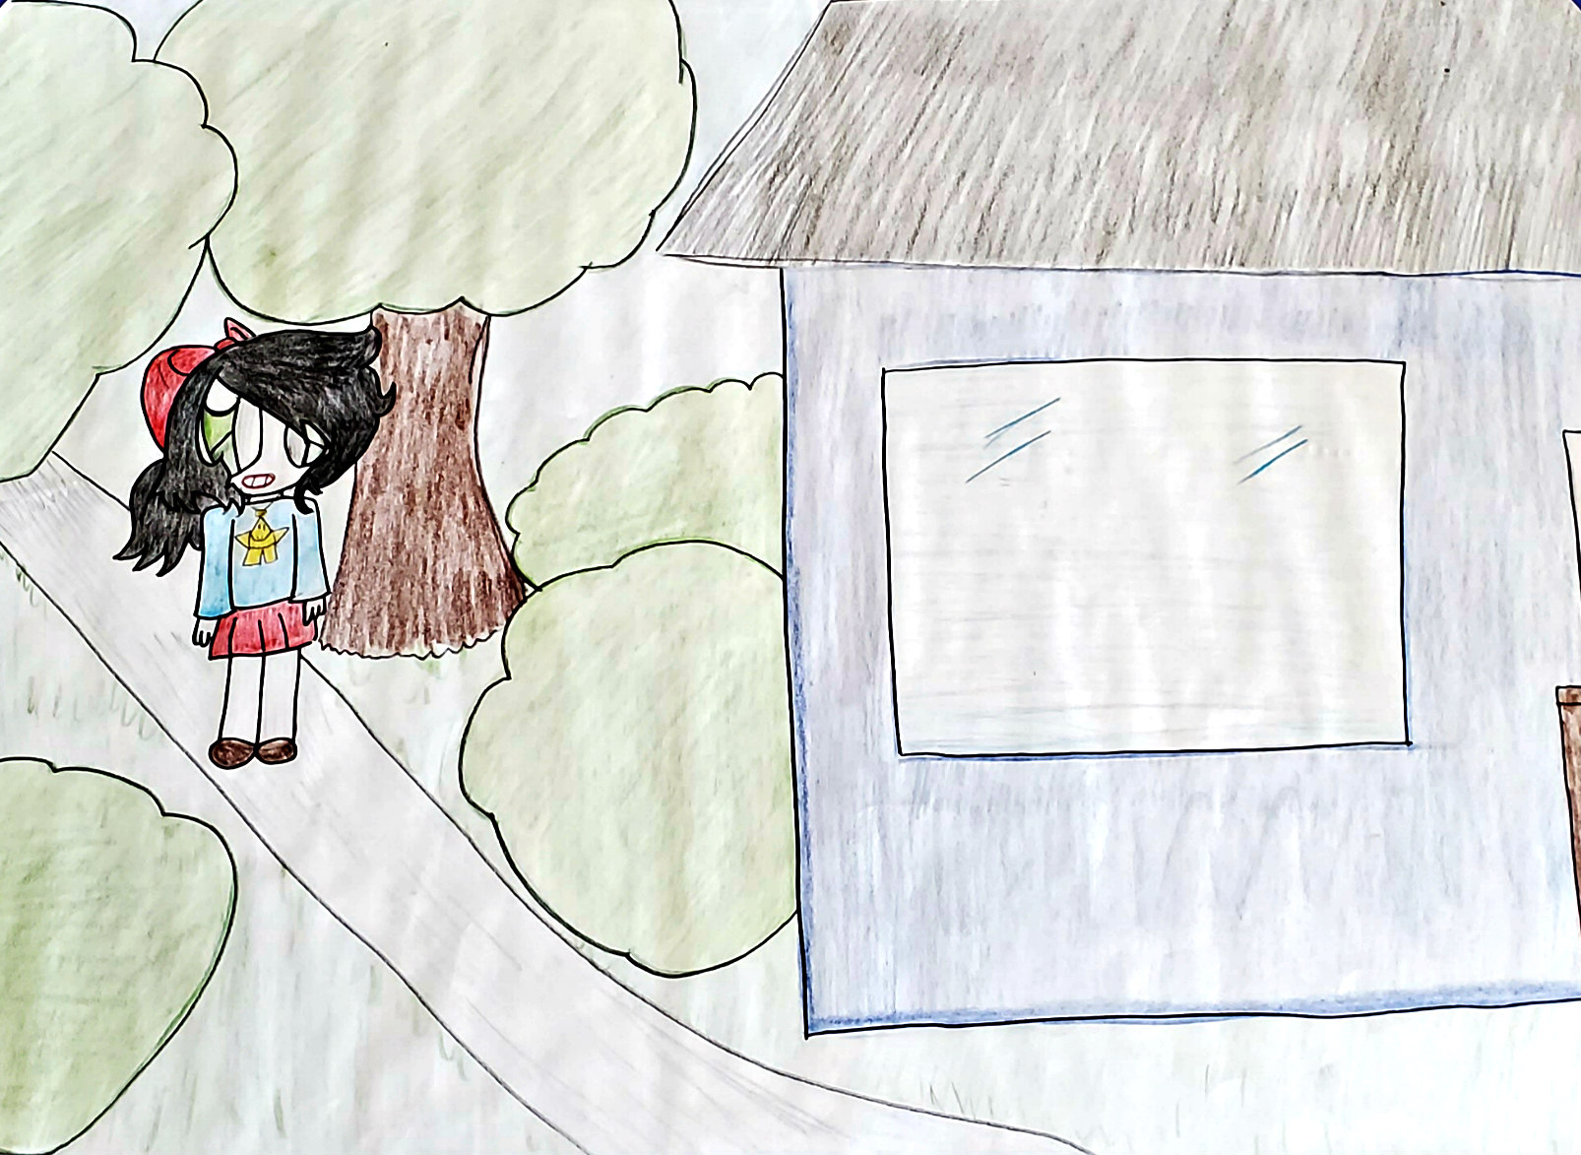

Niswi Makwag - 2

Niswi Makwag - 3
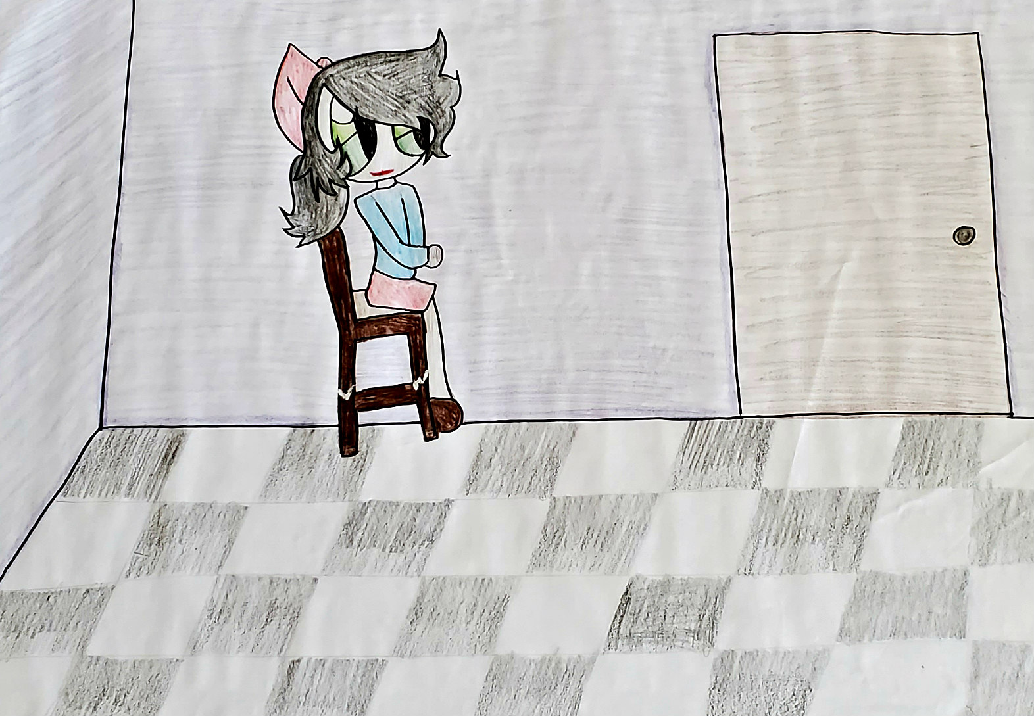

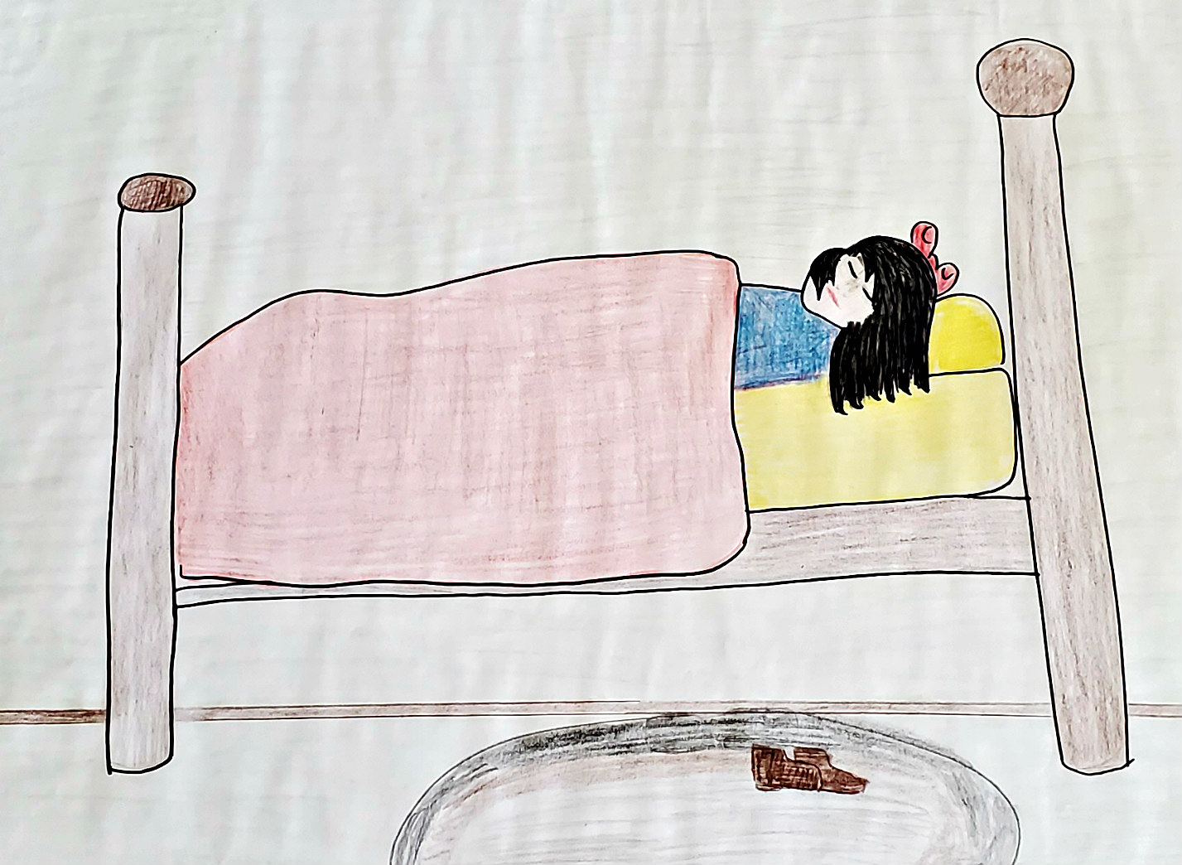
Niswi Makwag - 4

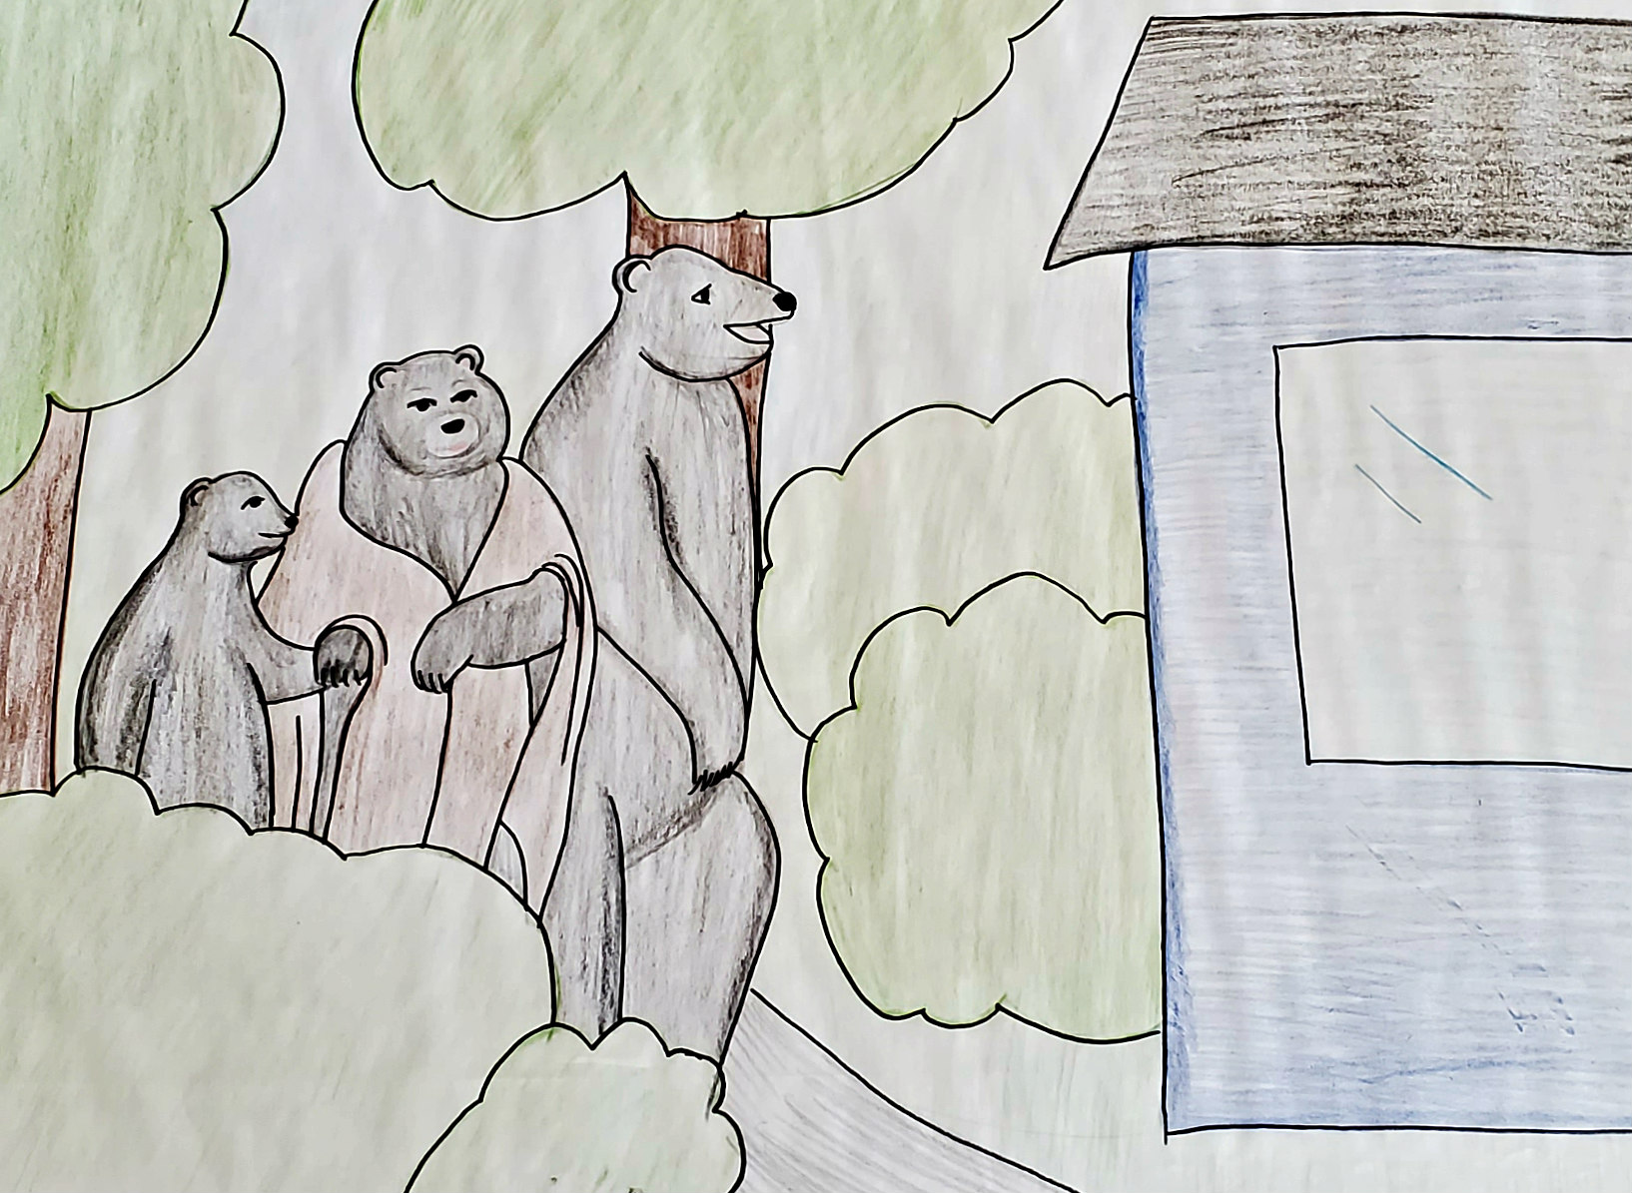

Niswi Makwag - 5

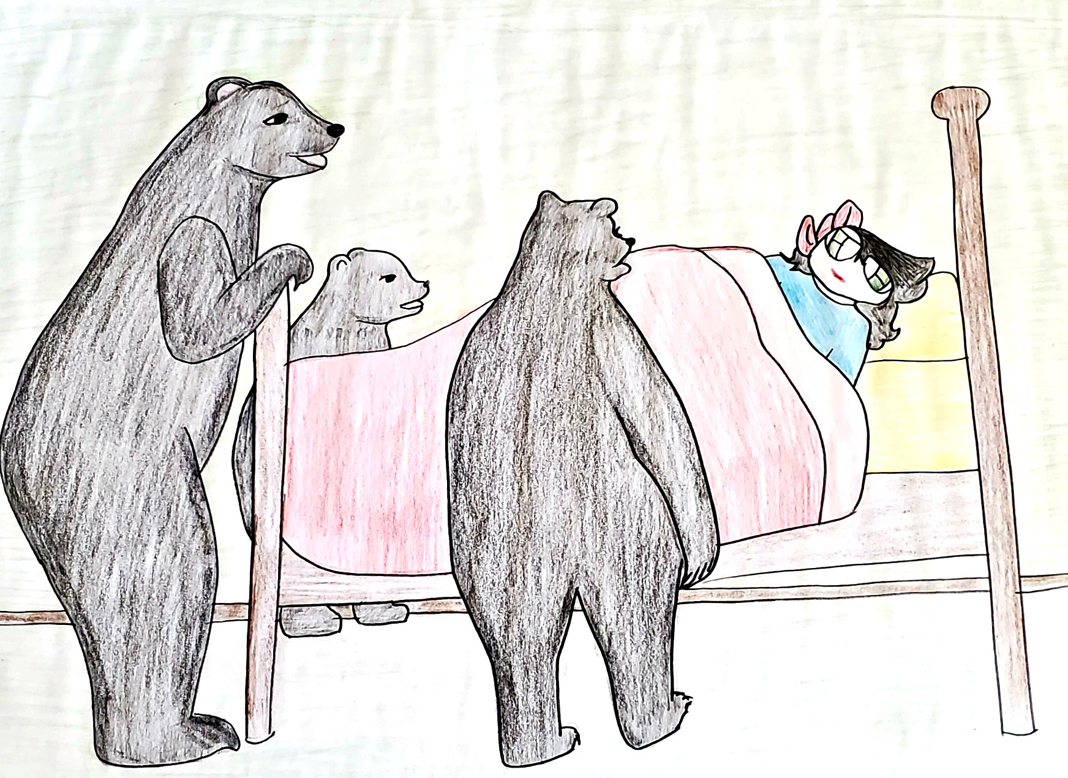

Niswi Makwag - 6

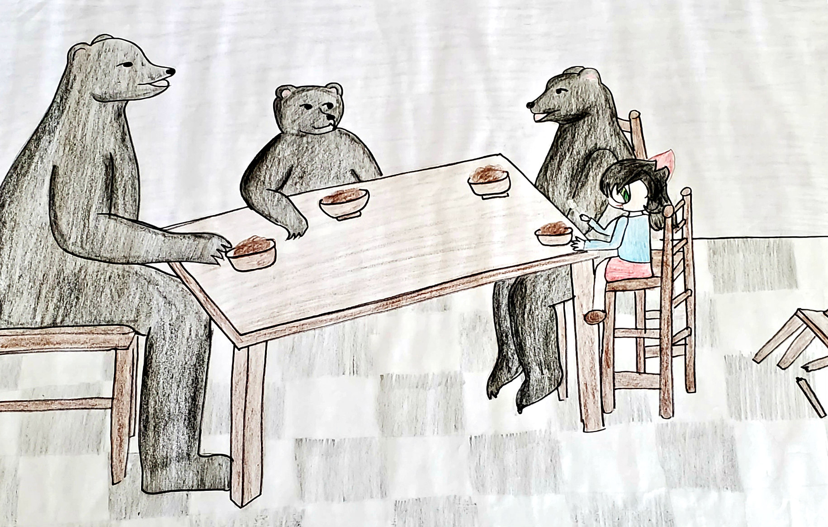

Niswi Makwag - 7

