Naanan Moonzoog
Five Moose
Sung to the tune of “Five Little Speckled Frogs”
Gaa-ozhiibii’iged/Gaa-nagamod: Bernice Greene

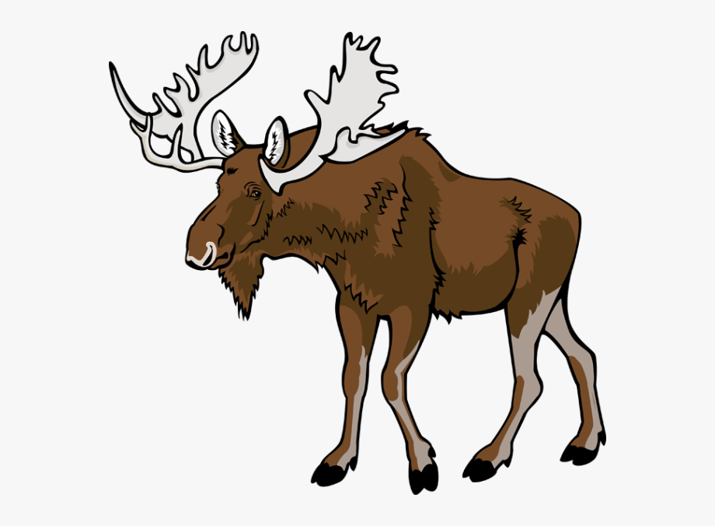Naanan moonzoog niwaabamaag noopiming made niibawiyaad. Bezhig a’a moonz apane noopiming, niiwin eta moonzoog niwaabamaag.
(I see five moose standing in the bush. One moose is very far in the bush, now I see only four moose.)
Niiwin moonzoog niwaabamaag noopiming made niibawiyaad. Bezhig a’a moonz apane noopiming, niswi eta moonzoog niwaabamaag.
(I see four moose standing in the bush. One moose is very far in the bush, now I see only three moose.)
Niswi moonzoog niwaabamaag noopiming made niibawiyaad. Bezhig a’a moonz apane noopiming, niizh eta moonzoog niwaabamaag.
(I see three moose standing in the bush. One moose is very far in the bush, now I see only two moose.)
Niizh moonzoog niwaabamaag noopiming made niibawiyaad. Bezhig a’a moonz apane noopiming, bezhig eta moonz niwaabamaa.
(I see two moose standing in the bush. One moose is very far in the bush, now I see only one moose.)
Bezhig a’a moonz niwaabamaa noopiming made niibawid. Bezhig a’a moonz apane noopiming, mii sa apane igi moonzoog.
(I see five moose standing in the bush. One moose is very far in the bush, now there’s no more moose.)

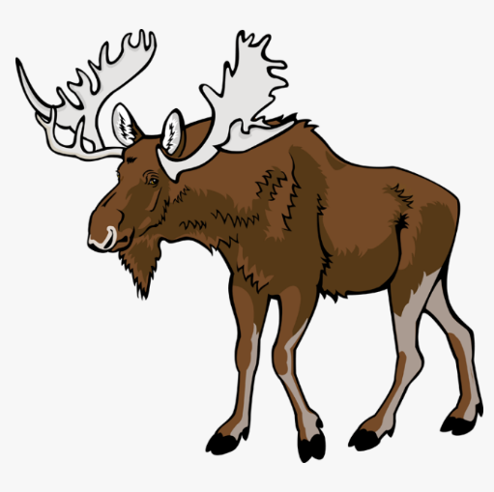
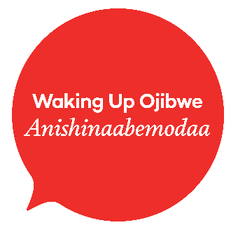
Naanan Moonzoog

- Teach counting bezhig, niizh, niswi, niiwin, naanan. You can count the Moonzoog Cards as well.
- Teach a grammar pattern for I see him/her or I see them. You can switch out the noun for any animal, person, or animate object.
Niwaabamaa moonz. I see a moose.
Niwaabamaag moonzoog. I see more than one moose.
You can also teach the grammar pattern for I hear him/her or I hear them. You can switch out the noun for any animal, person, or animate object.
Ninoondawaa ikwe. I hear a woman.
Ninoondawaag ikwewag. I hear women.
- Use the Moonzoog Cards while singing the Naanan Moozoog song to show understanding of what is being sung.
- Teach the actions that go along with the Naanan Moonzoog song. Have the students create a video to send home or share on social media. You can find the action in our Action Guide.

Lesson Ideas
A Resource from the Anishinaabemodaa Initiative & Bernice Greene

Materials:
- Lyrics for Naanan Moonzoog
- Moonzoog Cards
- Naanan Moonzoog Actions Guide

Moonzoog Cards
Naanan Moonzoog Action Guide

Naanan
Hold up five fingers
moonzoog
Make antlers on your head
niwaabamaag
Make binoculars around your eyes
noopiming
Point to the bush/forest
made niibawiyaad.
Use four fingers to demonstrate legs standing on your other hand
Bezhig a’a
Hold up one finger
moonz
Make antlers on your head
apane
Gesture very far away, as if the moose ran away
noopiming,
Point to the bush/forest
niiwin eta moonzoog
Hold up four fingers
niwaabamaag.
Make binoculars around your eyes

Naanan Moozoog

