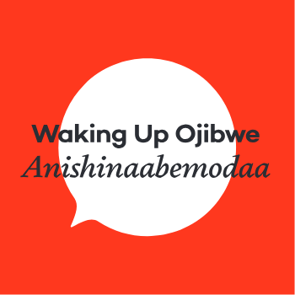
Miijim/Wiisiniwin Phrase List

Gigizhebaa-wiisiniwin Breakfast food/breakfast
Naawakwe-wiisiniwin Lunch food/lunch
Onaagoshi-wiisiniwin Supper food/supper

Wiisini He/she is eating
Wiisinin Eat
Weweni-wiisinin Eat carefully/properly
Miizhishin Give it to me

Noondeskade He/she is hungry
Ninoondeskade I am hungry
Ginoondeskade You are hungry
Ginoondeskade na? Are you hungry?

Debishkinii He/she is full
Nindebishkinii I am full
Gidebishikinii You are full
Gidebishikinii na? Are you full?

Minopogwad It tastes good (inanimate)
Minopogwad ina? Does it taste good?
Minopogozi It tastes good (animate)
Minopogozi na? Does it taste good?

