Gidagindaasomin!
We Count!
Gaa-ozhiibii’iged & Gaa-nagamod: Bernice Greene

Weya, weya, weya, weya
Weya heya, weya heya
Weya heya, weya heya
Weya heya, heya!
Bezhig, Niizh, Niswi, Niiwin, One, Two, Three, Four,
Naanan, Ningodwaaswi, Five, Six,
Niizhwaaswi, Nishwaaswi, Seven, Eight,
Zhaangaswi, Midaaswi, Nine, Ten,
Midaaswi gidagindaasomin! We count to Ten!
Weya heya, weya heya
Weya heya, weya heya
Weya heya, weya heya
Weya heya, heya!

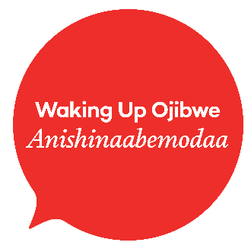

- Practice counting 1-10 in Anishinaabemowin.
- Sing the Gidagindaasomin song together.
- Print and use resources from our numbers kit: http://www.wakingupojibwe.ca/pathways/families/agindaasowinan/
- Check out this playlist on YouTube dedicated to learning numbers in Anishinaabemowin:
https://www.youtube.com/playlist?list=PLSQo-gTeDRVI5b7ESqAYsEGG7HS3wl4uu&fbclid=IwAR3i_tUMO46gVAqy-kfzZUwE-HeTtaFP7M6YnwoRRsjc6mFv3vSuQXmdLkQ

Lesson Ideas
A Resource from the Anishinaabemodaa Initiative & Bernice Greene

Materials:
- Lyrics for Gidagindaasomin!

Gidagindaasomin!

