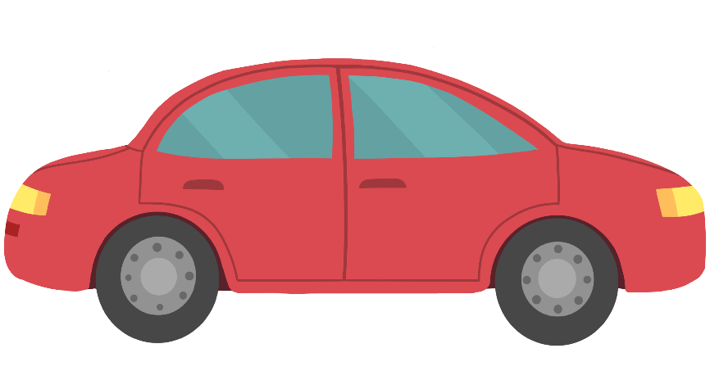

ozhaawashkwaa
waabijiiyaa
ozhaawashkwaa
ozhaawashkwaa
ozaawaa
ozaawaa
miskoonaagwad
miskwaa

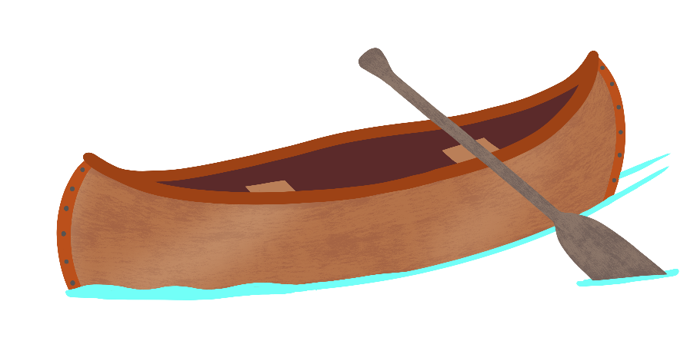

miskwaa

ozhaawashkwaa

ozhaawashkwaa

ozaawaa

ozaawaa

waabijiiyaa

ozhaawashkwaa

miskoonaagwad

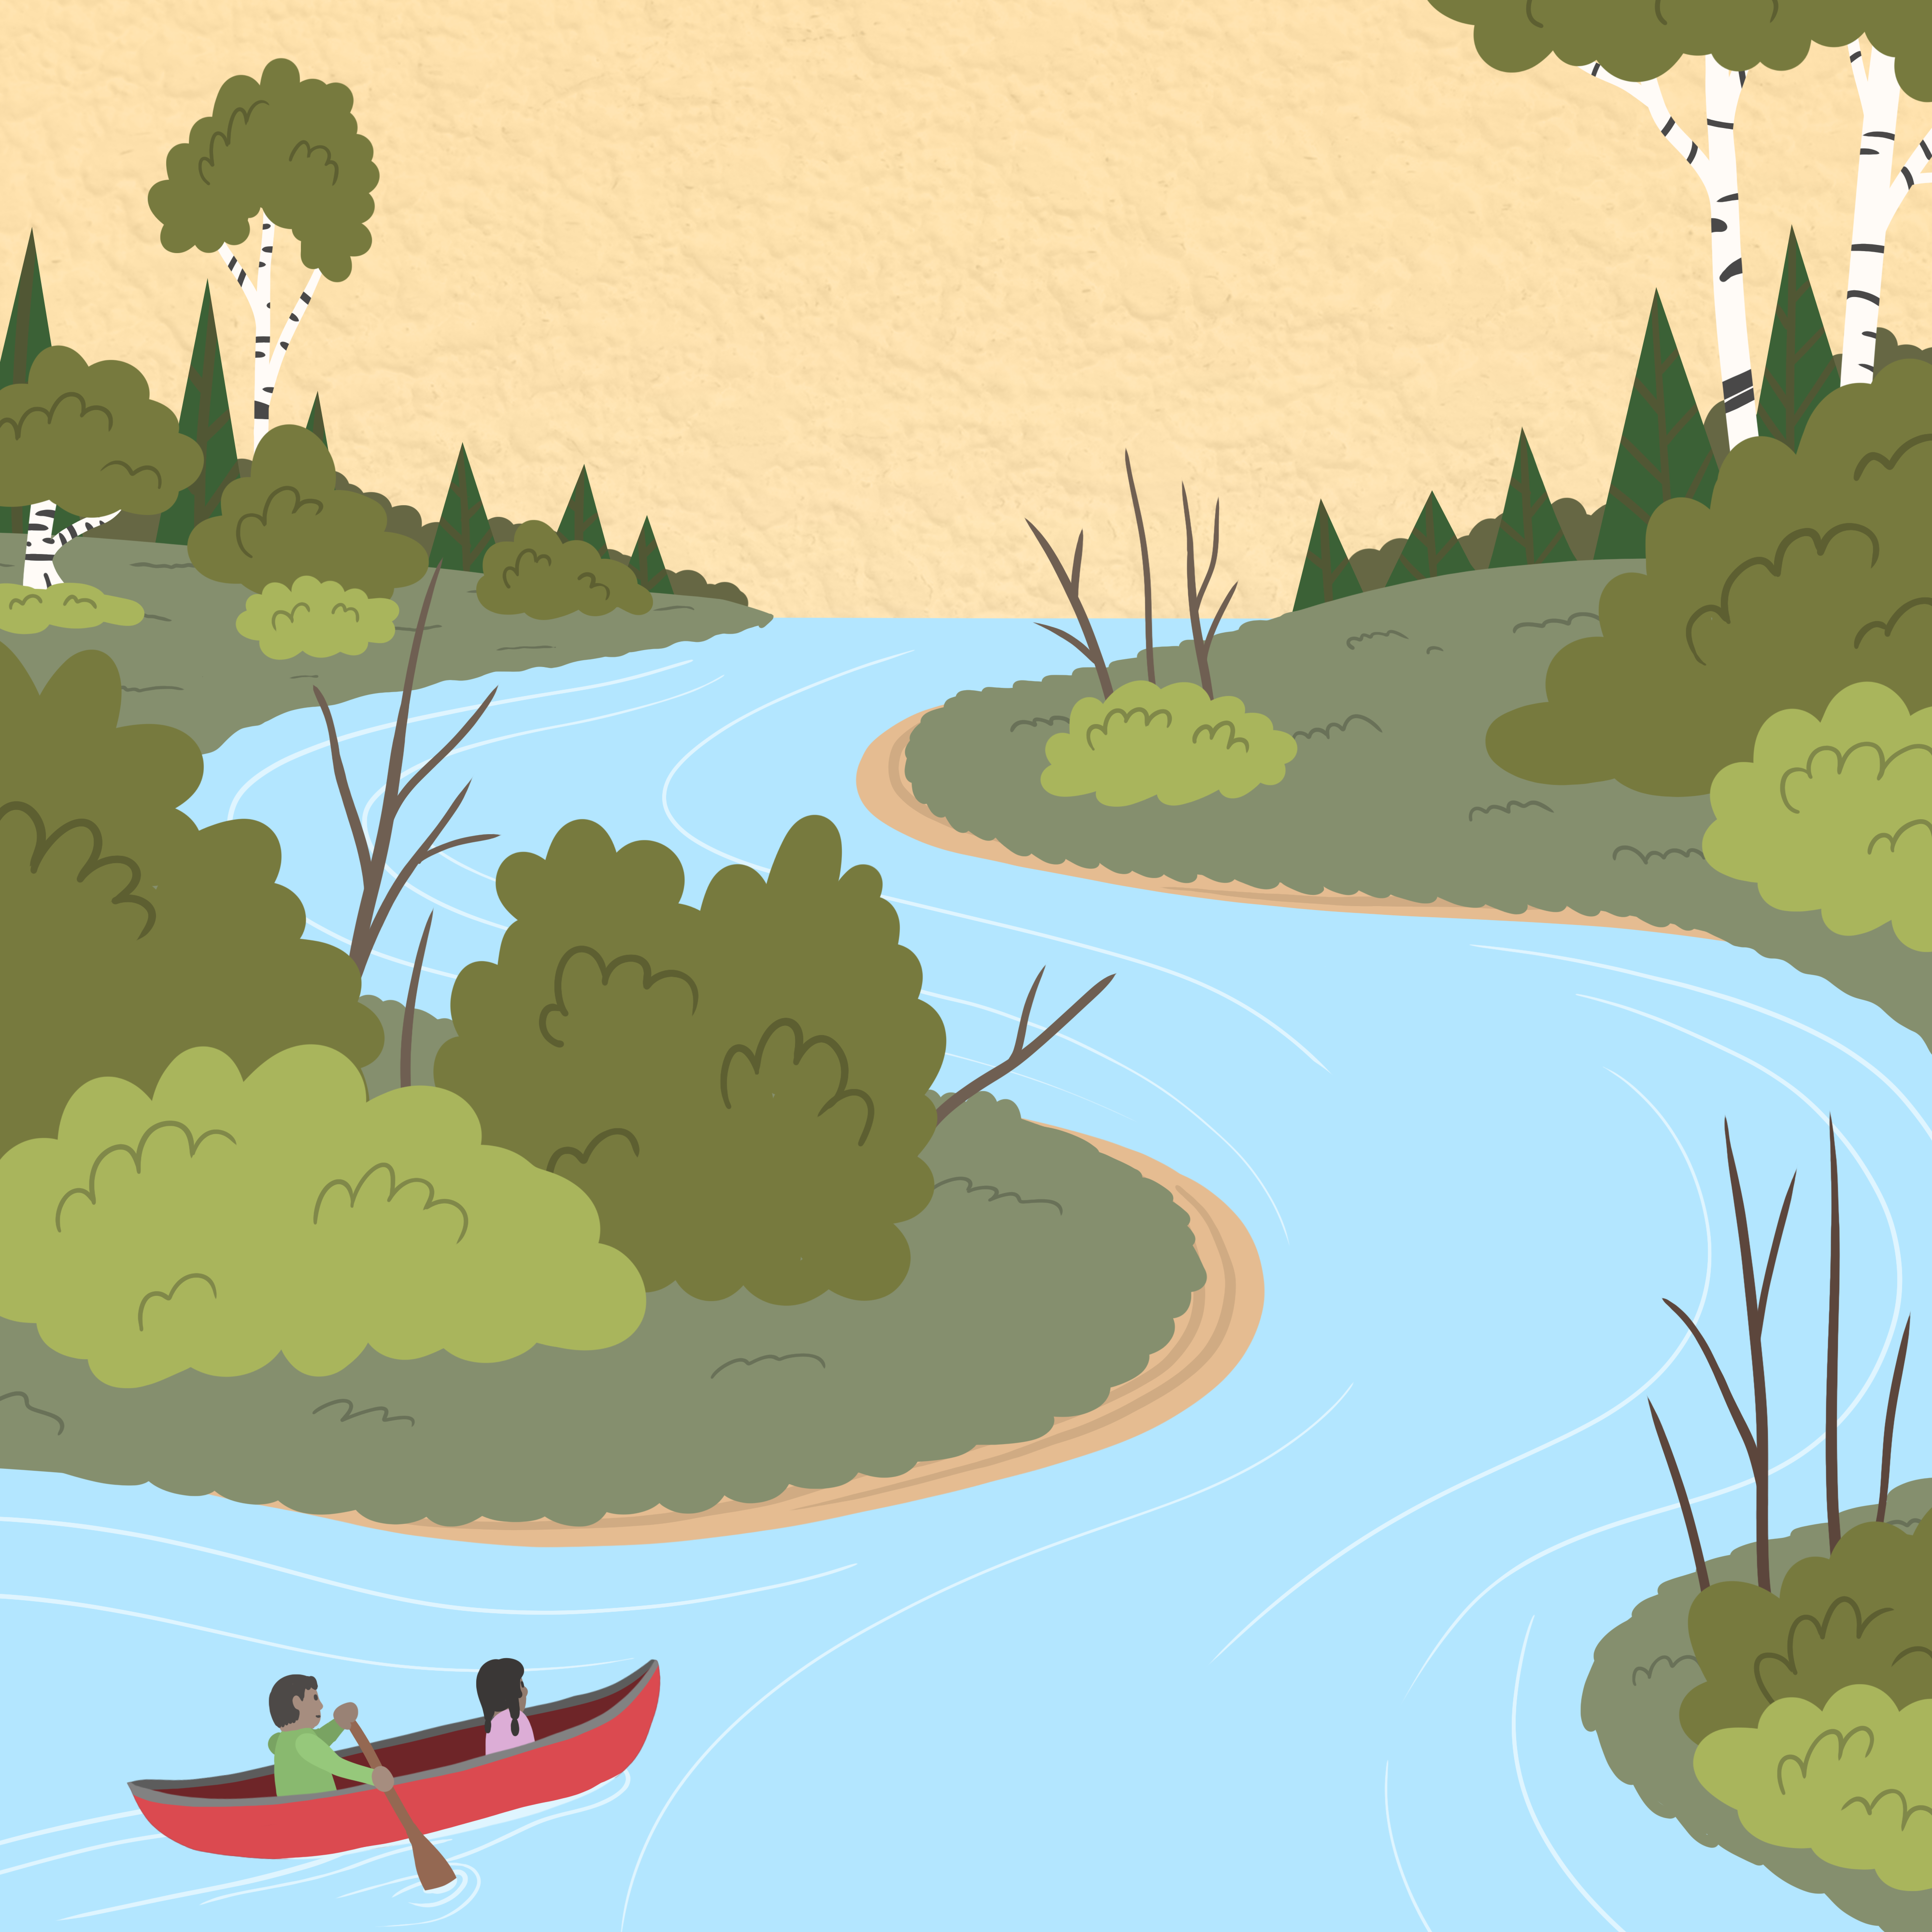
ziibiing

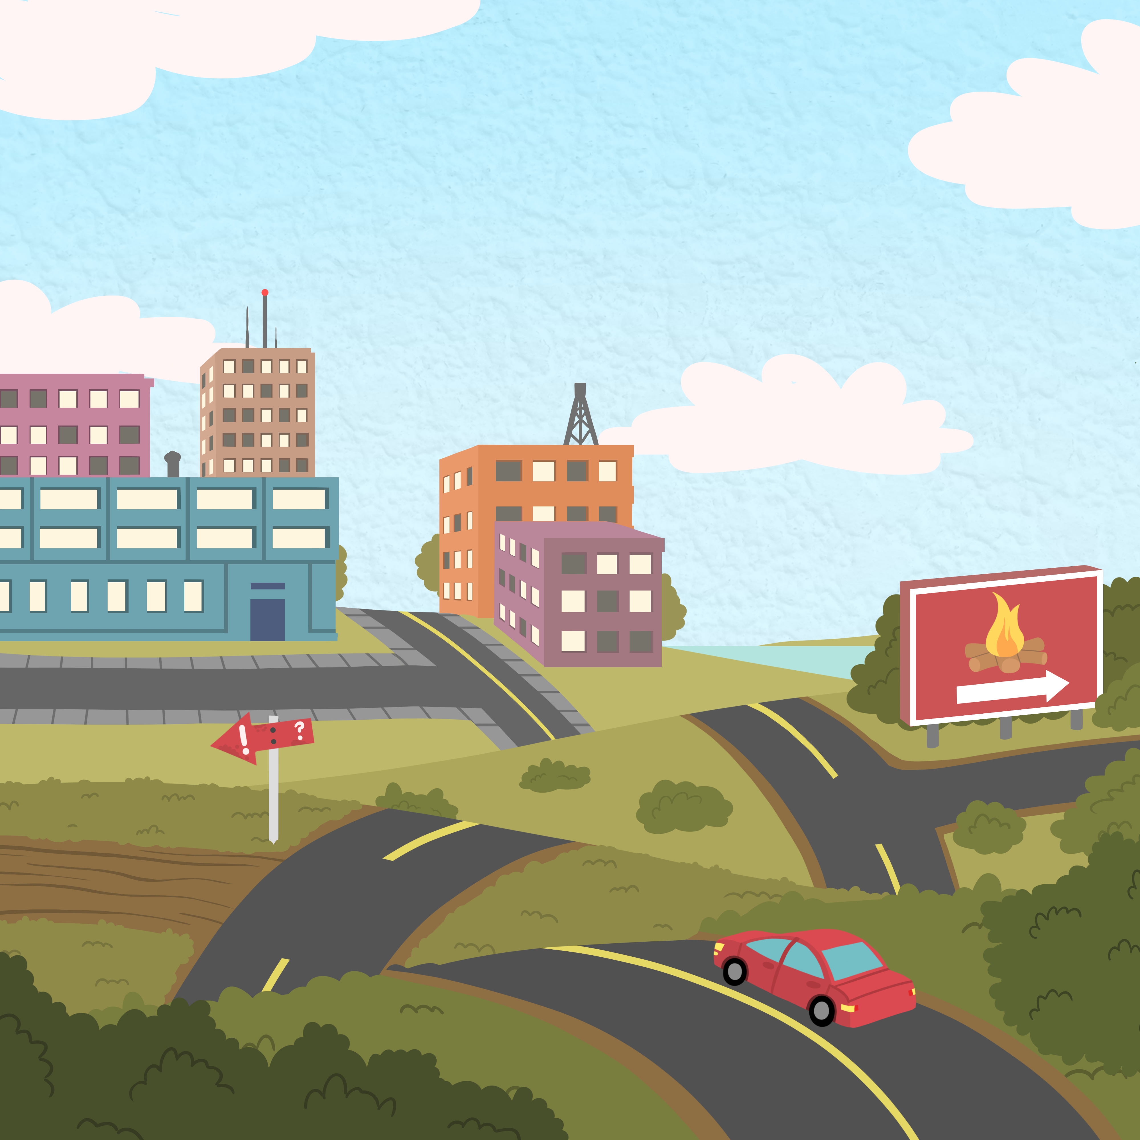

miikanaang

Sorting Prompts

Aaniin ezhinaagok? What does it look like? (colour)
Miskwaa. It is red.
Miskwaa odaabaan. It is a red car.
Miskwaa jiimaan. It is a red canoe.
Aandi ge-izhi-atoowin? Where will you put it?
Miikinaang On the road
Ziibing On the river

Gaawiin. No.
Eya. Yes.
Gegaa. Almost.
Weweni. Be careful.
Mii gwayak. That’s right.
Giminochige. You’re doing a good job.

