 

**ode’imin**

(oh-day’-ih-mihn)

**mishiimin**

(mih-shee-mihn)

 

**manoomin**

(muh-nooh-mihn)

**miinan**

(mee-nuhn)

 

**waawanoon**

(waah-wuh-noon)

**bakwezhigan**

(buh-kway-zhih-gun)

 9.9

**nibi**

(nih-bih)

**doodooshaaboo**

(doo-doo-shaah-boo)

 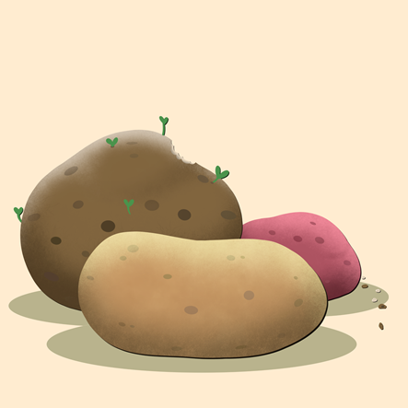

**opiniin**

(oh-pih-neen)

**zhoominag**

(zhoo-mih-nug)