 | Kii-mino-wiijiw  You are a good friend |  |  |  |  | Gizhawenimin  I love you
 | Kii-mino-wiijiw  You are a good friend |  |  |  |  | Gigizhewaadiz  You are kind
 | Gigizhewaadiz  You are kind |  | 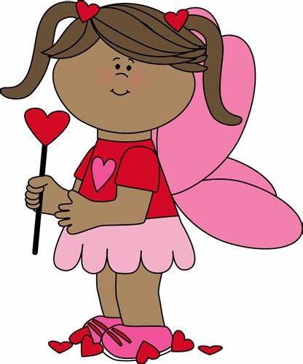 |  |  | Gizhawenimin  I love you
 | Gigizhewaadiz  You are kind |  |  |  |  | Kii-mino-wiijiw  You are a good friend
 | Gizhawenimin  I love you |  |  |  |  | Gigizhewaadiz  You are kind

 | Gigichiinendaagoz  You are special |  |  |  |  | Gizhawenimin  I love you
 | Giwawiyadendaagoz  You are funny |  |  |  |  | Kakininjiishin  Hug me
 | Gigizhewaadiz  You are kind |  |  |  |  | Gigichiinendaagoz  You are special
 | Kakininjiishin  Hug me |  |  |  |  | Gigichiinendaagoz  You are special
 | Giwawiyadendaagoz  You are funny |  |  |  |  | Gigizhewaadiz  You are kind

