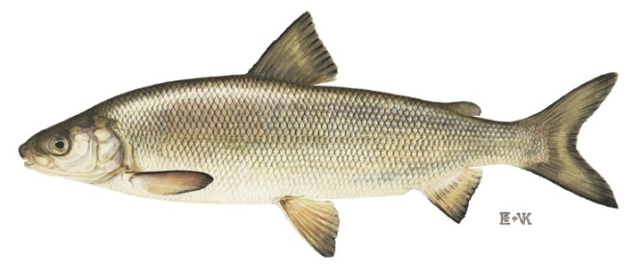
Adikameg
Uh-dih-kuh-mehg
Whitefish
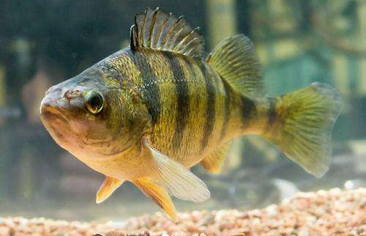
Asaawe
Uh-saw-weh
Perch
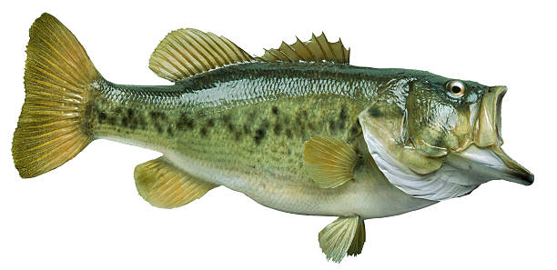
Ashigan
Uh-shih-gun
Bass
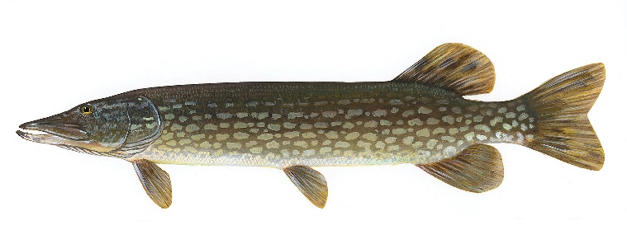
Ginoozhe
Gih-noo-zheh
Pike
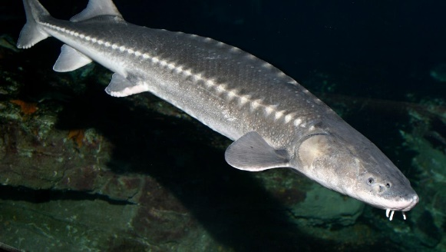
Name
Nuh-meh
Sturgeon
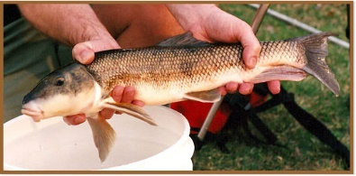
Namebin
Nuh-meh-bin
Sucker
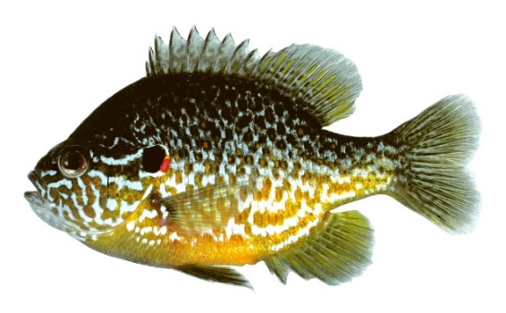
Agwadaashi
Uh-gwuh-daw-shih
Sunfish

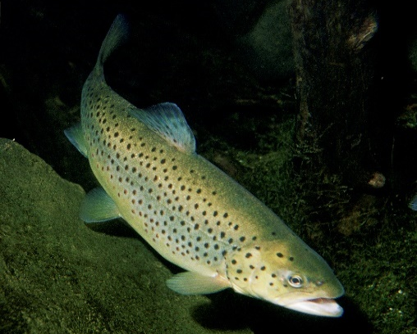
Namegos
Nuh-meh-gohs
Trout
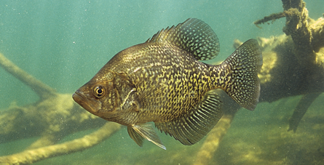
Gidagagwadaashi
Gih-duh-guh-gwuh-daw-shih
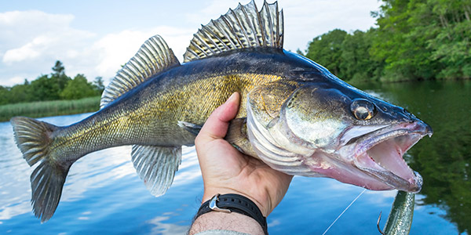
Crappie
Ogaa
Oh-gaw
Walleye

