Anishinaabemowin Alphabet
Ojibwe is most often used with the Double Vowel system. The seven vowels, seventeen consonants, and the glottal stop make up the Ojibwe alphabet.
a, aa, b, ch, d, e, g, h, ’, i, ii, j, k, m, n, o, oo, p, s, sh, t, w, y, z, zh
The consonants ch, sh, and zh are treated as one letter. The glottal stop is an important part of Ojibwe and when we use it, it is almost as if we cut our breath short very quickly.

Sometimes it is easier to understand the Ojibwe sounds when we compare them to what we know in English.
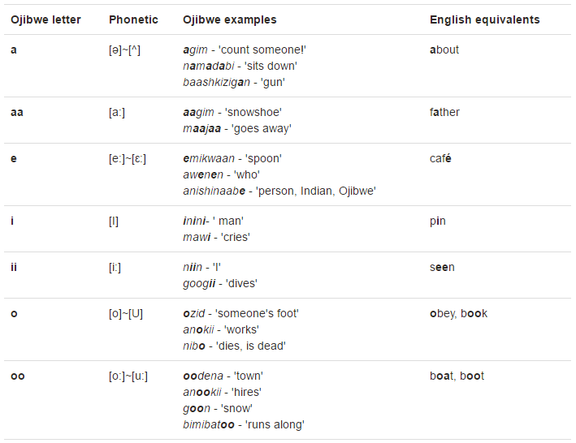
Ojibwe has many nasal sounds. When we see some words they have an ‘nh’ after a long vowel and the pronunciation sounds slightly different.
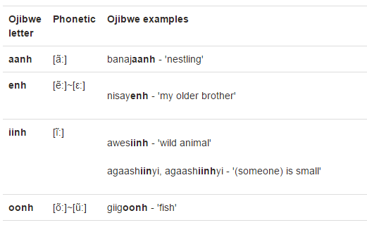

Ojibwe also has what are call ‘consonant clusters’. This means that there are two or more consonants in a row that are not separated by vowels. Similar to how ‘th’ is a consonant cluster in English, the Ojibwe consonant clusters are:
gw, kw, nd, ng, nj, shk
You can see these in words like memengwaa, makwa, aandeg, maang, nininj, and nashke,

