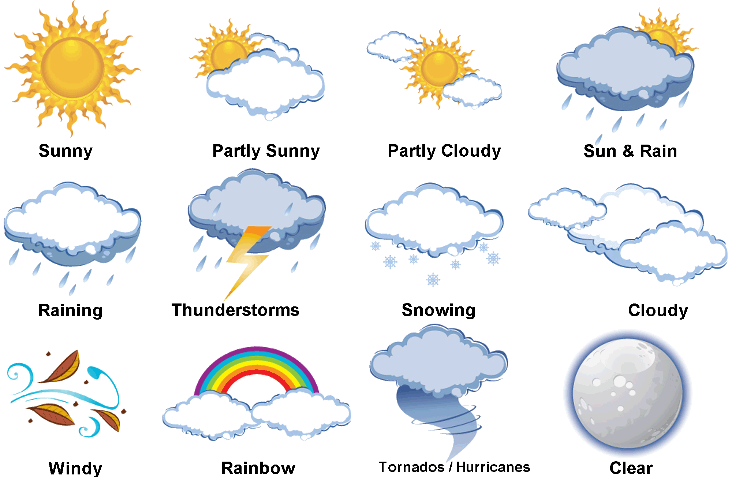

**Mashkowakojikaazon!**(Freeze like the snow!)

**Gizhibaabizon!**(Spin like a tornado!)

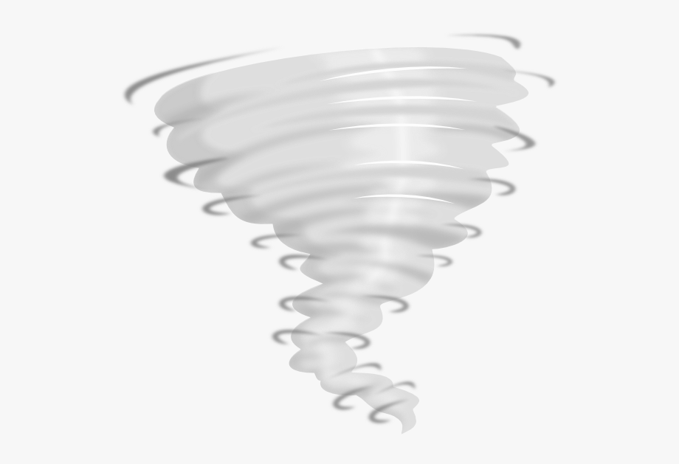



**Abwezokaazon!**(Sweat in the sun!)

**Babaamaashin!**(Get blown around in the wind!)







**Bangibiisaakaazon!**(Fall like the rain!)

**Waawaasikwanekaazon!**(Jump like the lightnig!)