Vocabulary:

Asabikeshii(yag) – Spider(s)

Oshkiinzhig(oon) – Eye(s)

Ozhaashijiiyaa – It is slimy

Mikoojiinan _____ - Find _____ (with your fingers)

Mikoojiin asabikeshii – Find the spider (with your fingers)

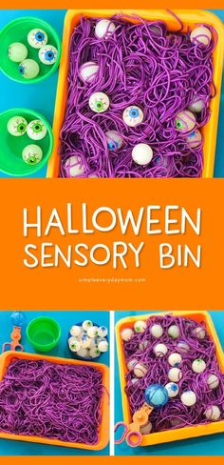Mikoojiinan oshkiinzhig – Find the eye (with your fingers)