**Gagishgiganan**

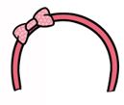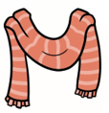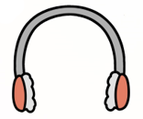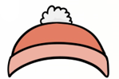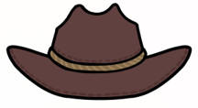

**bibooniwiwakwaan(an)**

**basikwebizon(an)**

**naabikaagan(an)**

**giizhootawage’on(an)**

**oshkiinzhigokaanan**

**naabishebizon(an)**



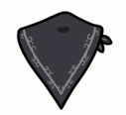

**desiwiwakwaan(an)**

**gashkiikwepizon(an)  
ziinzoodibepizon(an)**





**diba’igeswaanens(ag)**



**dadibininjiibizon(ag)**

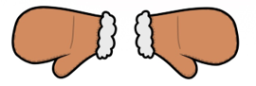

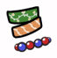

**dadibinikebizon(an)**

**minjikawan(ag)**

**gichipizon(an)**

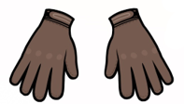

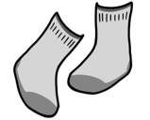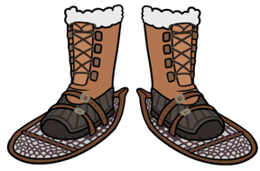

**niiskininjii-minjikawan(ag)**

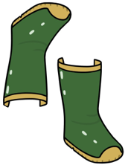

**azhigan(ag)**

**aagim(ag)**

**biboonikizin(an)**

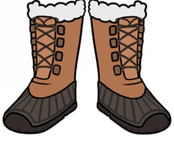

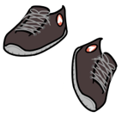

**bimaadagaaziimakizin(an)**

**bagiyaanishakizin(an)**

**biito-babagiwayaan(an)**

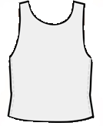

**biitooshkigan(an)**

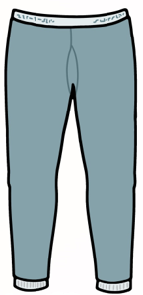

**biitooshkiganens(ag)**

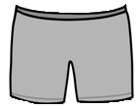

**first – akawe/nitam  
next – miinawaa  
and then – miinawaa dash  
last – ishkwaaj  
  
put it on h/! – biisikamoozh!  
take it off h/! – giisikamoozh!**

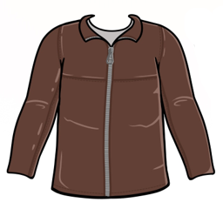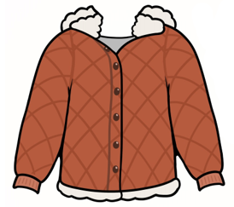

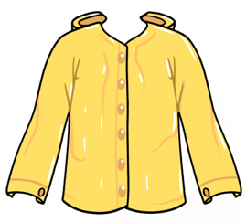

**bashkwegino-biisikawaagan(an)**

**bibooni-biisikawaagan(an)**

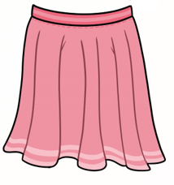

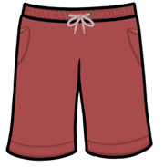

**gimiwani-biisikawaagan(an)**

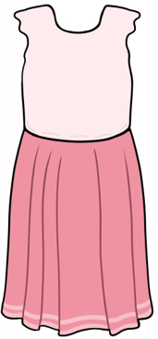

**giishkijii-magooday(an)  
giishkijii-magoodas(an)**

**giishkijii-madaas(ag)**

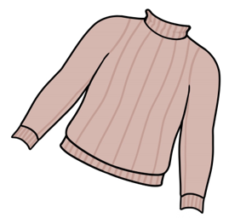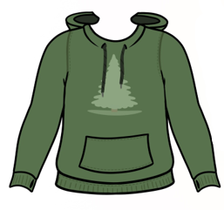

**zhiibigwayabiinda’oozan(an)**

**biinda’oozan(an)**

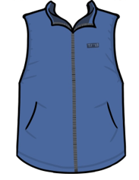

**magooday(an)  
magoodas(an)**

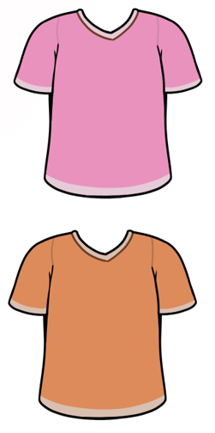

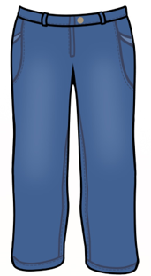



**gibide’ebizon(an)**

**babagiwayaan(an)**

**midaas(ag)**