zhiibigaadenin
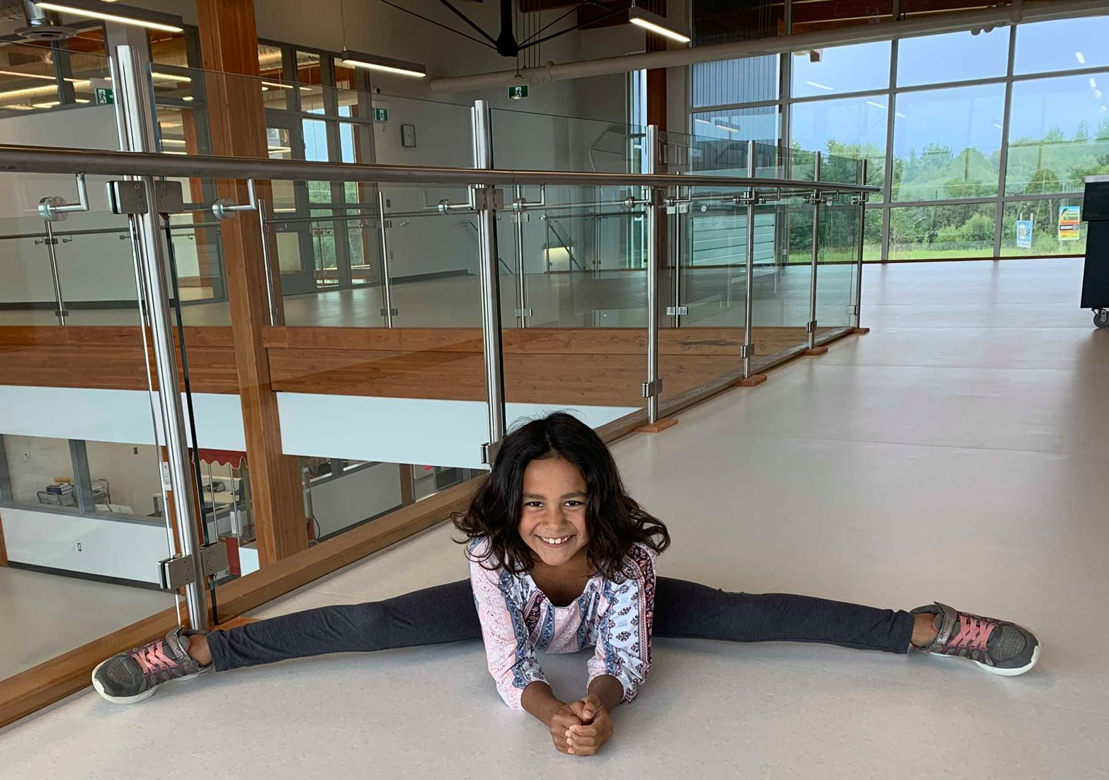

zhiibigaadenin
zhee-bih-gaah-day-nihn
stretch your legs

zhiibininjiinin

zhiibininjiinin
zhee-bih-nihn-jee-nihn
stretch your fingers

zhiibinikenin
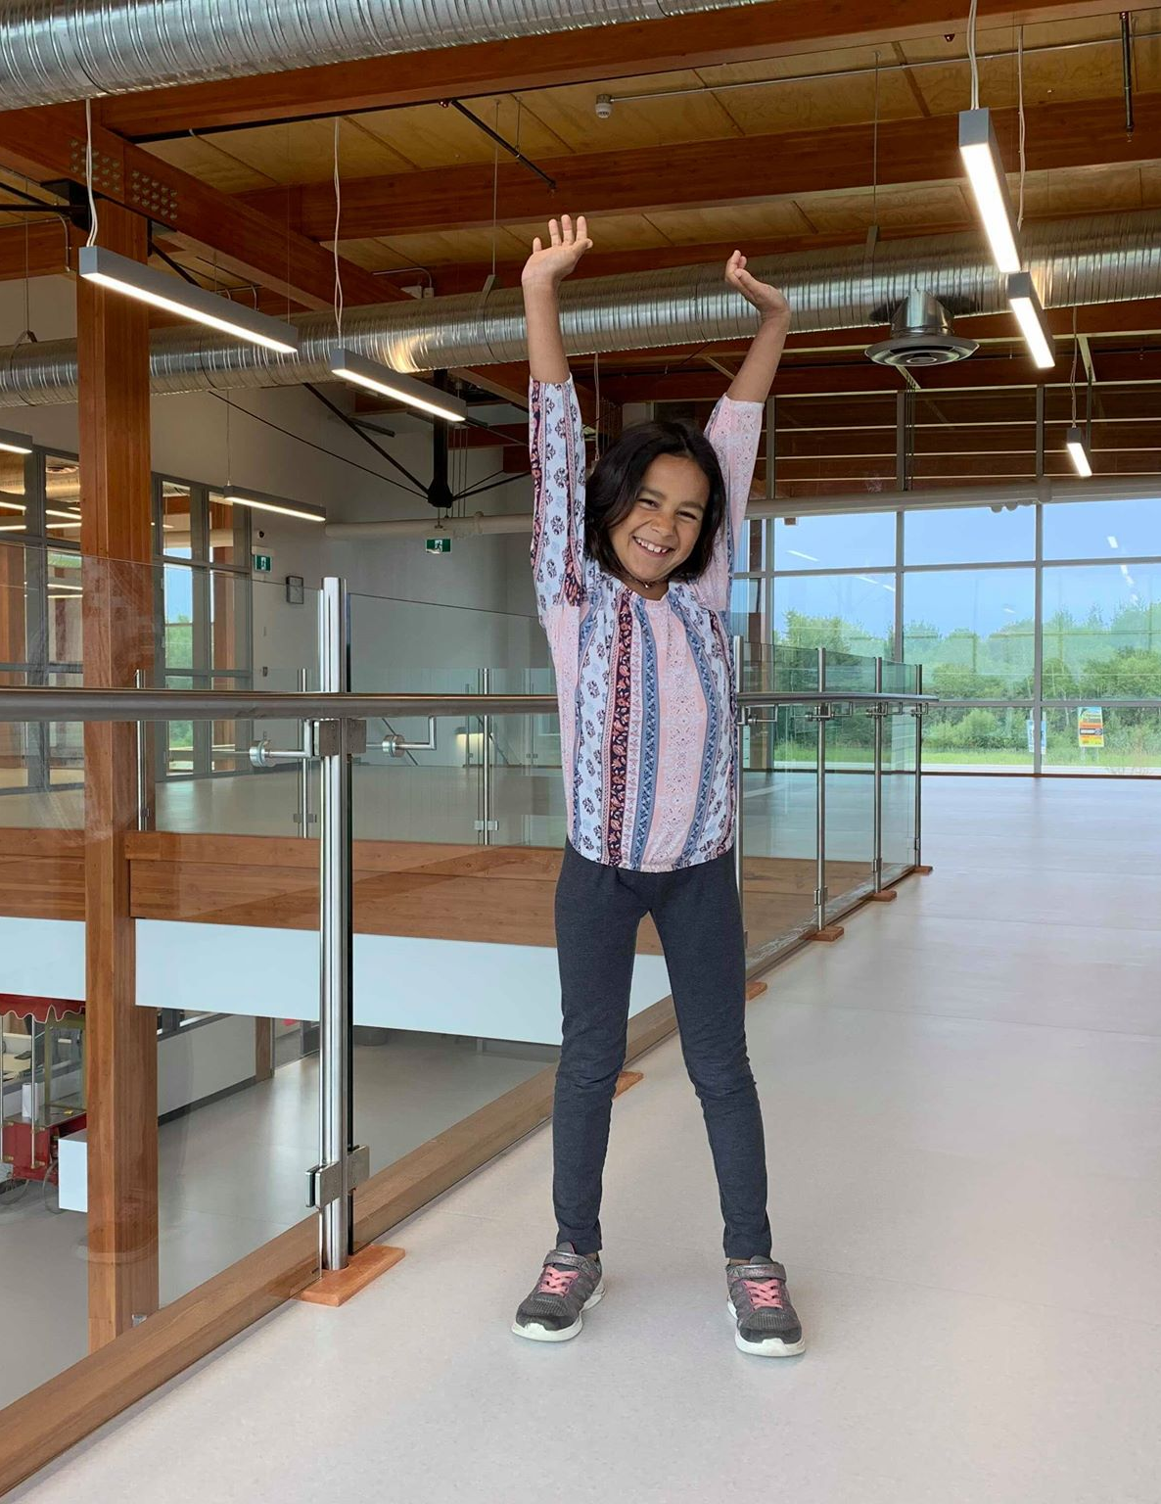

zhiibinikenin
zhee-bih-nih-kay-nihn
stretch your arms

zhiibaawaganenin

zhiibaawaganenin
zhee-baah-oh-gah-nay-nihn
stretch your back

zhiibizidenin

zhiibizidenin
zhee-bih-zih-day-nihn
stretch your feet

zaaminan gizidan
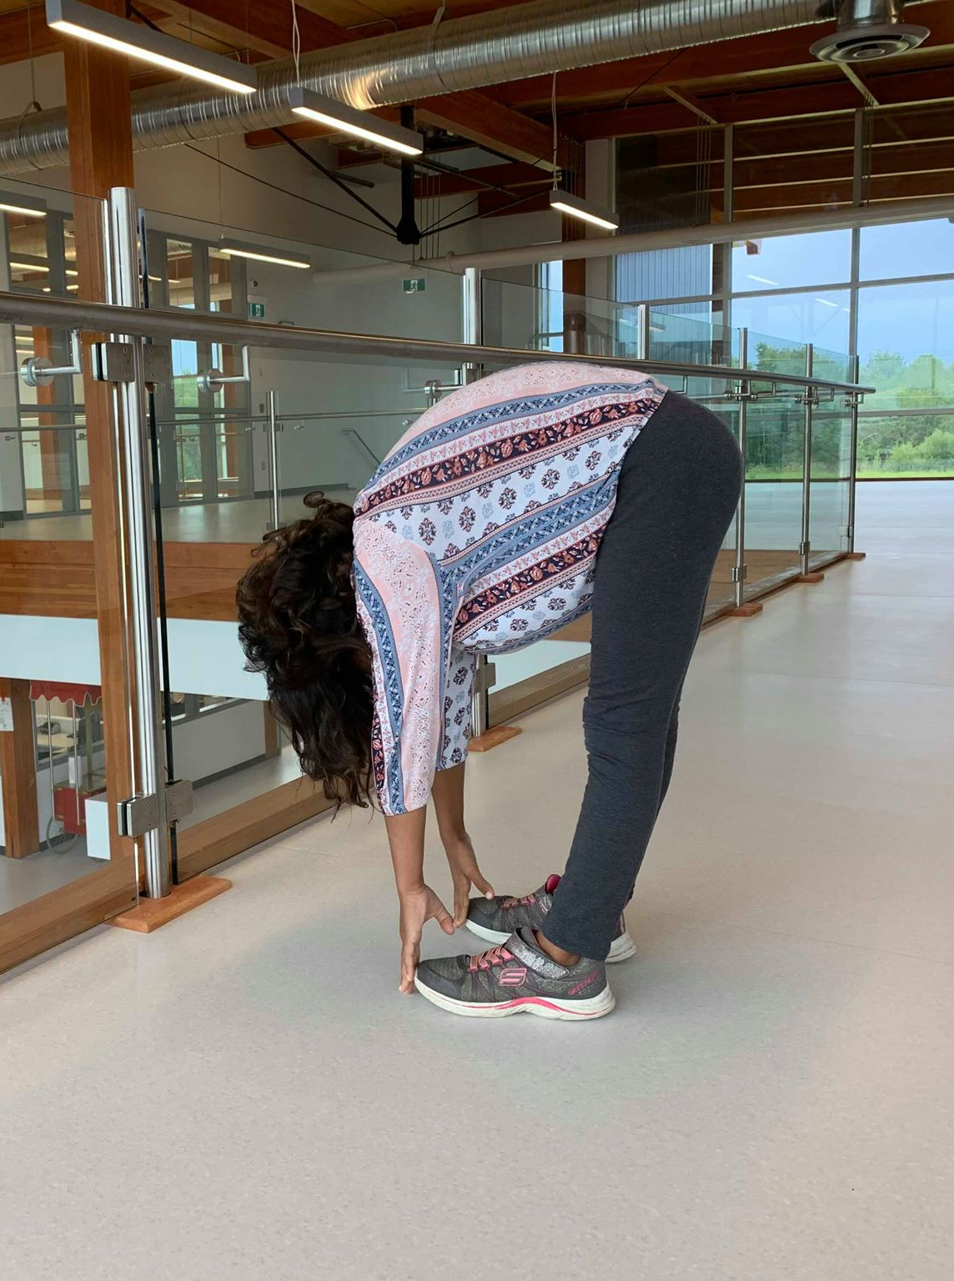

zaaminan gizidan
zaah-mih-nun gih-zih-dun
touch your toes

zaaminan gishtigwan
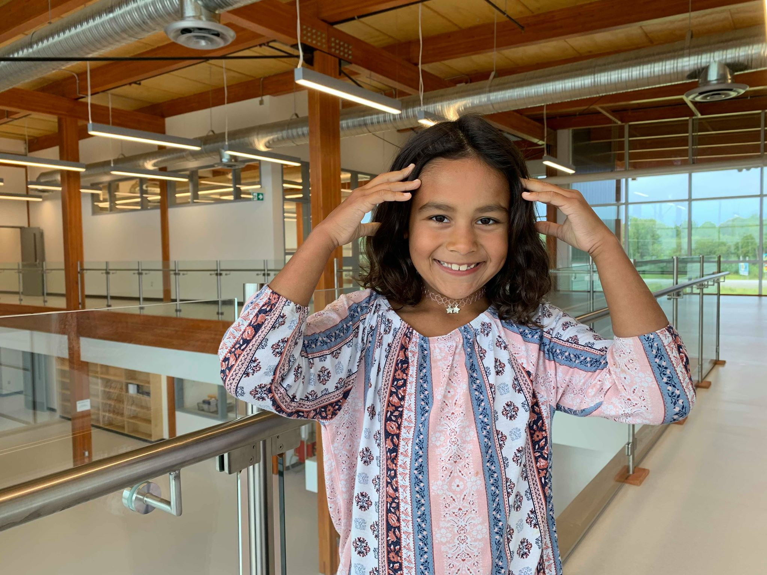

zaaminan gishtigwan
zaah-mih-nun gish-tih-gwun
touch your head

zaaminan gimisad

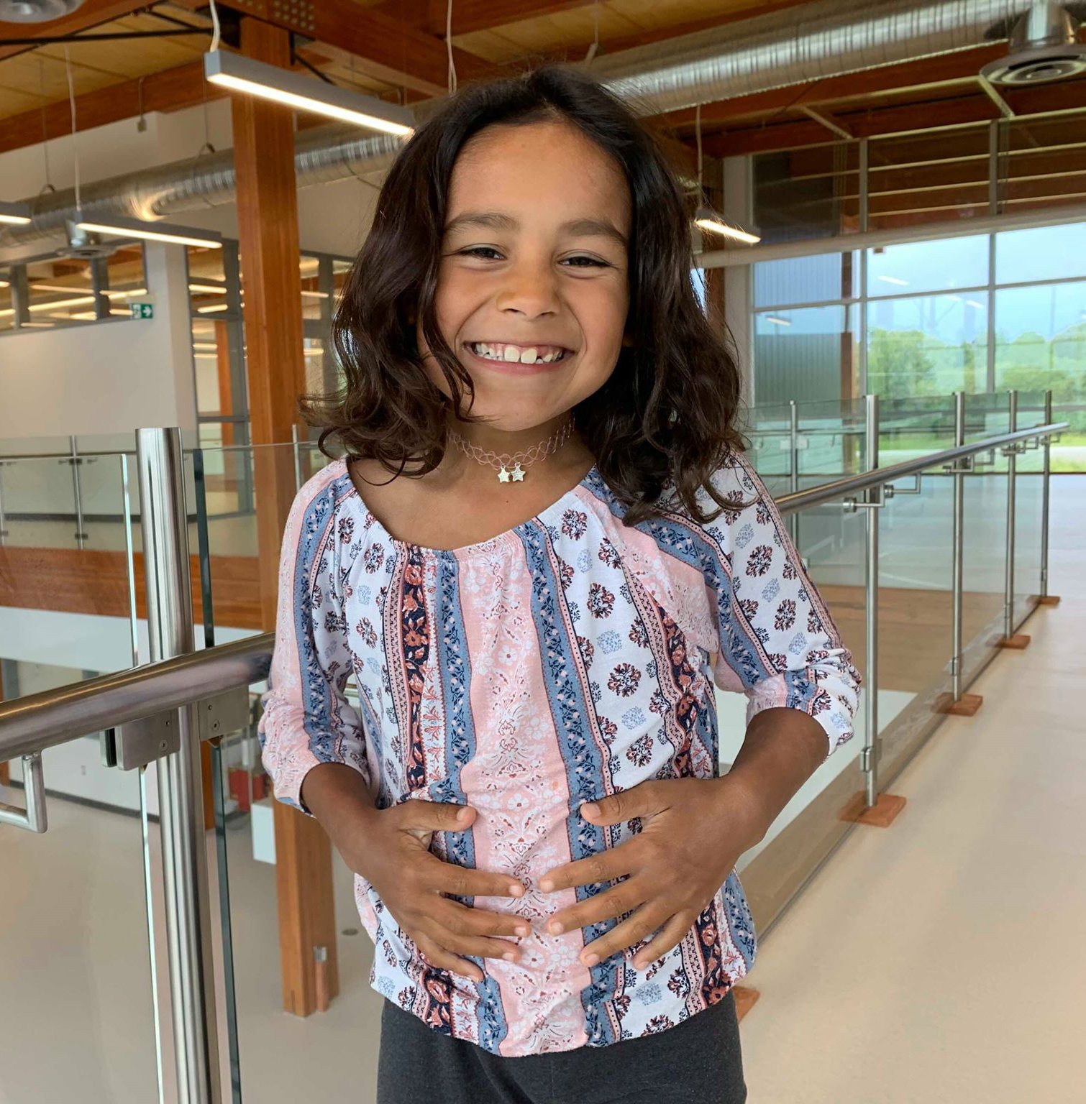

zaaminan gimisad
zaah-mih-nun gih-mih-sut
touch your stomach

zaamin gidigoog

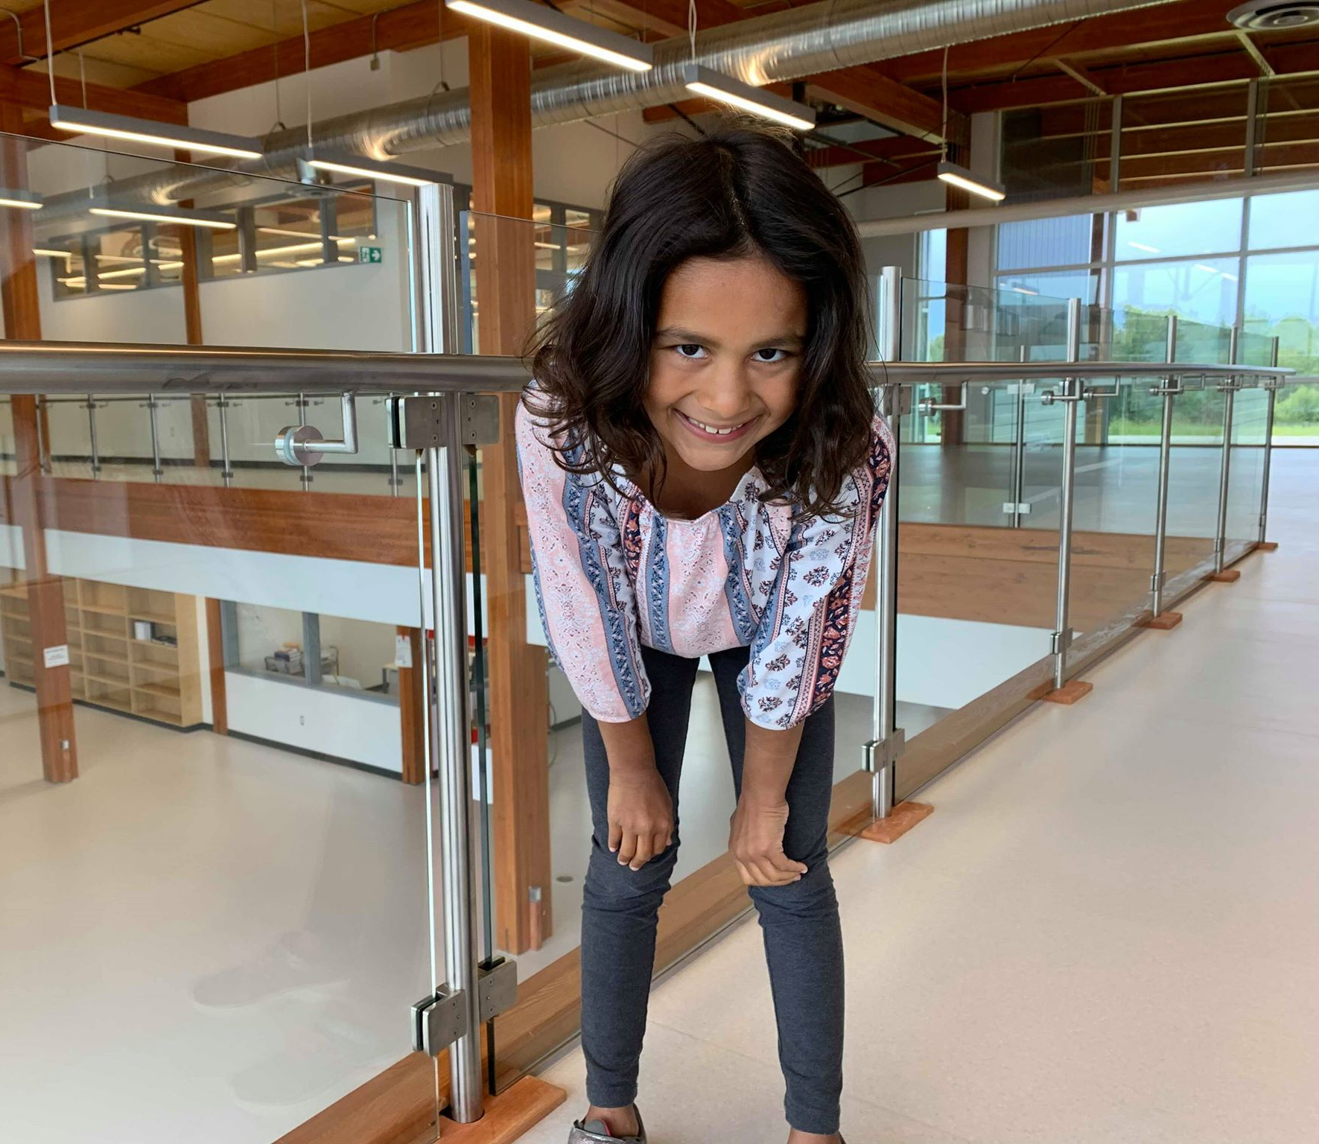

zaamin gidigoog
zaah-mihn gih-dih-goohg
touch your knees

zaaminan gijaan

zaaminan gijaan
zaah-mih-nun gih-jaahn
touch your nose

zaamin gidinimaaganag
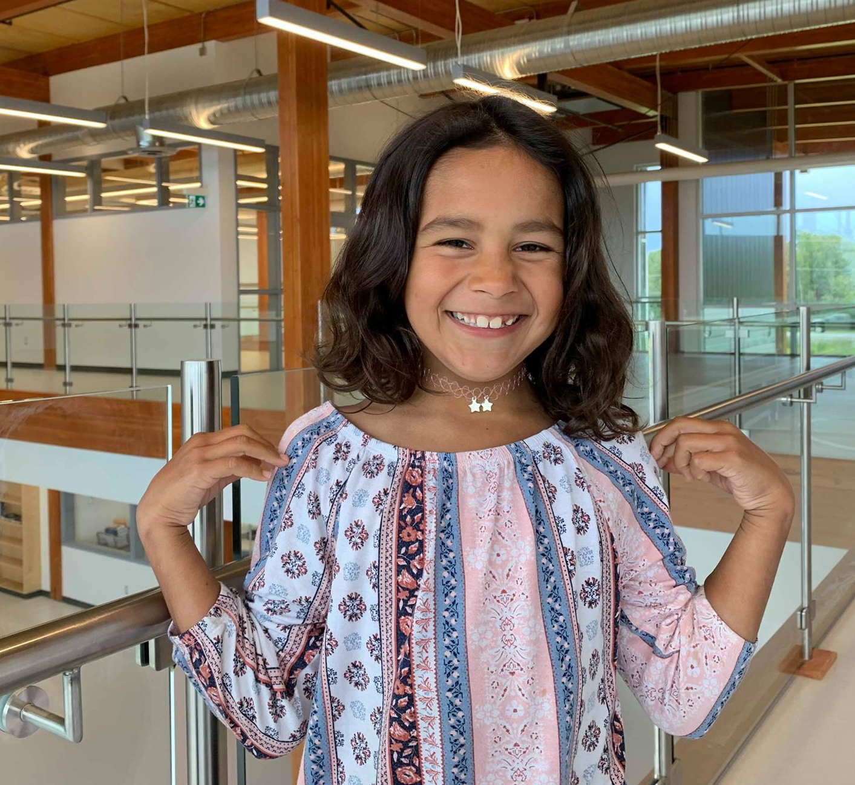

zaamin gidinimaaganag
zaah-mihn
gih-dih-nih-maah-guh-nug
touch your shoulders

zaaminan gishkiinzhigoon
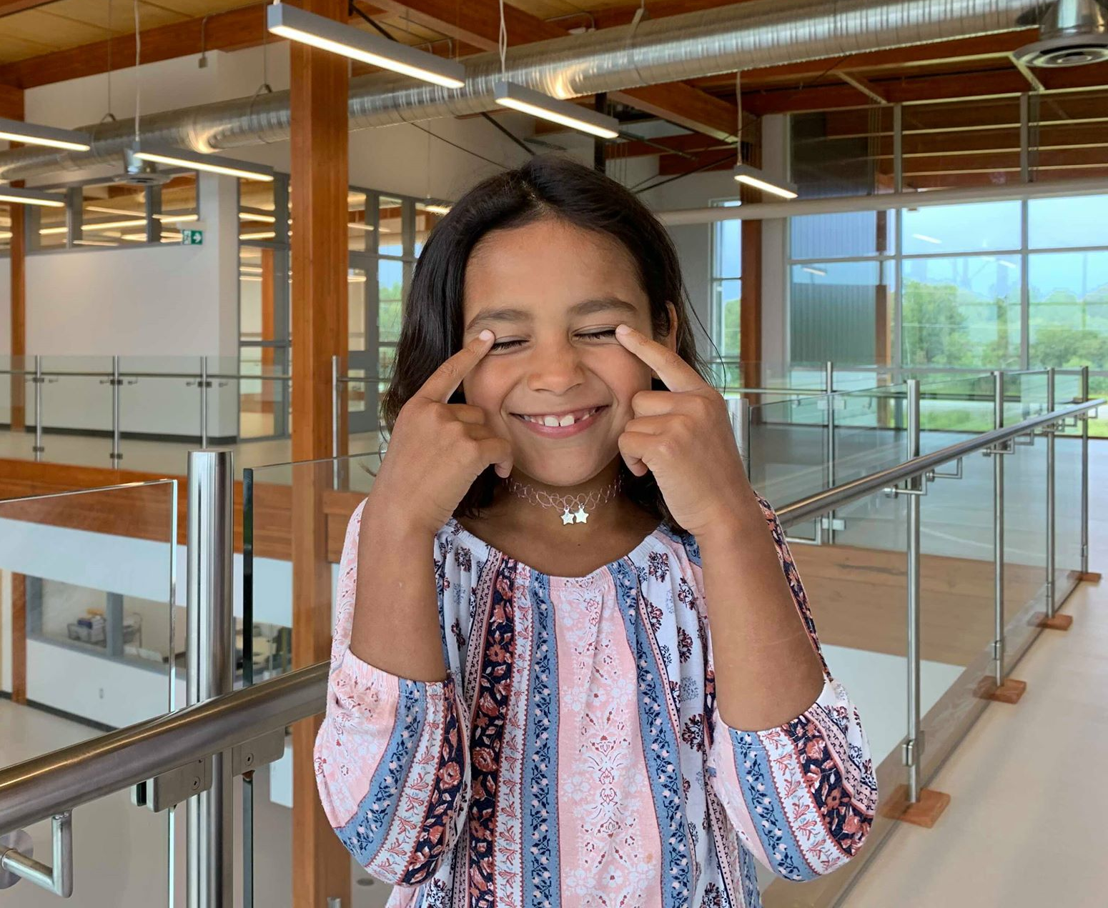

zaaminan gishkiinzhigoon
zaah-mih-nun gi-shkeen-zhih-goohn
touch your eyes

zaaminan gitawagan
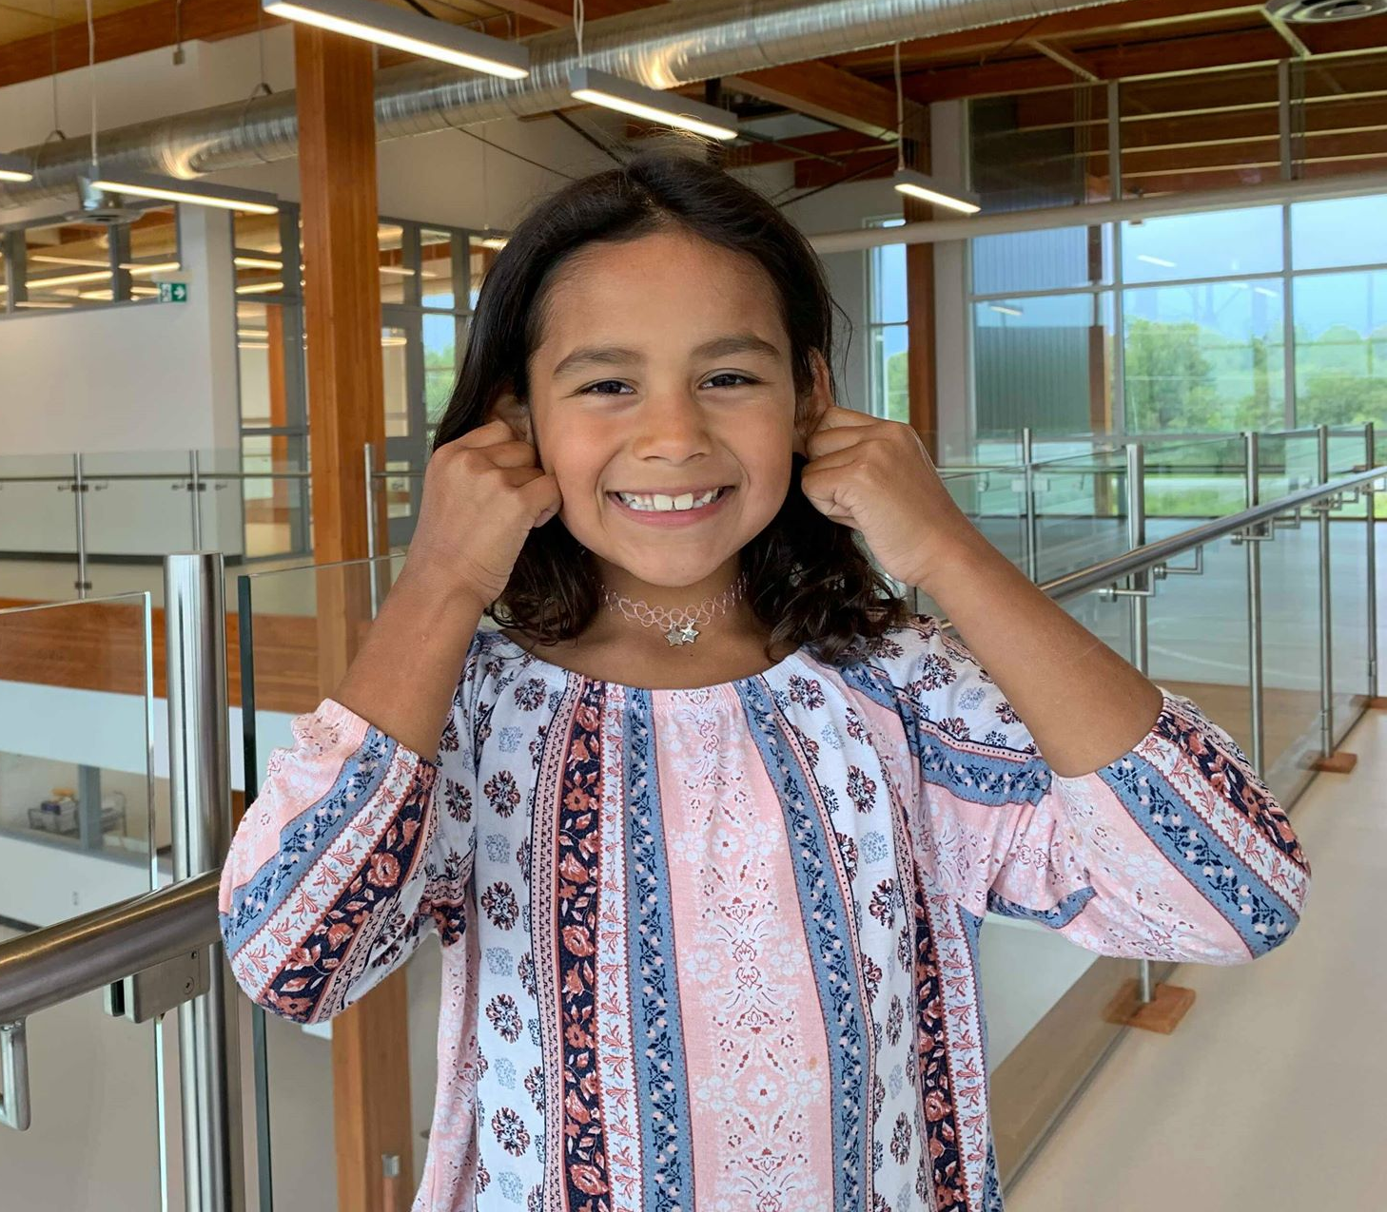

zaaminan gitawagan
zaah-mih-nun gih-tau-wuh-gun
touch your ears

zaaminan gidoon
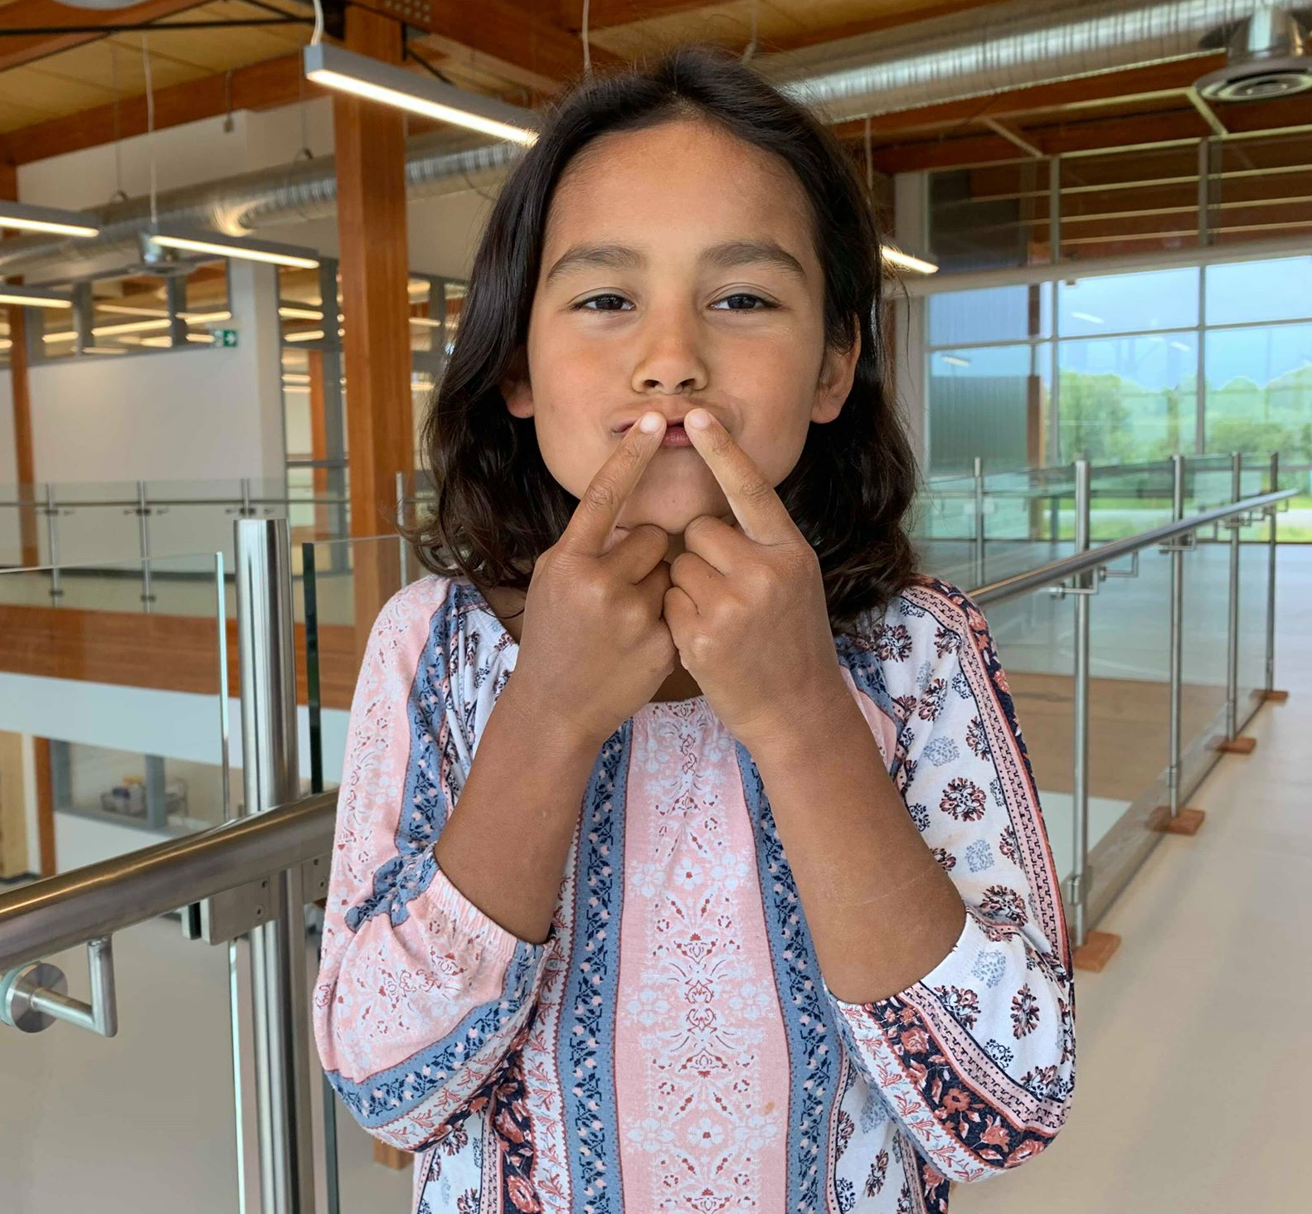

zaaminan gidoon
zaah-mih-nun gih-doohn
touch your mouth

