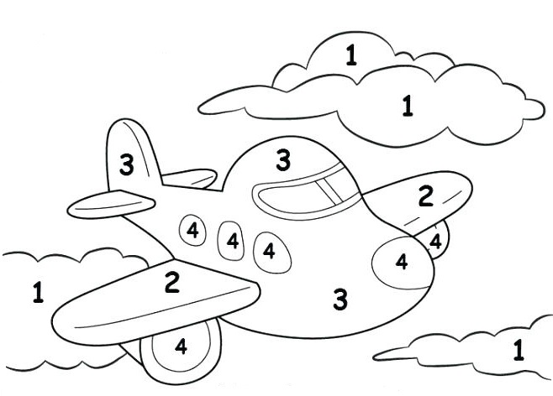
Ozhibii’igen Agindaasowinan

1 - Waabishkaa 2 - Miskwaa 3 - Ozaawaa 4 - Ozhaawashkwaa

