Nindizhinikaaz…
My Name Is…

Aaniin ezhinikaazowin?
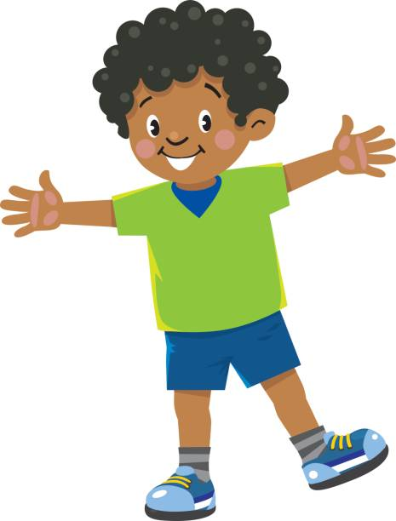

John nindizhinikaaz.
Aaniin ezhinikaazowin?
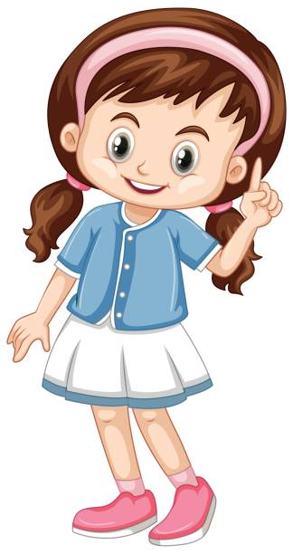

Jessica nindizhinikaaz.
Aaniin ezhinikaazowin?

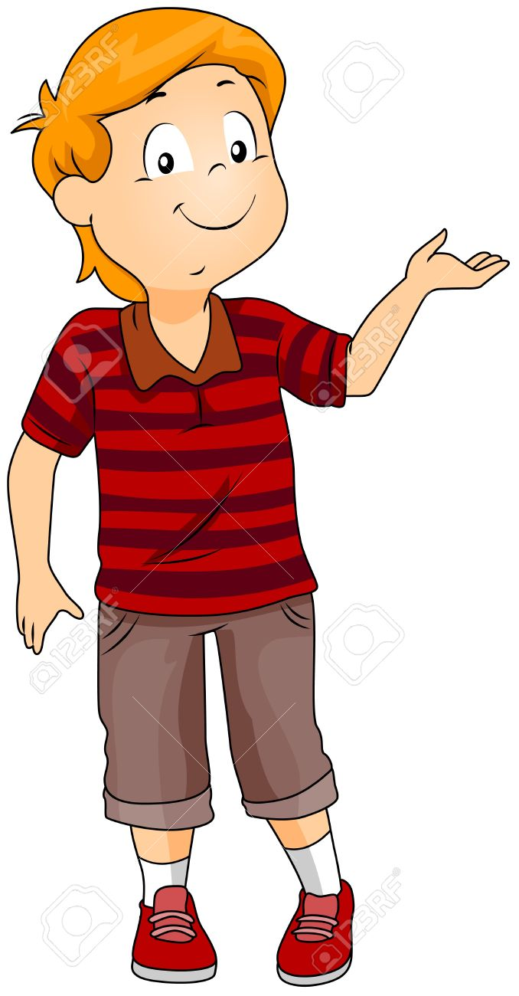

Sam nindizhinikaaz.
Aaniin ezhinikaazowin?

Sally nindizhinikaaz.
Aaniin ezhinikaazowin?

Talia nindizhinikaaz.
Aaniin ezhinikaazowin?

Tim nindizhinikaaz.
Aaniin ezhinikaazowin?

Angel nindizhinikaaz.
Aaniin ezhinikaazowin?

Andy nindizhinikaaz.
Aaniin ezhinikaazowin?

William nindizhinikaaz.

Aaniin ezhinikaazowin?

