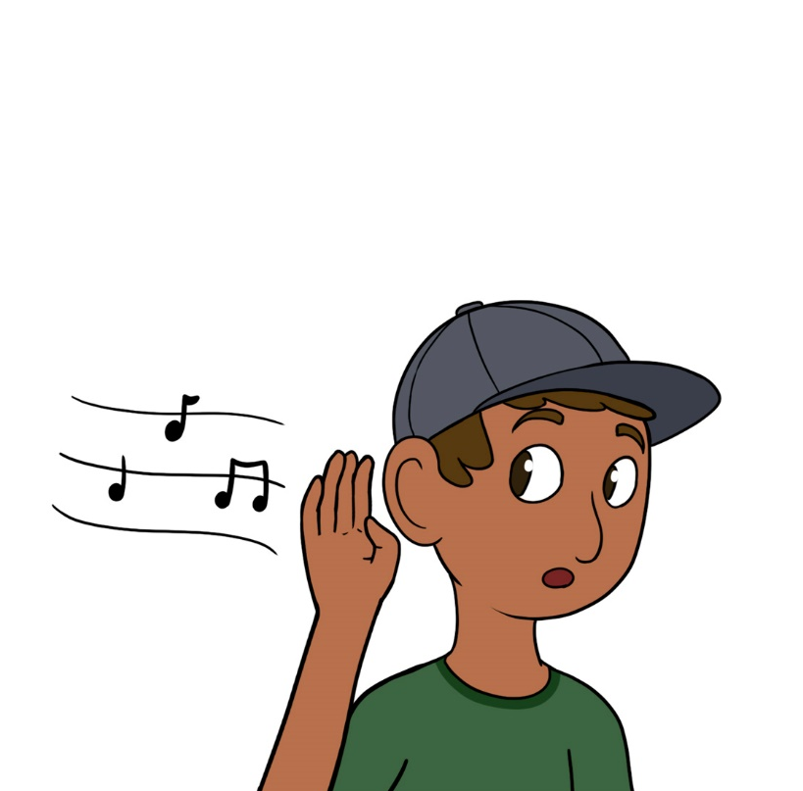

Bizindan!

Bih-zin-dun
Listen!

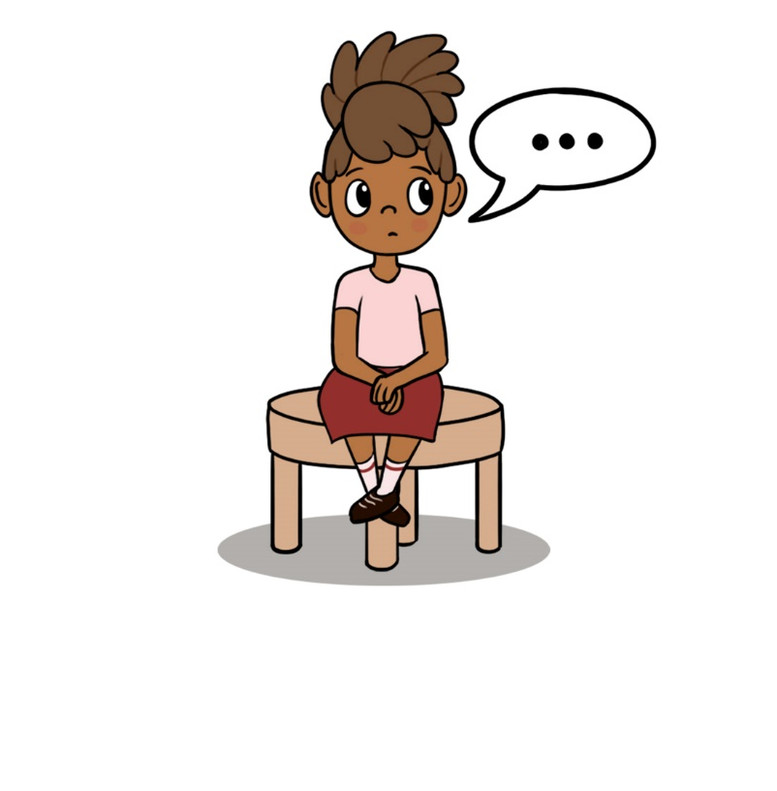

Bizaanabin!

Bih-zawn-nuh-bin
Sit quietly!

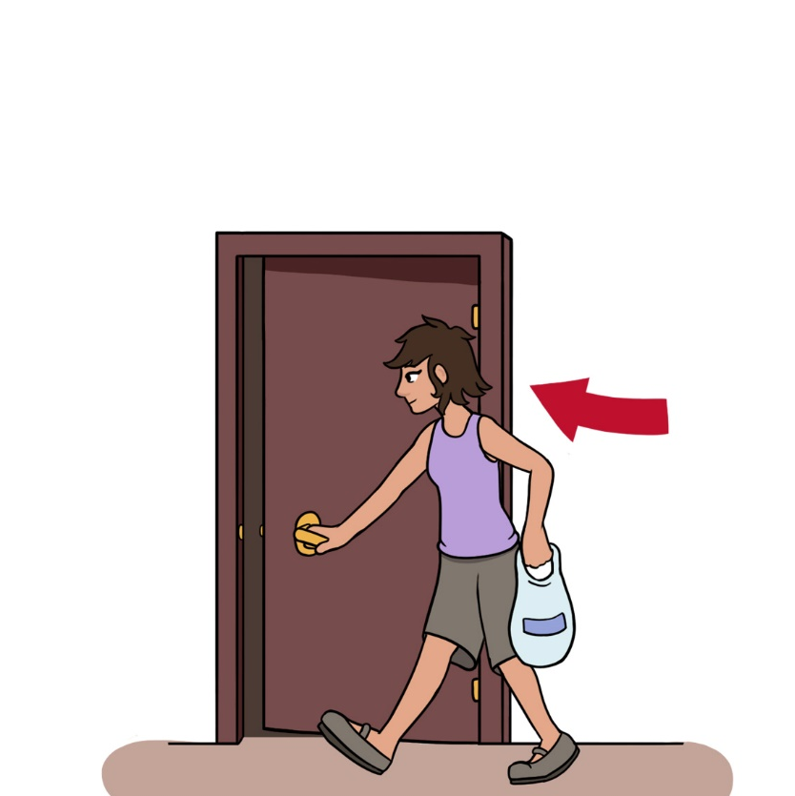

Biindigen!

Been-dih-gen
Enter!

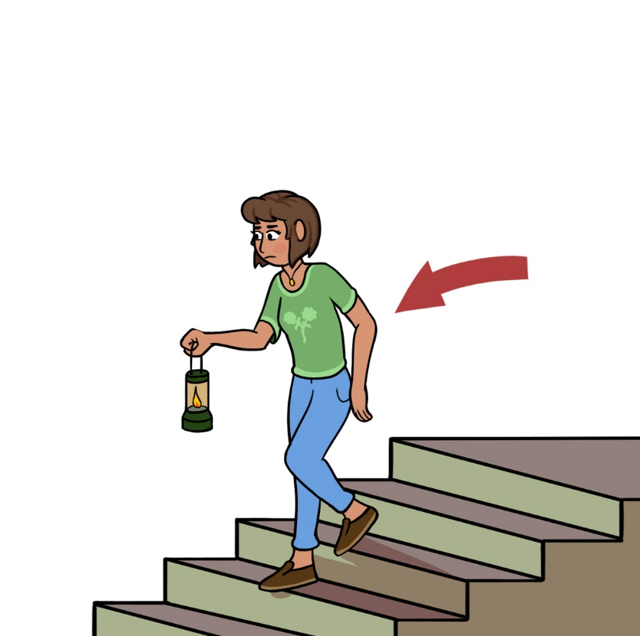

Niisaandawen!

Nee-sawn-duh-wen
Go downstairs!

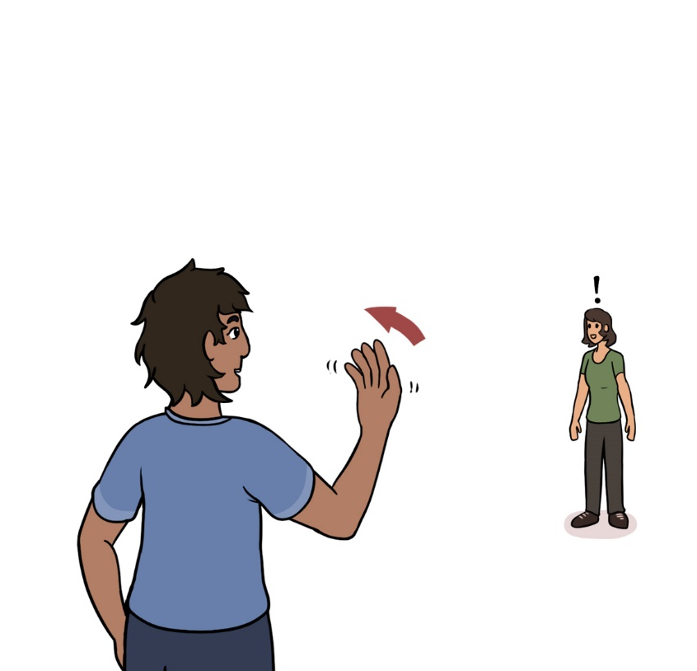

Ambe omaa!

Uhm-bay oh-maw
Come here!

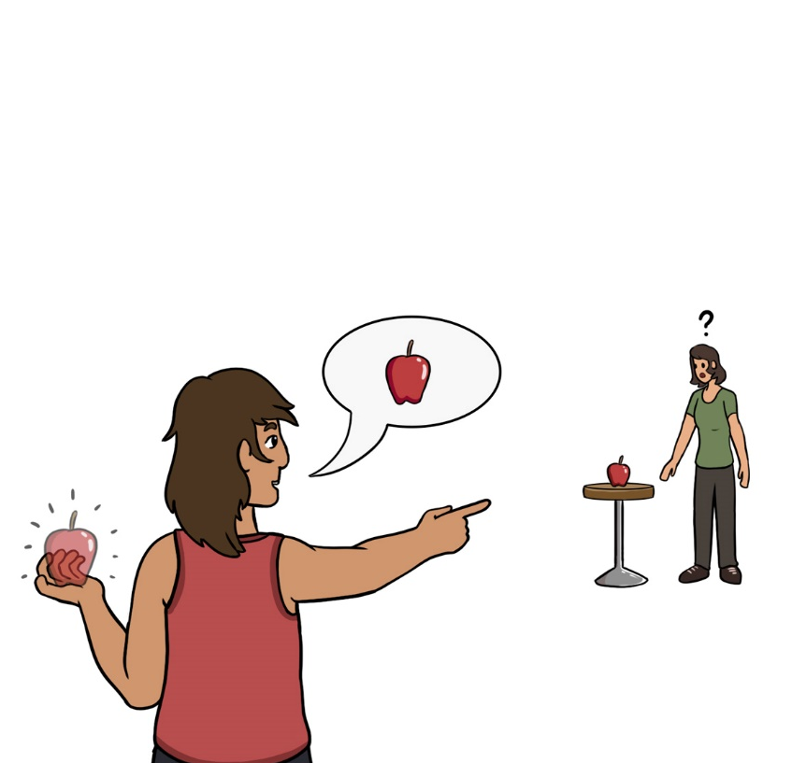

Biidoon!

Bee-doon
Bring it!

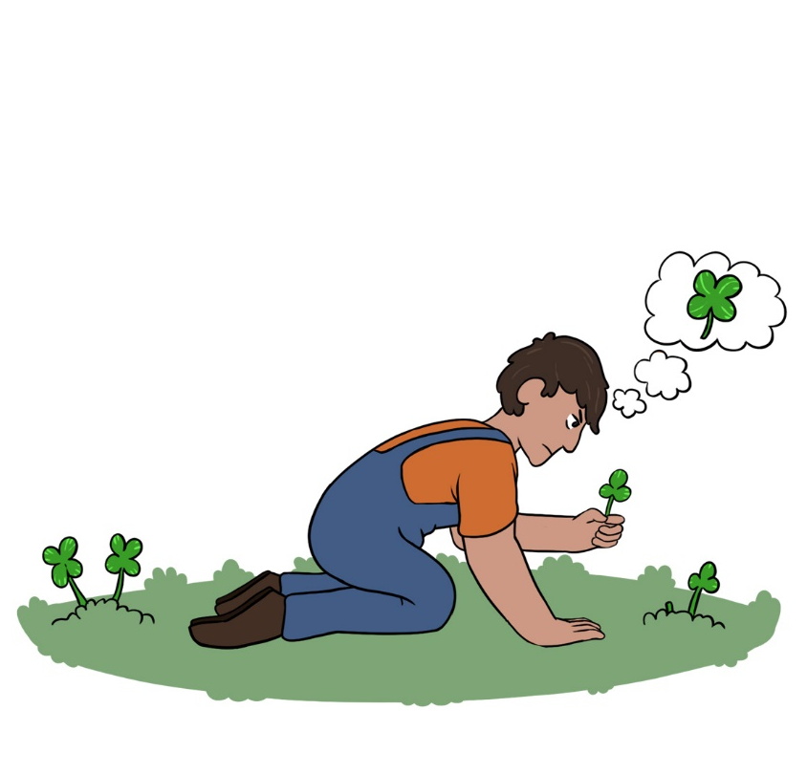

Mikan!

Mih-kun
Find it!

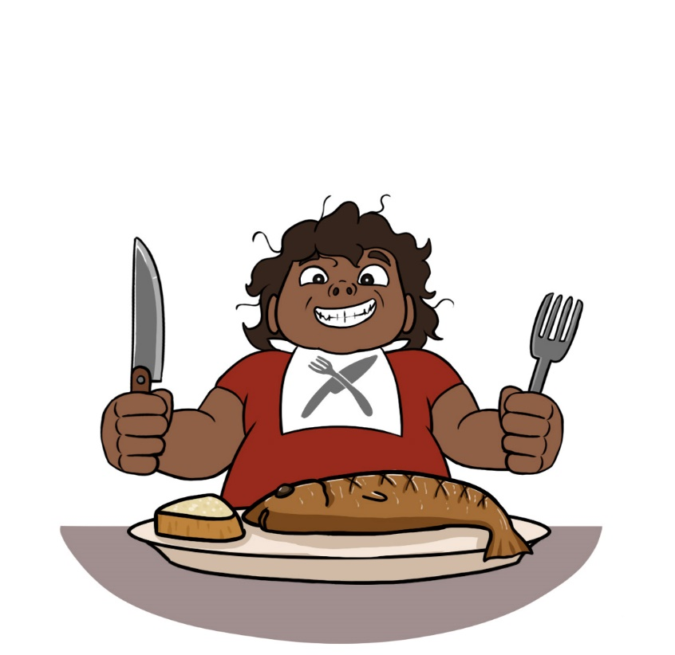

Amo!

Uh-moh
Eat it!

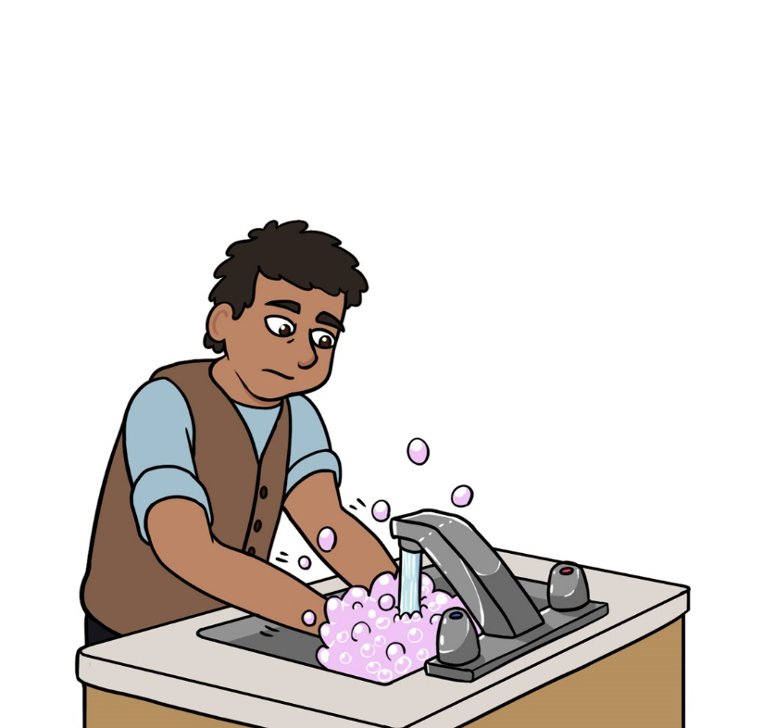

Giziininjiin!

Gih-zee-nin-jeen
Wash your hands!

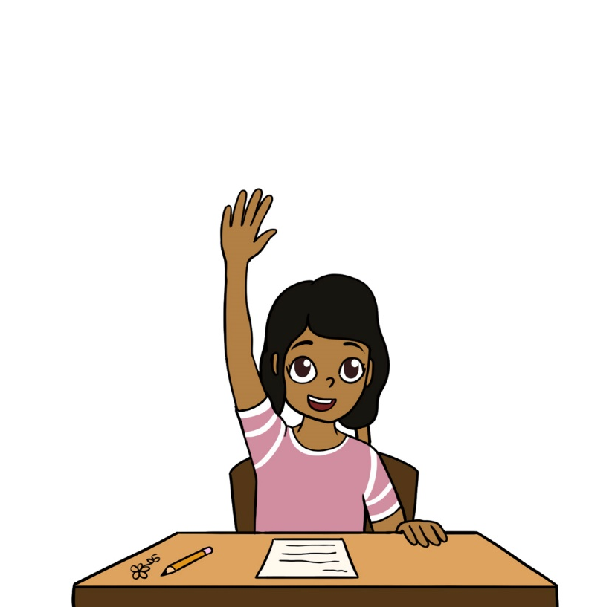

Shiibinikenin!

Shee-bih-nih-kay-nin
Raise your arm!

Gaasiininjii’on!

Gaw-see-nin-jee-ohn
Dry your hands!

Agoodoon!

Uh-goo-doon
Hang it up!

Aabezin!

Aw-beh-zin
Behave!

Gojitoon minawaa!

Goh-jih-toon mih-nuh-waw
Try it again!

Gizii’aabide’on!

Gih-zee-aw-bih-day-ohn
Brush your teeth!

Odaapinan!

Oh-daw-pih-nun
Pick it up!

Ombidiiyenin!

Ohm-bih-dee-yay-nin
Lift your bum!

Giigidon!

Gee-gih-dohn
Speak up!

Gaagiigidon!

Gaw-gee-gih-dohn
Speak/Talk!

Boonitoon!

Boo-nih-toon
Leave it alone!

