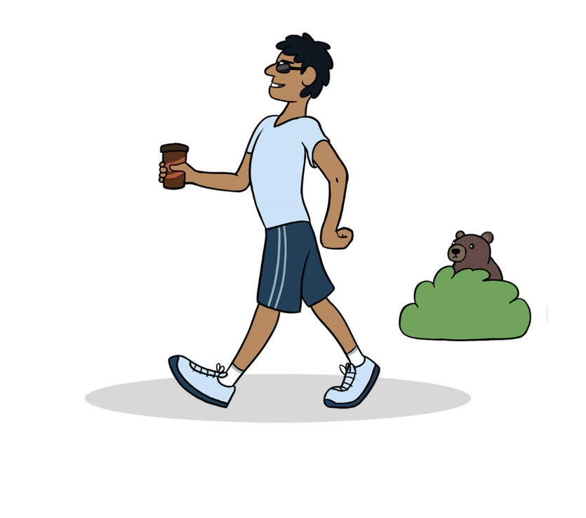

Bimosen!

Bih-moe-sehn
Walk!

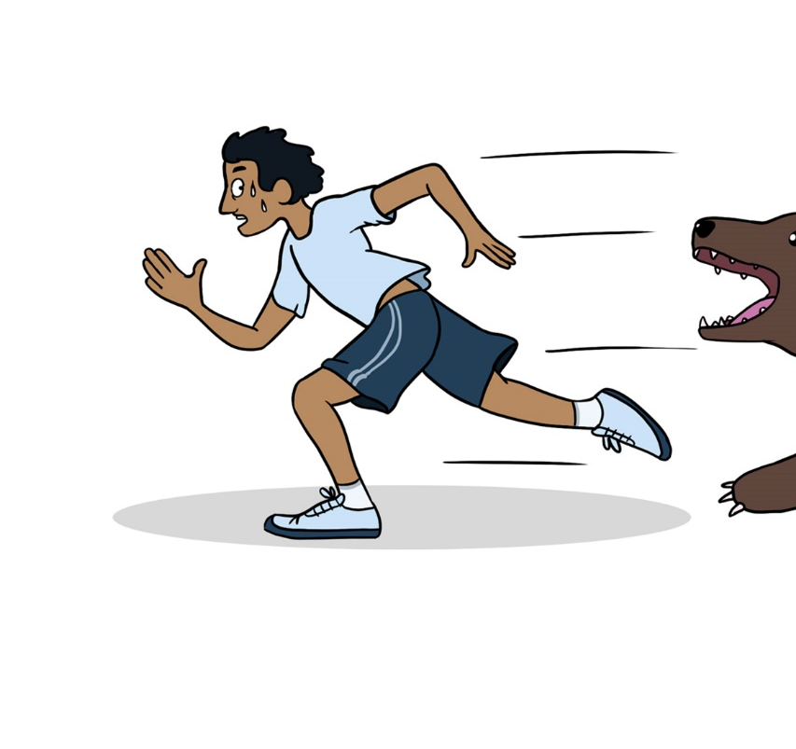

Bimibatoon!

Bih-mih-buh-toon
Run!

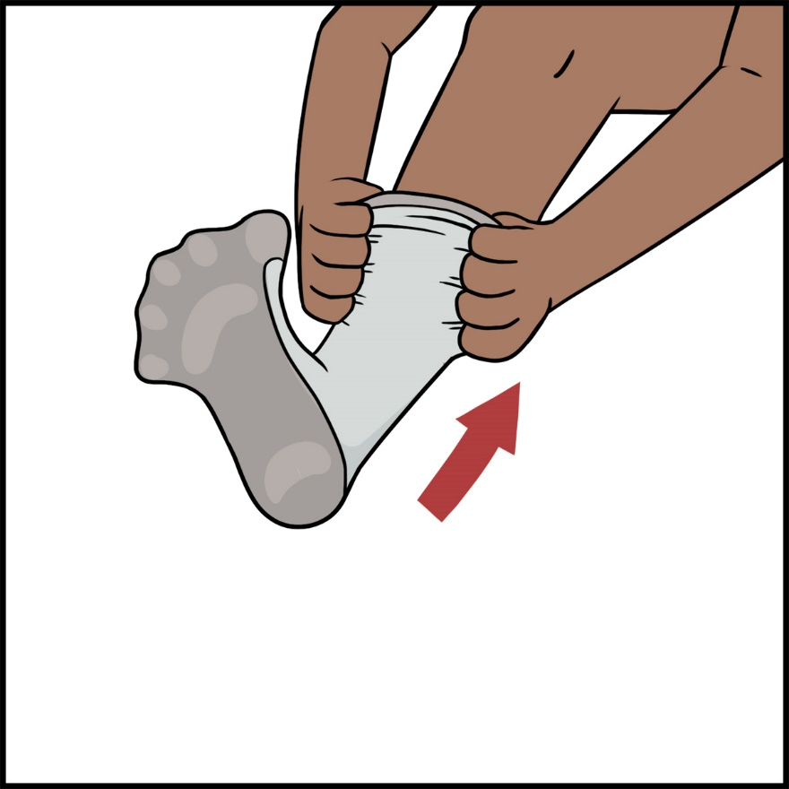

Biisikan!

Bee-sih-kun
Put it on!

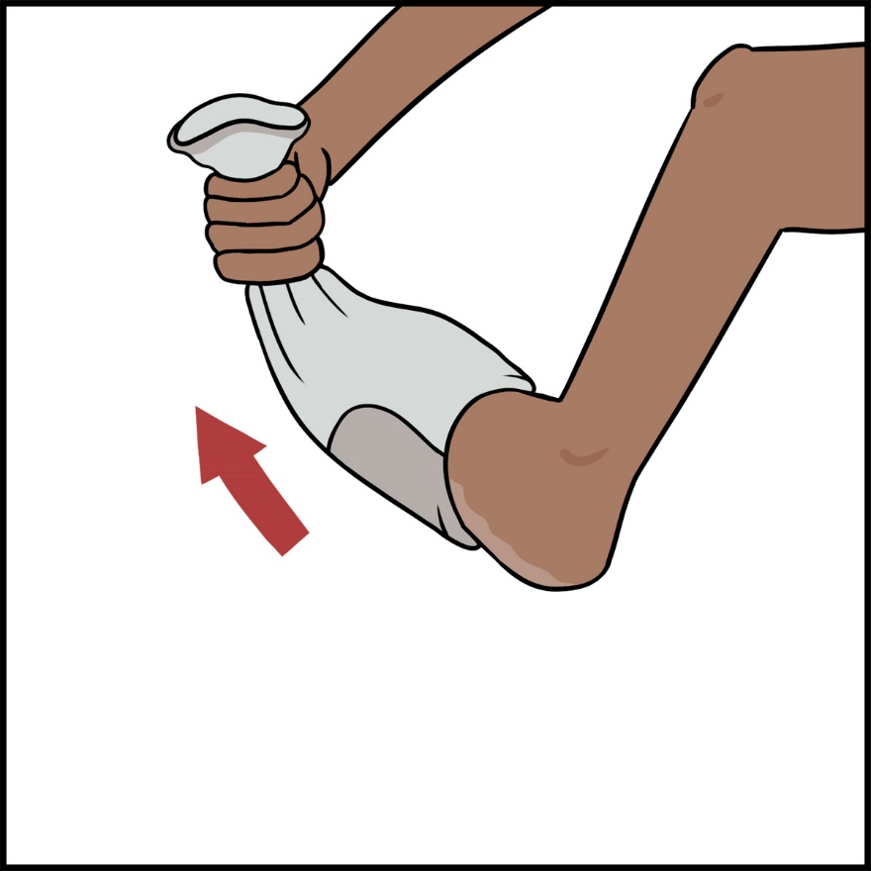

Giisikan!

Gee-sih-kun
Take it off!

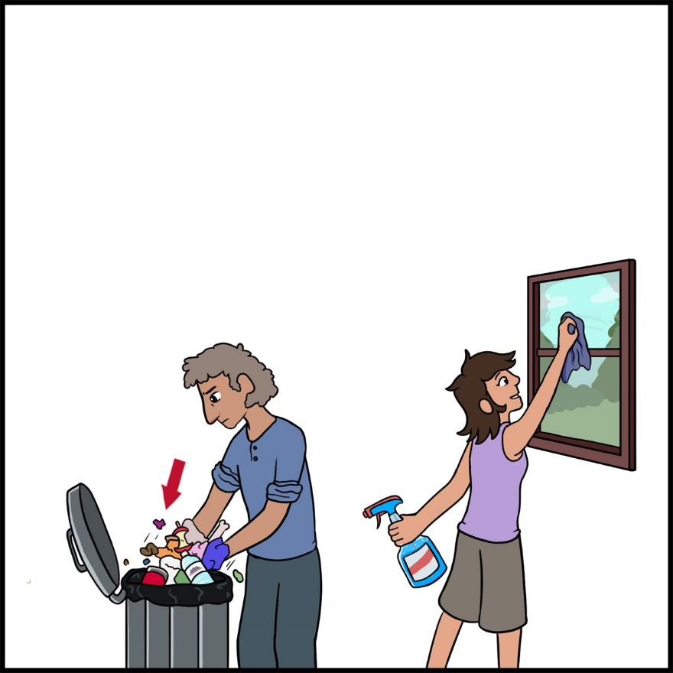

Biinichigen!

Bee-nih-chih-gen
Clean up!

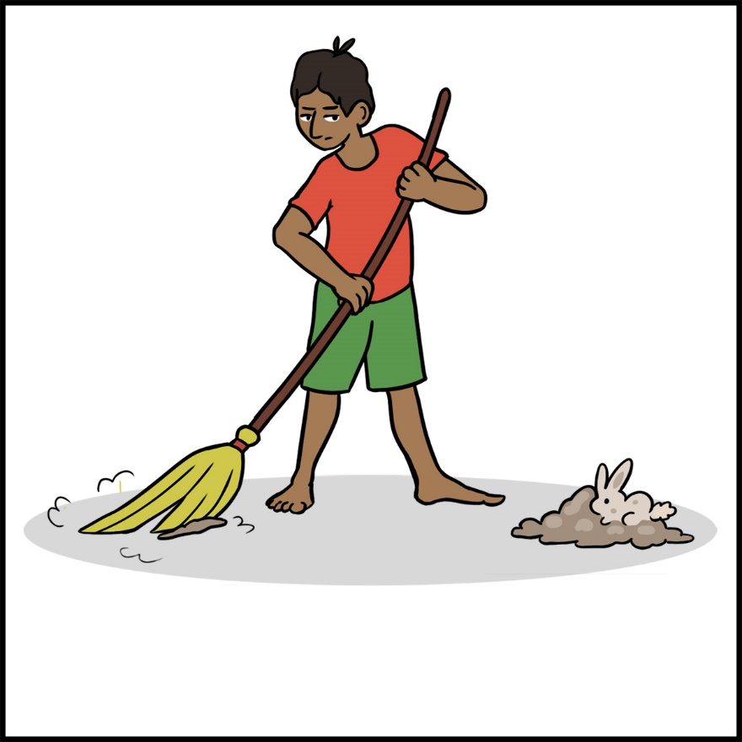

Jiishate’igen!

Jee-shuh-tay-ih-gehn
Sweep!

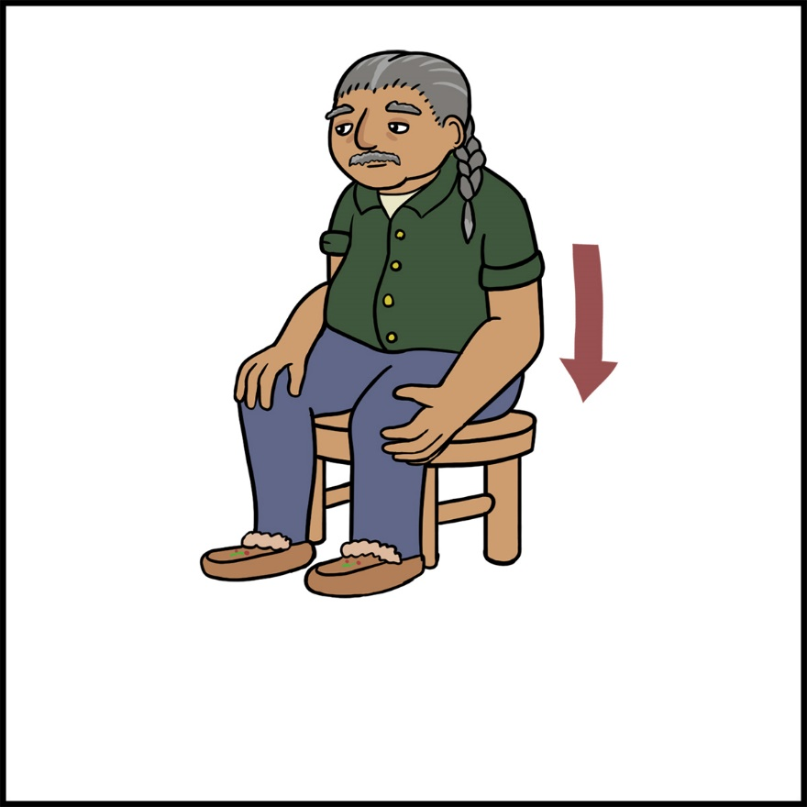

Namadabin!

Nuh-muh-duh-bin
Sit down!

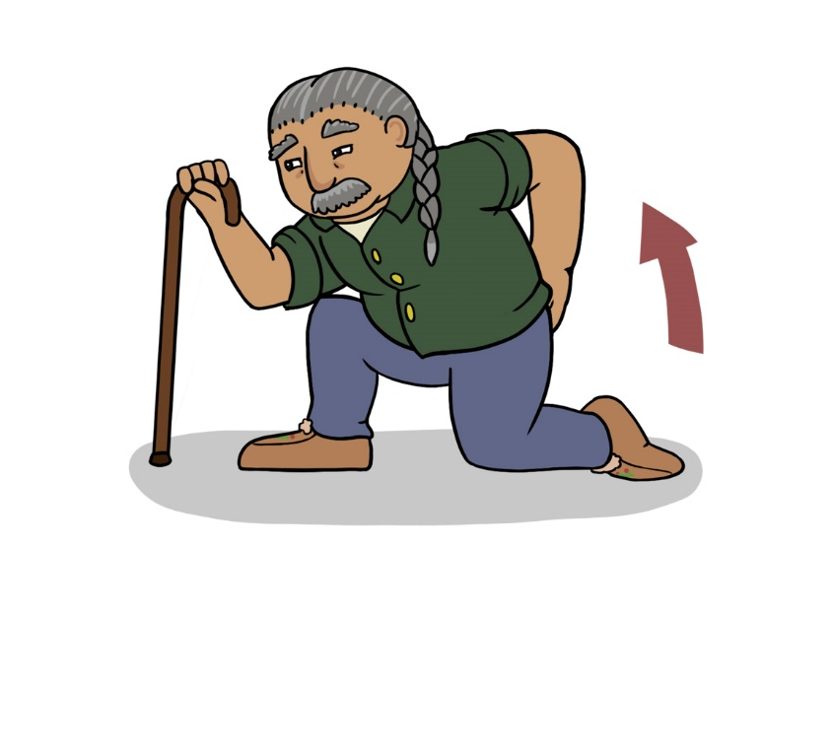

Onishikaan!

Oh-nish-kahn
Get up!

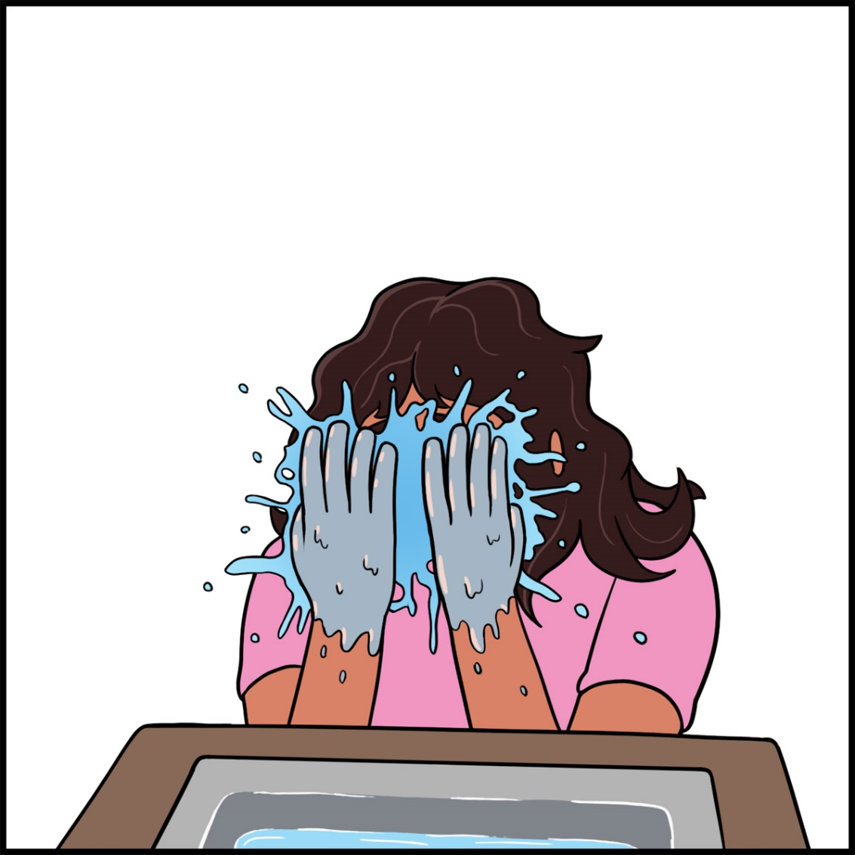

Giziingwen!

Gih-zeeng-gwen
Wash your face!

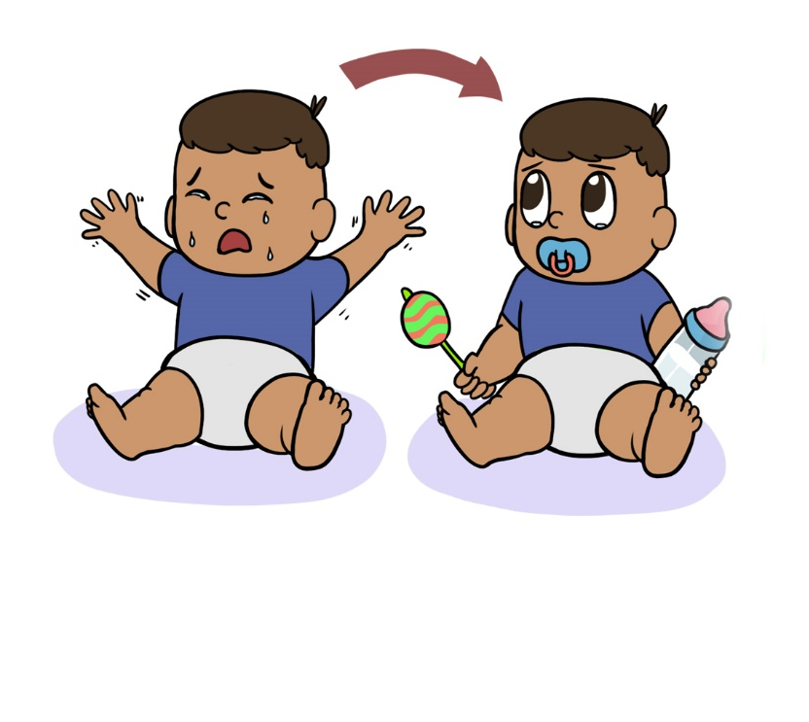

Bizaani-ayaan!

Bih-zaw-nih-uh-yawn
Settle down!

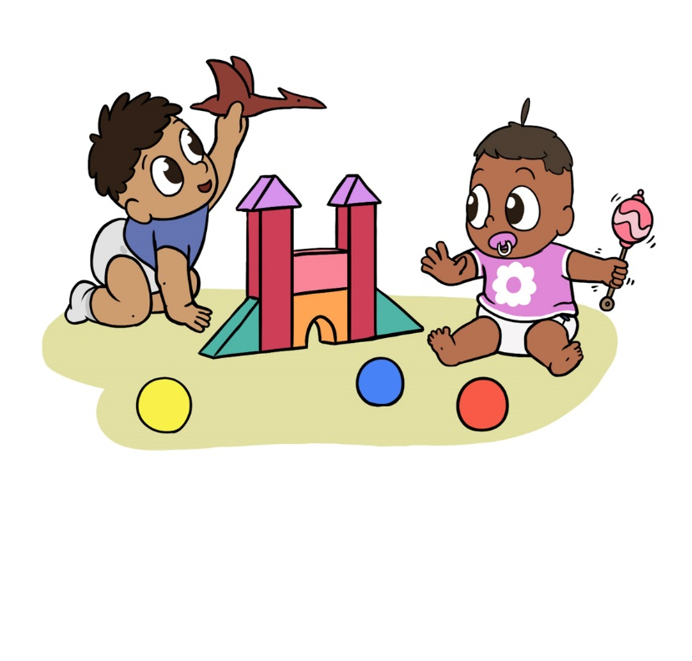

Babaa-odaminon!

Buh-baw-oh-duh-mih-nohn
Play around!

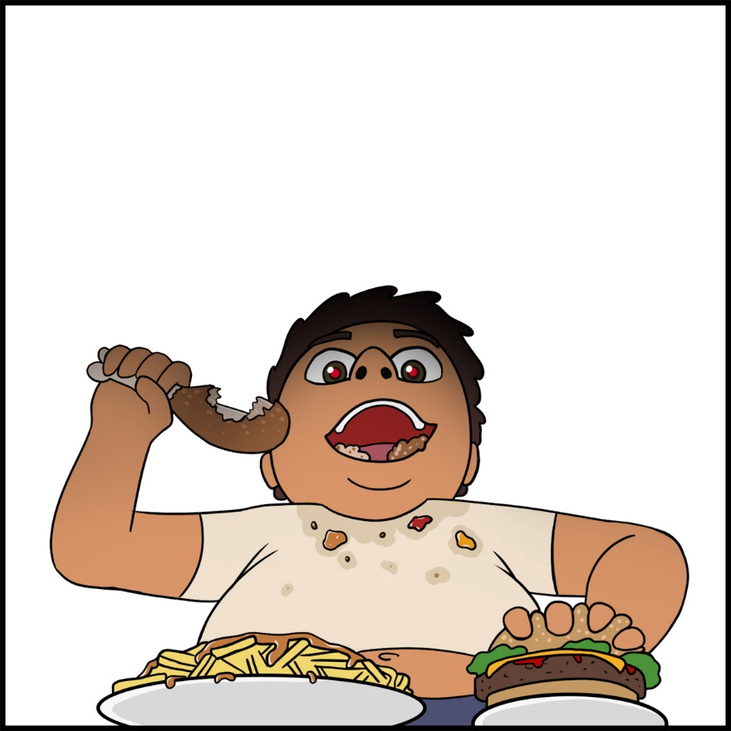

Wiisinin!

Wee-sih-nin
Eat!

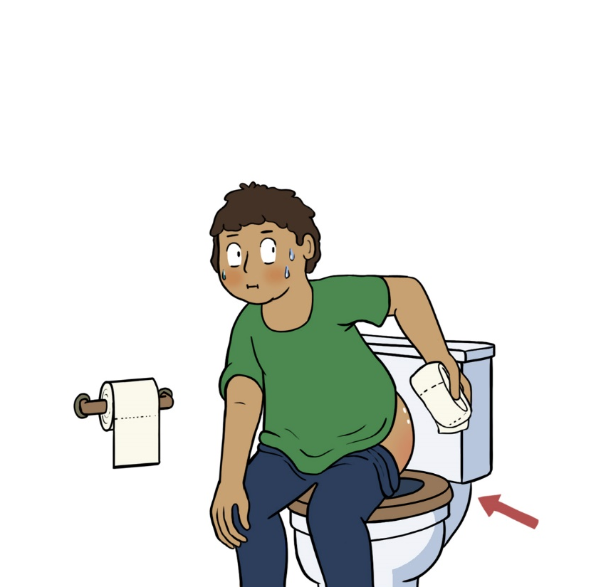

Giziindime’on!

Gih-zeen-dih-may-ohn
Wipe your bum!

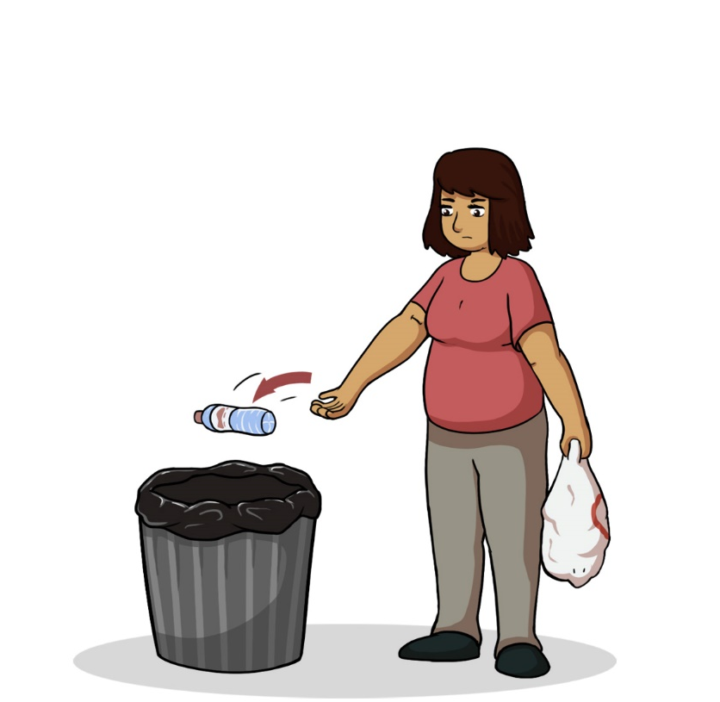

Webinan!

Way-bih-nun
Throw it away!

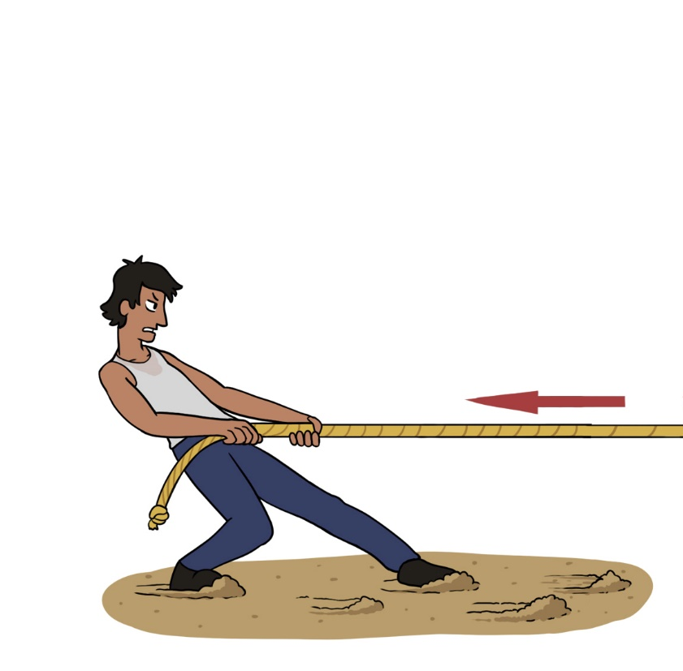

Wiikobidoon!

Wee-koh-bih-doon
Pull it!

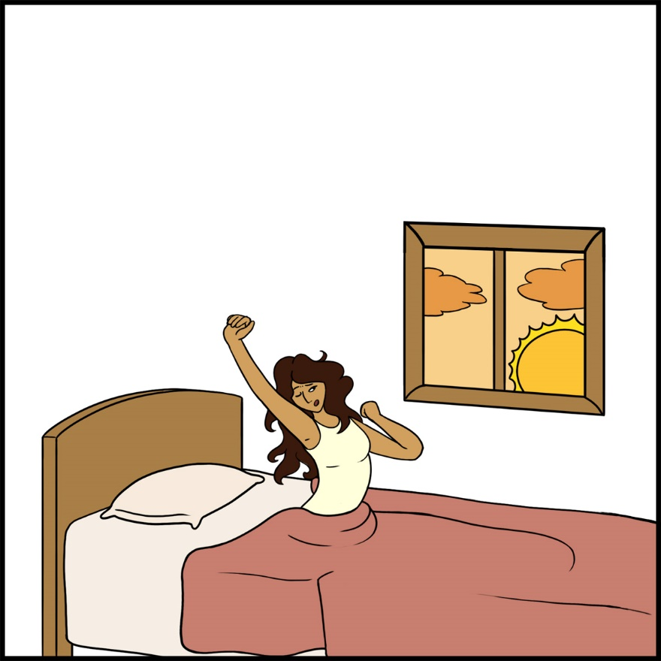

Goshkozin!

Gohsh-koh-zin
Wake up!

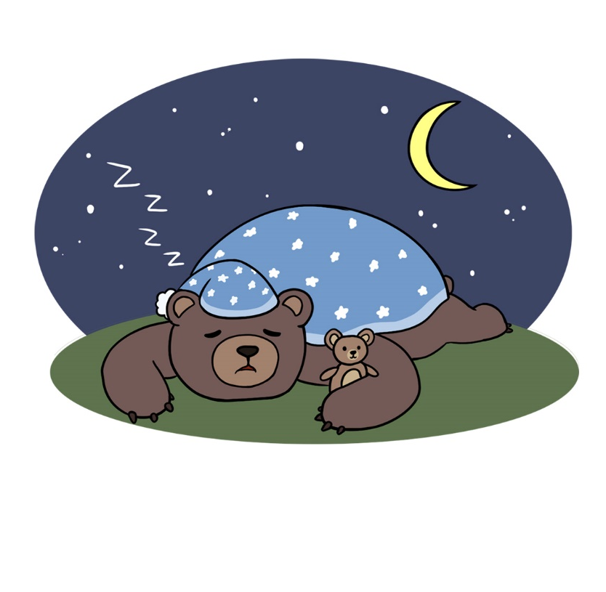

Nibaan!

Nih-bawn
Sleep!

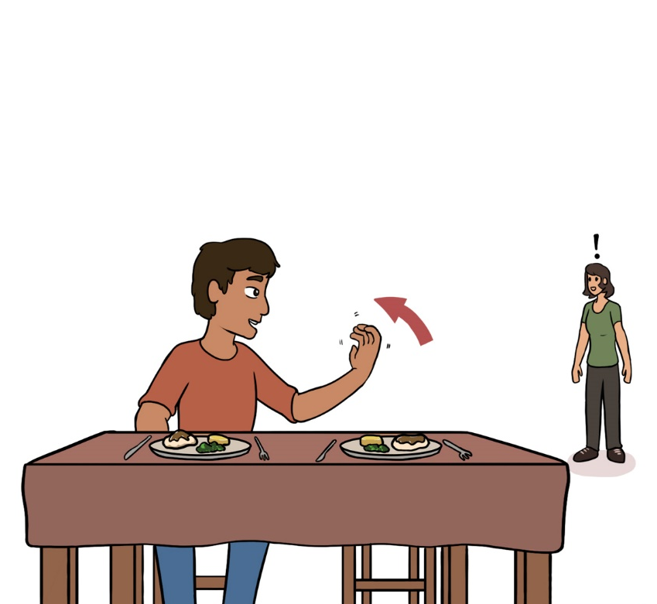

Biwiisinin!

Bih-wee-sih-nin
Come eat!

Gawishimon!

Guh-wih-shih-mohn
Lay Down!

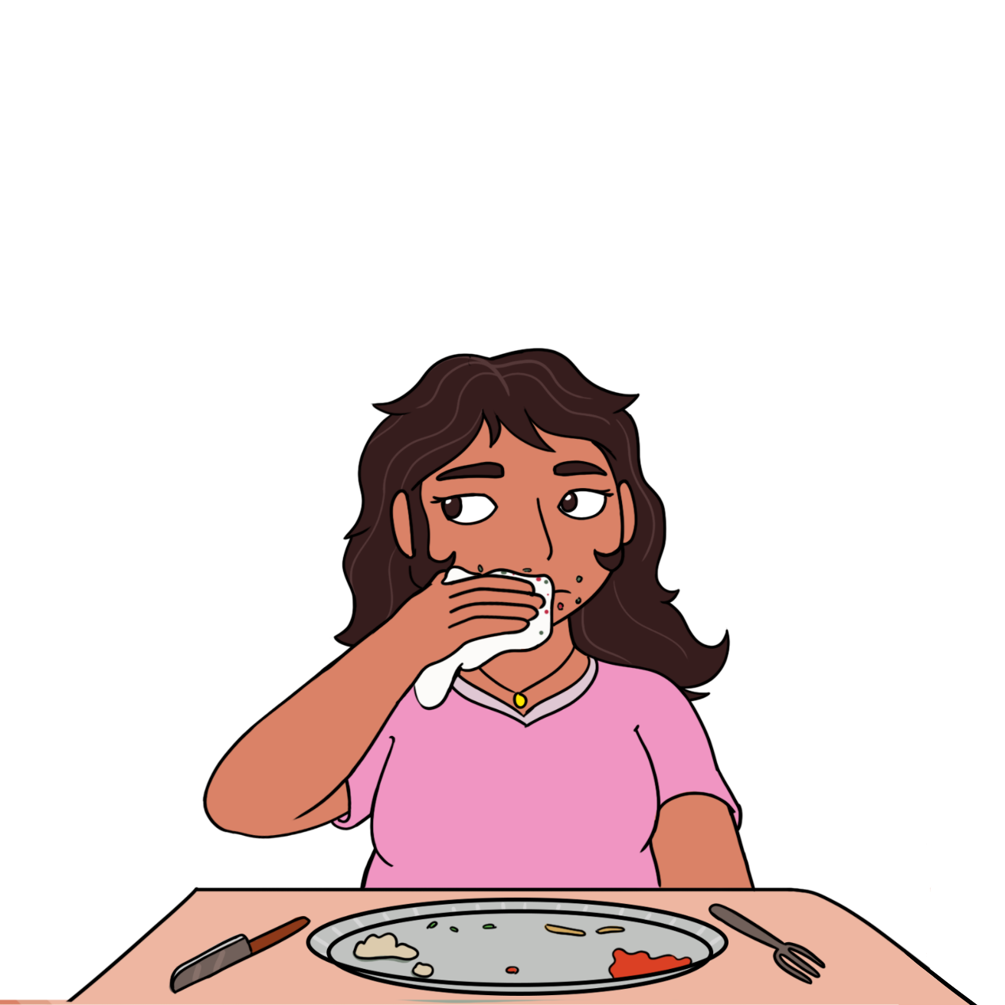

Giziingwe’on!

Gih-zeeng-gway-ohn
Wipe your face!

