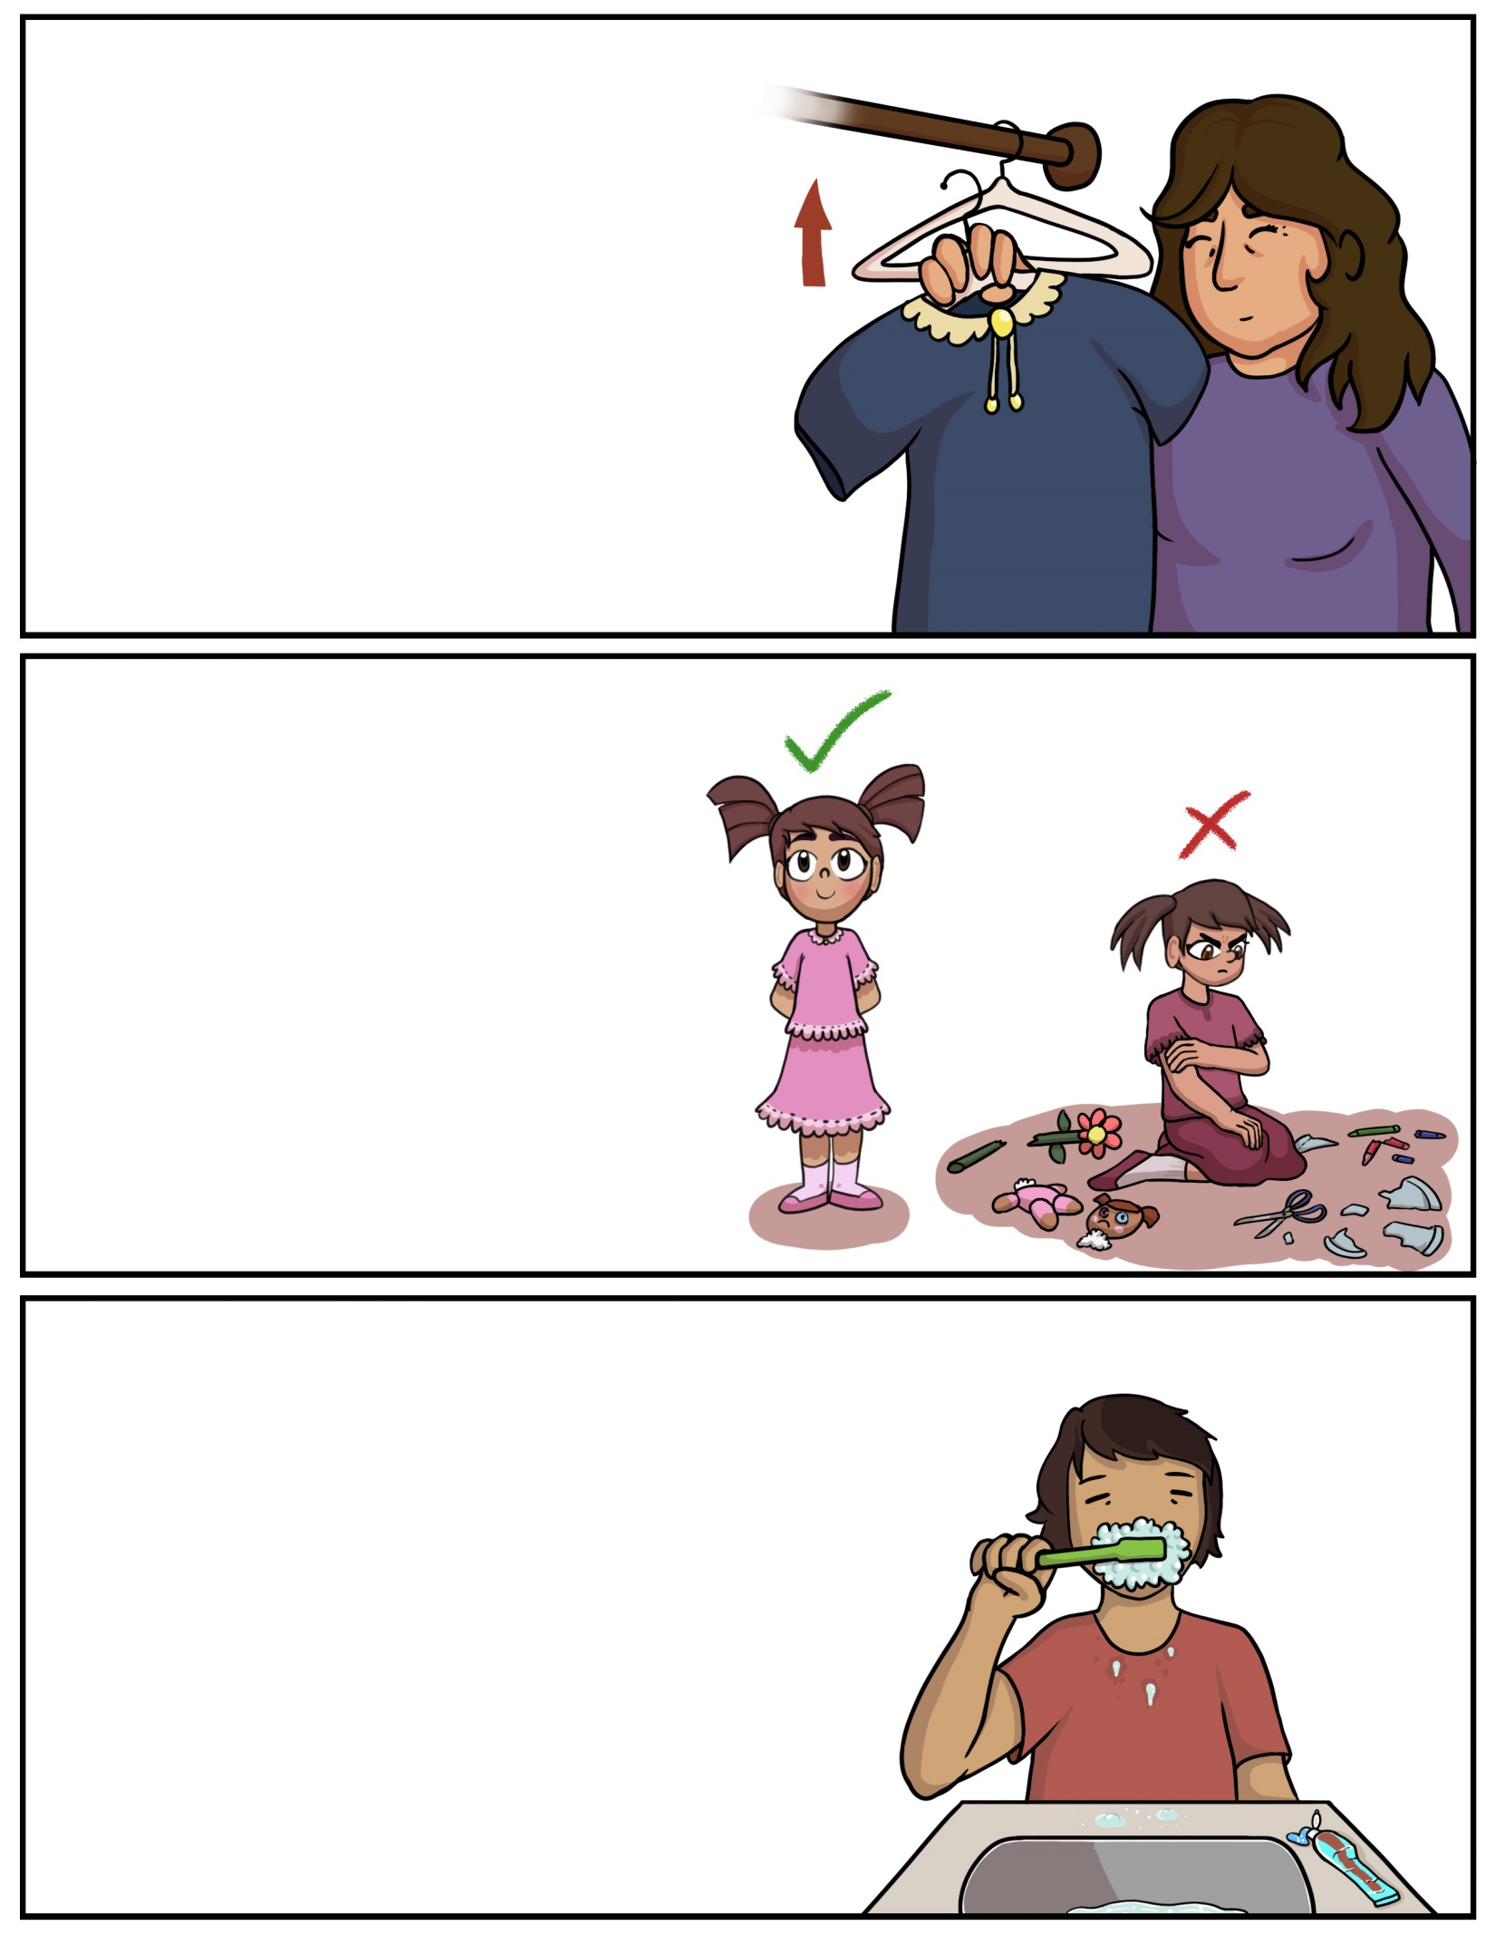

**Agoodoon – Hang it up**(Uh-g**oo**-d**oo**n) **Agoodoog – Hang it up (2+)**(Uh-g**oo**-d**oo**g)**Agoodoodaa – Let’s hang it up (ALL)**(Uh-g**oo**-d**oo-**d**aw**)

**Gizii’aabide’on – Brush your teeth** (Gih-z**ee**-**aw**-bih-deh-ohn)**Gizii’aabide’og – Brush your teeth (2+)**(Gih-z**ee**-**aw**-bih-deh-ohg)

**Gizii’aabide’odaa – Let’s brush our teeth (ALL)** (Gih-z**ee**-**aw**-bih-deh-oh-d**aw**)

**Aabezin – Behave** (Aw-beh-zin)**Aabezig – Behave (2+)(Aw**-beh-zig)**Aabezidaa – Let’s behave (ALL)(Aw**-beh-zih-d**aw**)

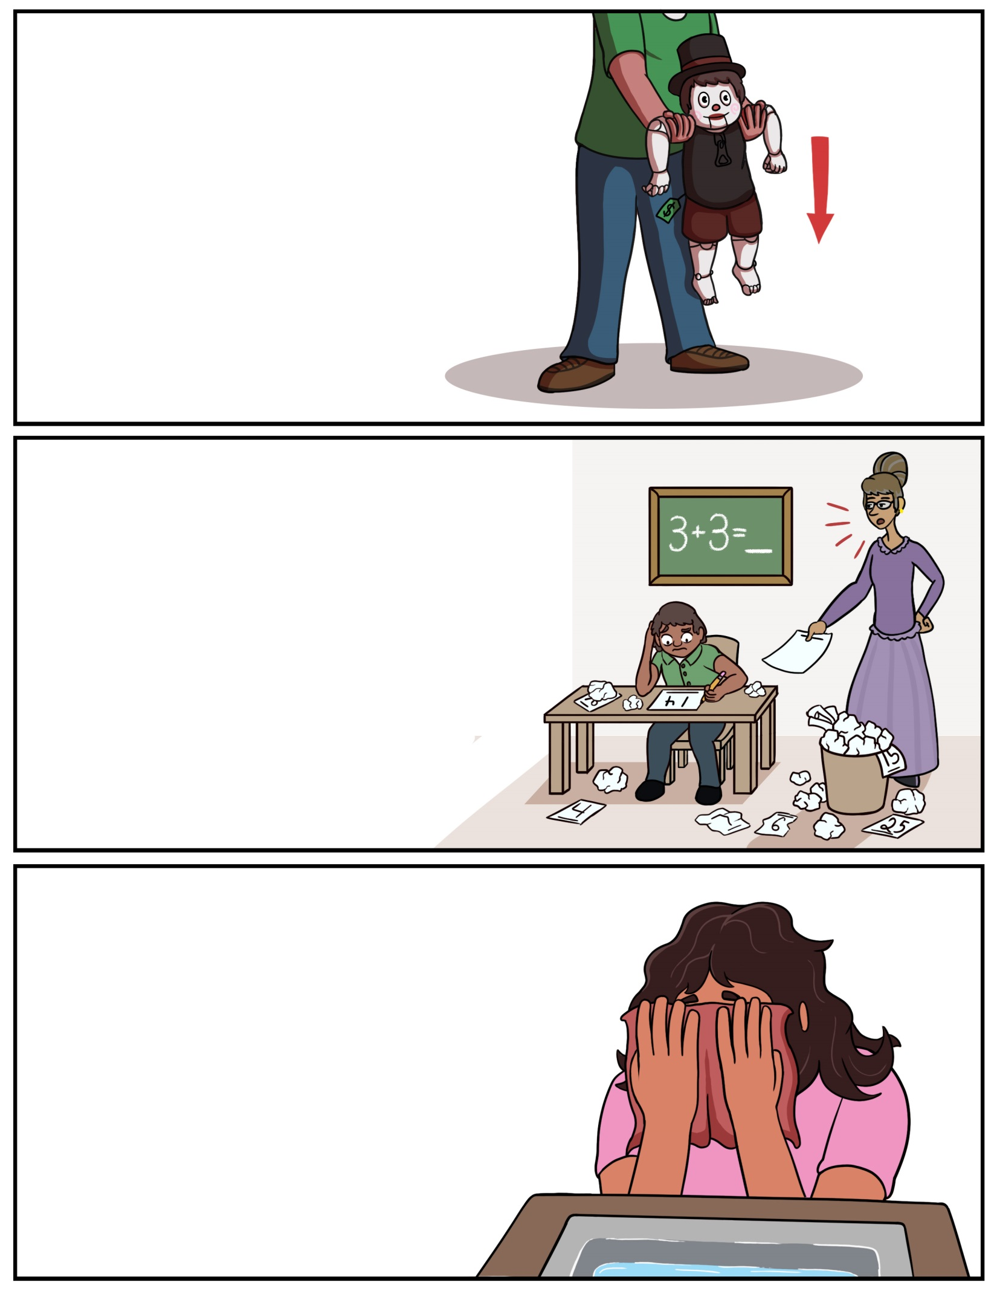

**Bagidinan – Set it down**(Buh-gih-dih-nun) **Bagidinamok – Set it down (2+)**(Buh-gih-dih-nuh-mohk)**Bagidinandaa – Let’s set it down (ALL)**(Buh-gih-dih-nun-d**aw**)

**Gaasiingwe’on – Dry your face**(Gaw-s**ee**n-gweh’-ohn)**Gaasiingwe’og – Dry your face (2+)**(Gaw-s**ee**n-gweh’-ohg)**Gaasiingwe’odaa – Let’s dry our face (ALL)**

(Gaw-s**ee**n-gweh’-oh-d**aw**)

**Gojitoon miinawaa – Try it again**(Goh-jih-t**oo**n m**ee**n-uh-w**aw**)**Gojitoog miinawaa – Try it again (2+)**(Goh-jih-t**oo**g m**ee**n-uh-w**aw**)**Gojitoodaa miinawaa – Let’s try it again (ALL)**(Goh-jih-t**oo**-d**aw** m**ee**n-uh-w**aw**)

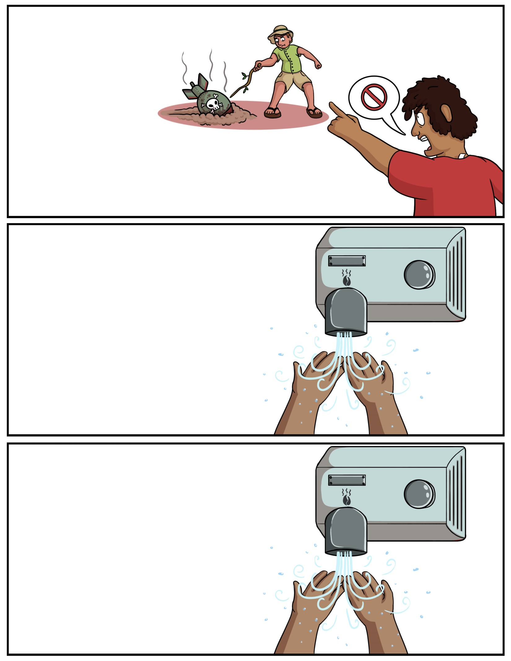

**Boonitoon – Leave it alone** (B**oo**-nih-t**oo**n) **Boonitoog – Leave it alone (2+)**(B**oo**-nih-t**oo**g)**Boonitoondaw – Let’s leave it alone (ALL)**(B**oo**-nih-t**oo-**d**aw**)

**Bengwaninjii’on – Dry your hands**(Ben-gwuh-nin-j**ee**’-ohn)**Bengwaninjii’oyok – Dry your hands (2+)**(Ben-gwuh-nin-j**ee**’-oh-yohk)**Bengwaninjii’odaa – Let’s Dry Our Hands (ALL)** (Ben-gwuh-nin-j**ee**’-oh-d**aw**)

**Gaasiininjii’on – Dry your hands**(G**aw**-s**ee**-nin-jee’-ohn)**Gaasiinji’og – Dry your hands (2+)**(G**aw**-s**ee**-nin-jee’-ohg)**Gaasiinji’odaa – Let’s dry our hands (ALL)**(G**aw**-s**ee**-nin-jee’-oh-d**aw**)

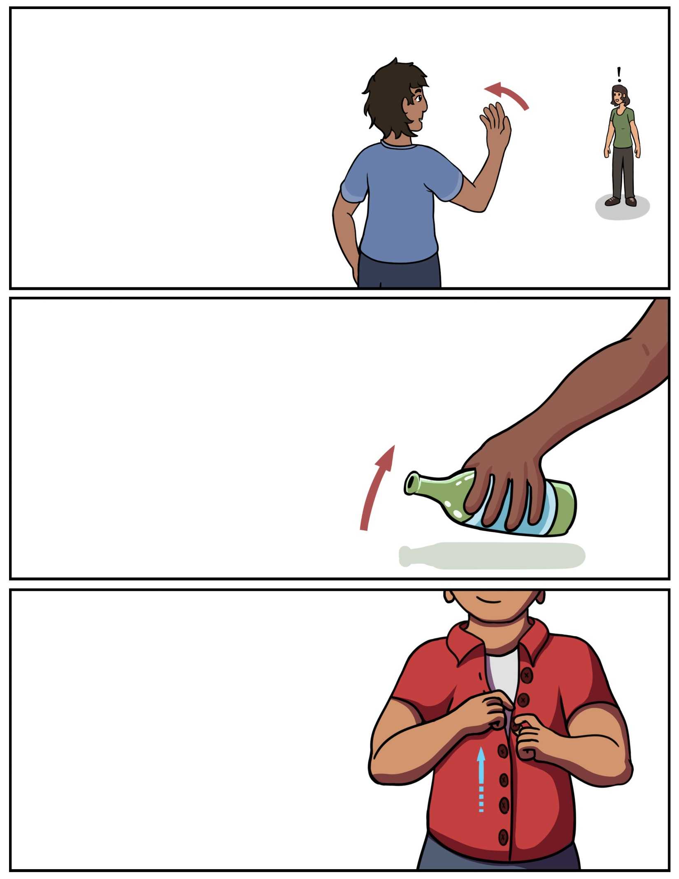

**Bengwaninjii’on**(Ben-gwuh-nin-j**ee**’-ohn)**Bengwaninjii’oyok - (2+)**(Ben-gwuh-nin-j**ee**’-oh-yohk)**Bengwaninjii’odaa - (ALL)** (Ben-gwuh-nin-j**ee**’-oh-d**aw**)

**Zagaakwa’on – Button it up** (Zuh-g**aw**-kwuh’-ohn)**Zagaakwa’og – Button it up (2+)**(Zuh-g**aw**-kwuh’-ohg)**Zagaakwa’odaa – Let’s button it up (ALL)** (Zuh-g**aw**-kwuh’-oh-d**aw**)

**Odaapinan – Pick it up** (Oh-d**aw**-pin-uhn)**Odaapinamok – Pick it up (2+)**(Oh-d**aw**-pin-uh-mohk)**Odaapinandaa – Pick it up (ALL)**(Oh-d**aw**-pin-uhn-d**aw**)

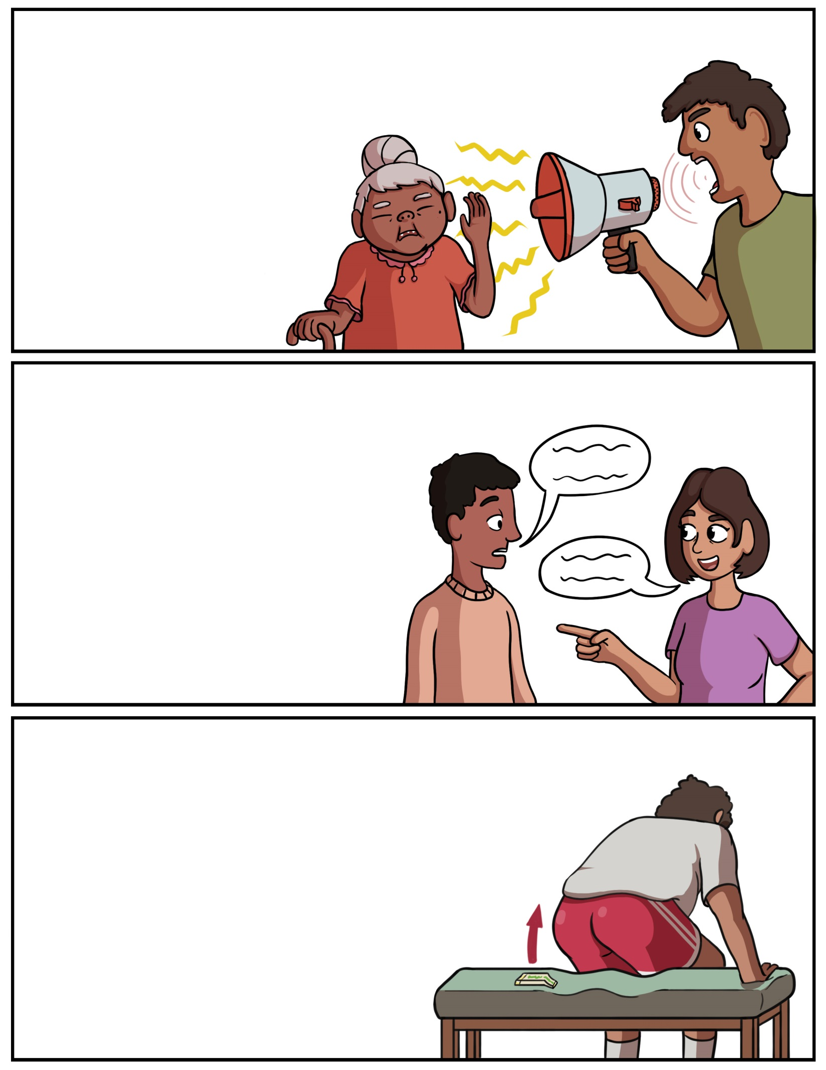

**Giigidon – Speak up**(G**ee**-gih-don) **Giigidog – Speak up (2+)**(G**ee**-gih-dohg)**Giigidodaa – Let’s speak up (ALL)**(G**ee**-gih-doh-d**aw**)

**Ombidiiyenin – Lift your bum**(Ohm-bih-d**ee**-yeh-nin)**Ombidiiyenig – List your bum (2+)**(Ohm-bih-d**ee**-yeh-nig)**Ombidiiyenidaw – Let’s lift our bum (ALL)** (Ohm-bih-d**ee**-yeh-nih-d**aw**)

**Gaagiigidon – Speak/Talk** (G**aw**-g**ee**-gih-dohn)**Gaagiigidog – Speak/Talk (2+)**(G**aw**-g**ee**-gih-dohg)**Gaagiigidodaa- Let’s speak/talk (ALL)**(G**aw**-g**ee**-gih-doh-d**aw**)