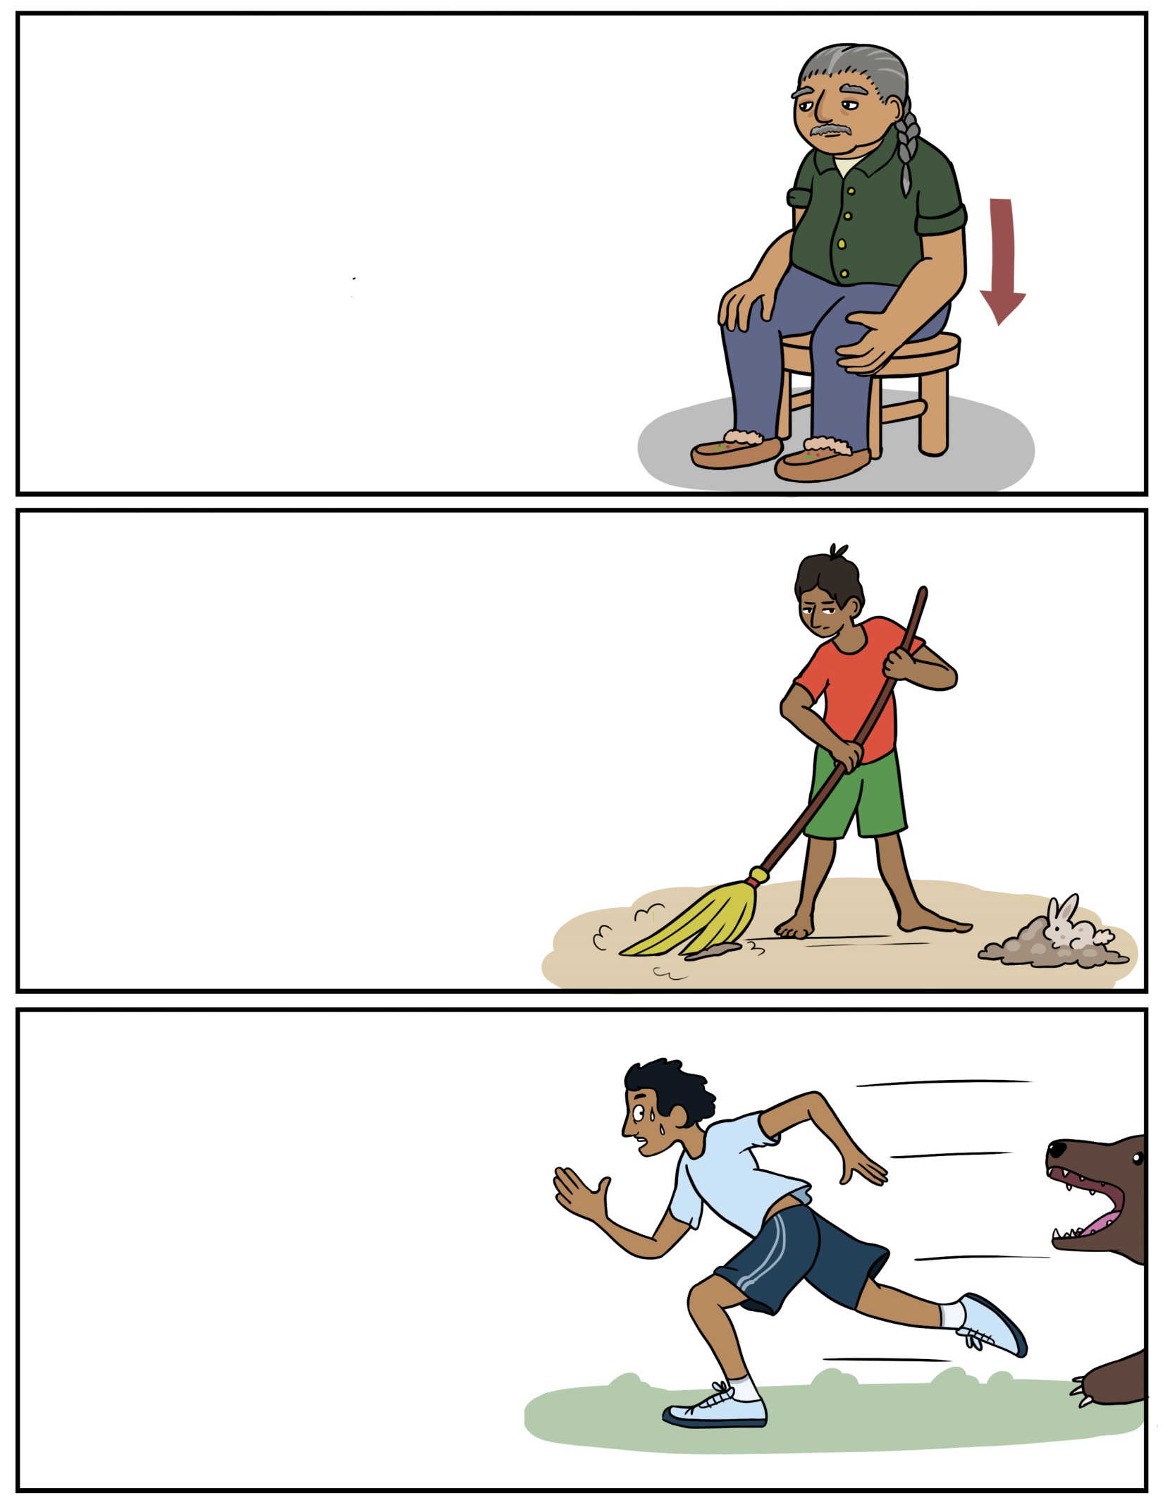

**Namadabin – Sit down** (Nuh-muh-duh-bin) **Namadabiyok – Sit down (2+)**(Nuh-muh-duh-bi-ohk)**Namadabig – Sit down (2+)**(Nuh-muh-duh-big)**Namadabidaa – Let’s sit down (ALL)**(Nuh-muh-duh-bih-daw)

**Jiishate’igen - Sweep** (Jee-shuh-teh-ih-gehn)**Jiishate’igeyok – Sweep (2+)**(Jee-shuh-teh-ih-geh-ohk)**Jiisate’igeg – Sweep (2+)**

(Jee-shuh-teh-ih-gehg)**Jiishate’igedaa – Let’s sweep (ALL)**(Jee-shuh-teh-ih-geh-daw)

**Bimibatoon - Run** (Bih-mih-buh-toon)**Bimibatooyok – Run (2+)**(Bih-mih-buh-too-yohk)**Bimibatoog – Run (2+)**

(Bih-mih-buh-toog)**Bimibatoodaa – Let’s run (ALL)** (Bih-mih-buh-too-daw)

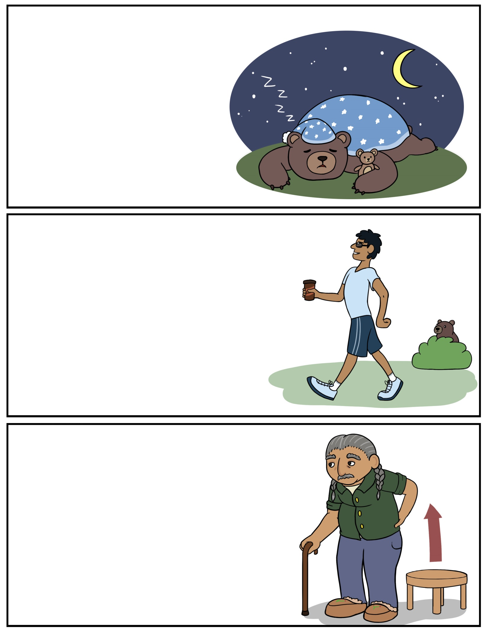

**Nibaan – Sleep** (Nih-bawn)**Nibaayok – Sleep (2+)**(Nih-baw-ohk) **Nibaag – Sleep (2+)**(Nih-bawg)**Nibaadaa – Let’s sleep (ALL)**(Nih-baw-daw)

**Niibowin – Stand up** (Nee-boh-win)**Niibowiyok – Stand up (2+)** (Nee-boh-wih-ohk)**Niibowig – Stand up (2+)**(Nee-boh-wig)**Niibowidaa – Let’s stand up (ALL)**(Nee-boh-wih-daw)

**Bimosen – Walk** (Bih-moh-sehn)**Bimoseyok – Walk (2+)**(Bih-moh-seh-ohk)**Bimoseg – Walk (2+)**(Bih-moh-sehg)**Bimosedaa – Let’s walk (ALL)**(Bih-moh-daw)

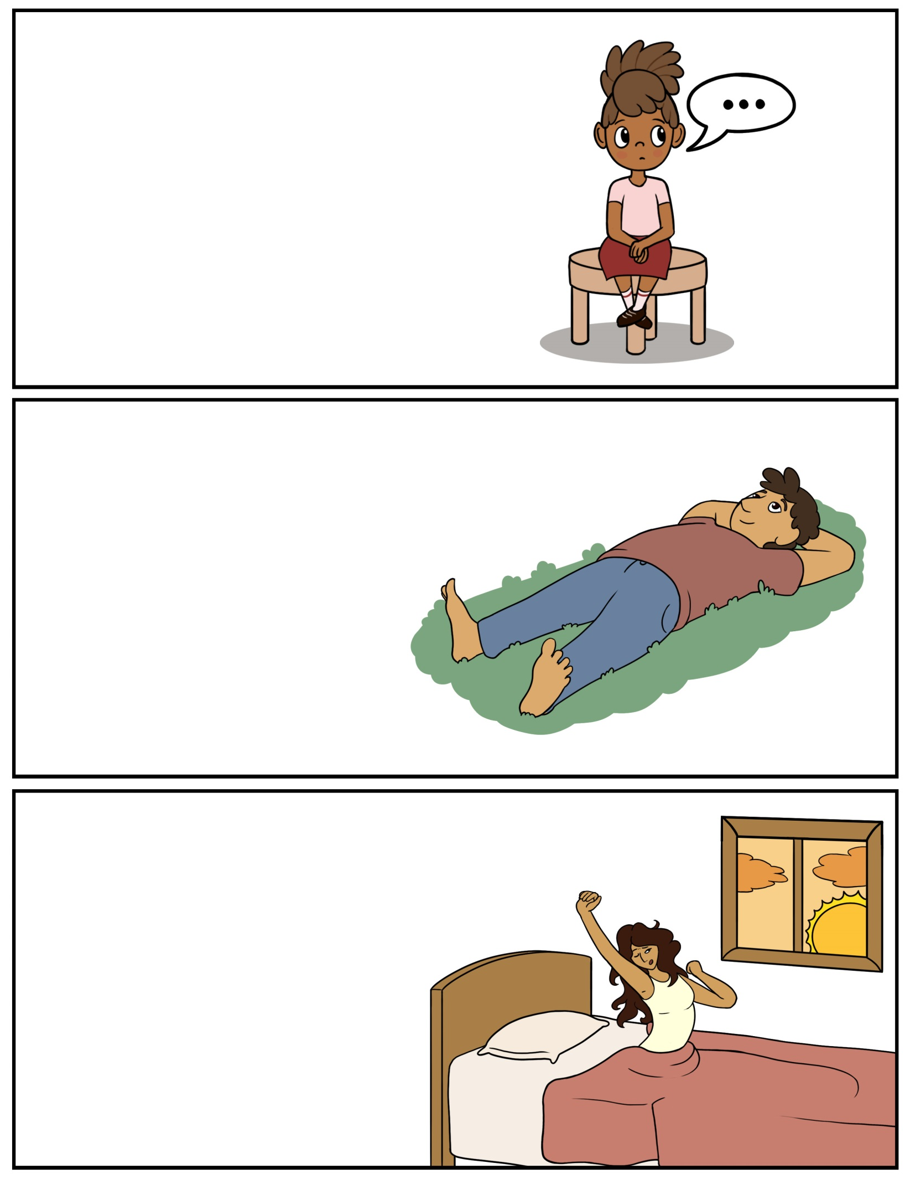

**Bizaanabin – Sit quietly** (Bih-zaw-nuh-bin) **Bizaanabig – Sit quietly (2+)**(Bih-zaw-nuh-big) **Bizaanabidaa – Let’s sit quietly (ALL)**(Bih-zaw-nuh-bih-daw)

**Goshkozin – Wake up** (Goh-shkoh-zihn)**Goshkoziyok – Wake up (2+)**(Goh-shkoh-zih-yohk)**Goshkozig – Wake up (2+)**(Goh-shkoh-zihg)**Goshkozidaa – Let’s wake up (ALL)**(Goh-shkoh-zih-daw)

**Gawishimon – Lay down** (Guh-wish-ih-mohn)**Gawishimog – Lay down (2+)**(Guh-wish-ih-mohg)**Gawishimodaa – Let’s lay down (ALL)**(Guh-wish-ih-moh-daw)

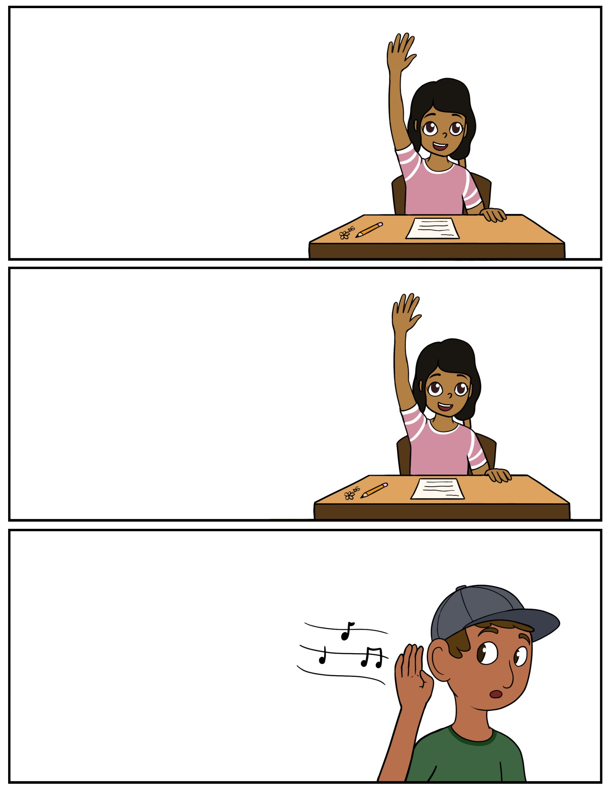

**Shiibinikenin – Raise your arm** (Shee-bih-nih-keh-nin) **Shiibinikenig – Raise your arm (2+)**(Shee-bih-nih-keh-nig) **Shiibinikenidaa – Let’s raise our arm (ALL)**(Shee-bih-nih-keh-nih-daw)

**Ombinikenin – Raise your arm**(Ohm-bih-nih-keh-nin)**Ombinikenig – Raise your arm (2+)**(Ohm-bih-nih-keh-nig)**Ombinikenidaa – Let’s raise our arm (ALL)**(Ohm-bih-nih-keh-ni-daw)

**Bizindan – Listen** (Bih-zin-duhn)**Bizindamok – Listen (2+)**(Bih-zin-duh-mohk)**Bizindandaa – Let’s listen (ALL)**(Bih-zin-duhn-daw)

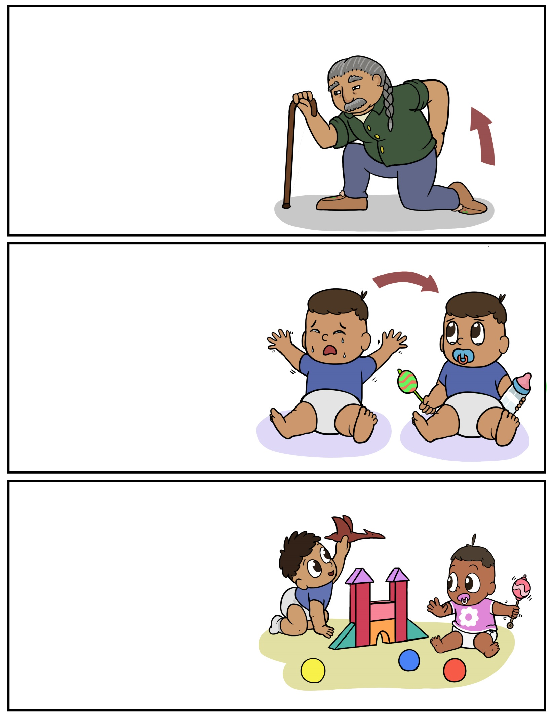

**Onishkaan – Get up** (Oh-nish-kawn) **Onishkaayok – Get up (2+)**(Oh-nish-kaw-yok) **Onishkaag – Get up (2+)**(Oh-nish-kawg) **Onishkaadaa – Let’s get up (ALL)**(Oh-nish-kaw-daw)

**Babaa odaminon – Play around**(Buh-baw-oh-dum-in-nohn)**Babaa odaminog – Play around (2+)**(Buh-baw-oh-dum-in-nohg)**Babaa odaminodaa – Let’s play around (ALL)**(Buh-baw-oh-dum-in-oh-daw)

**Bizaani-ayaan – Settle down** (Bih-zaw-ni-uh-yawn)**Bizaani-ayaag – Settle down (2+)**(Bih-zaw-ni-uh-yawg)**Bizaani-ayaadaa – Let’s settle down (ALL)**(Bih-zaw-ni-uh-yaw-daw)

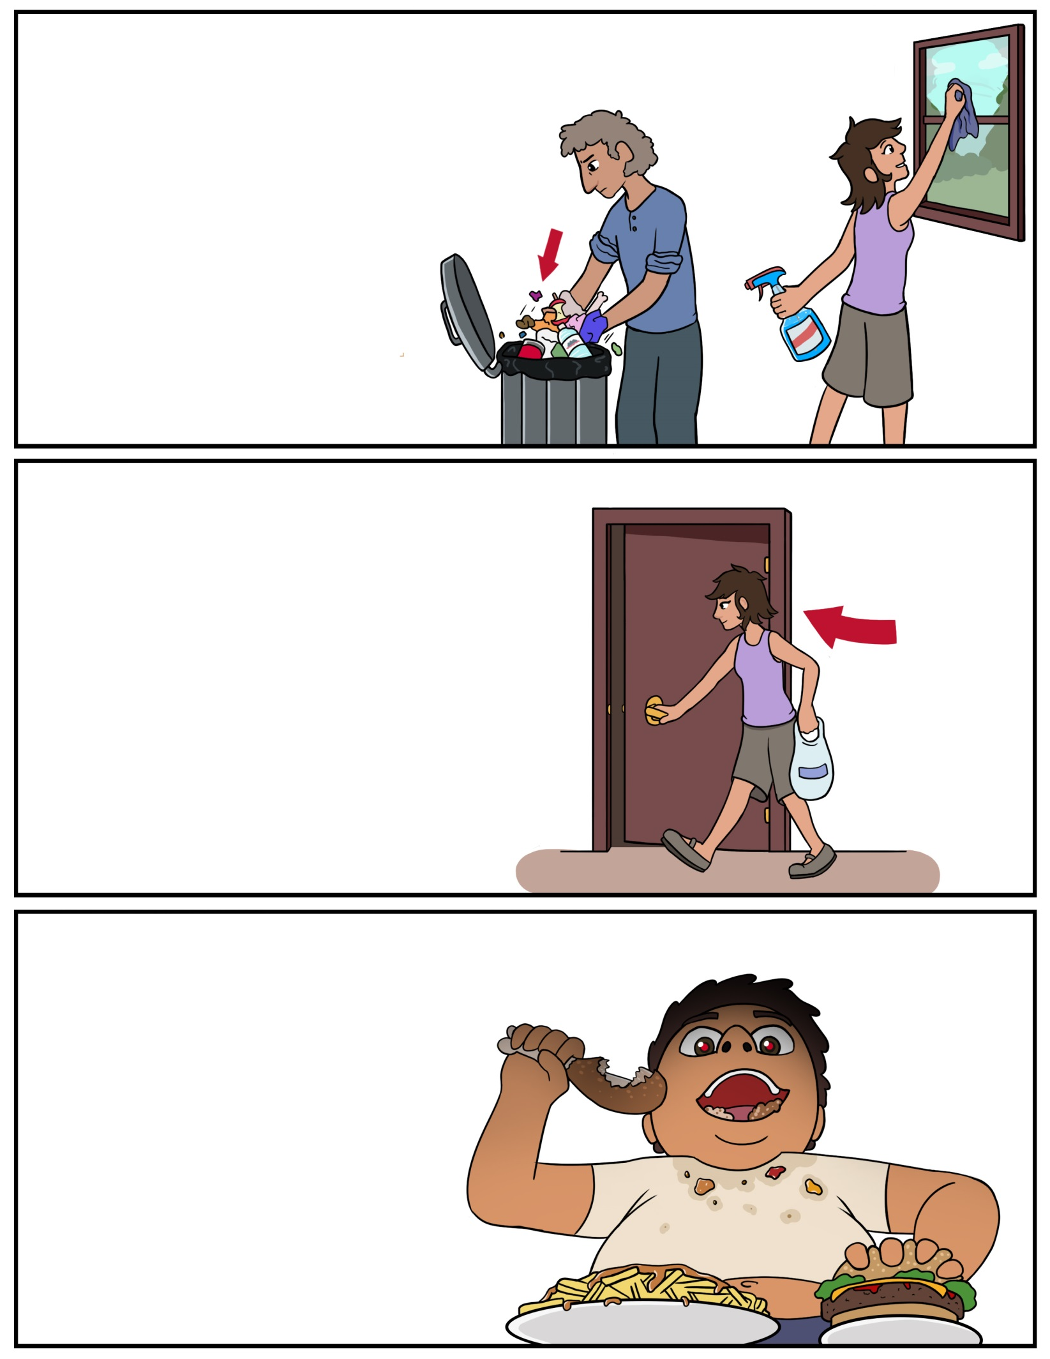

**Biinichigen – Clean up** (Bee-nih-chih-gehn) **Biinichigeyok – Clean up (2+)**(Bee-nih-chih-geh-ohk) **Biinichigeg – Clean up (2+)**(Bee-nih-chih-gehg) **Biinichigedaa – Let’s clean up (ALL)**(Bee-nih-chih-geh-daw)

**Wiisinin – Eat** (Wee-sih-nihn)**Wiisiniyok – Eat (2+)**(Wee-sih-nih-yohk)**Wiisinig – Eat (2+)**(Wee-sih-nihg)**Wiisinidaa – Let’s eat (ALL)**(Wee-sih-nih-daw)

**Biindigen – Enter** (Been-dih-gehn)**Biindigeyok – Enter (2+)**(Been-dih-geh-ohk)**Biindigeg – Enter (2+)**(Been-dih-gehg)**Biindigedaa – Let’s enter (ALL)**(Been-dih-geh-daw)

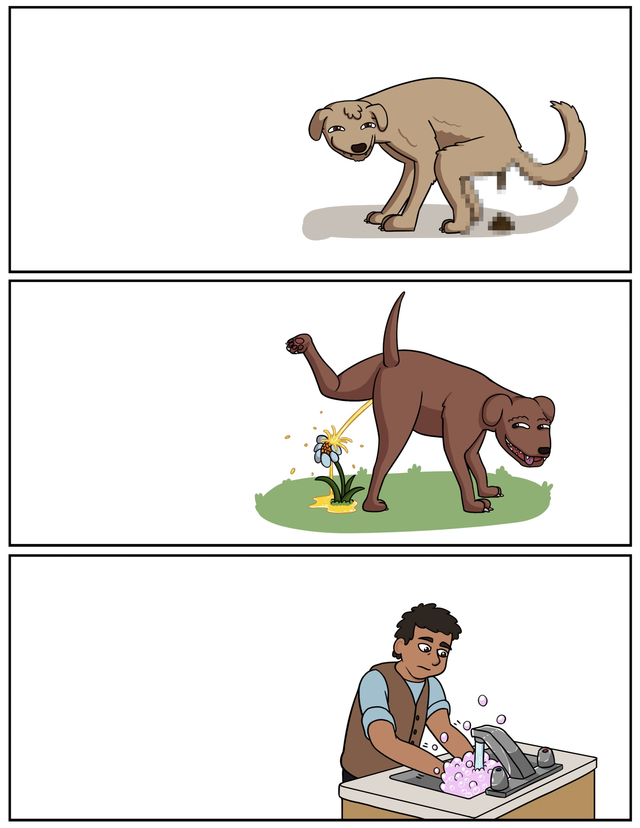

**Miiziin – Poop** (Mee-zeen) **Miiziiyok – Poop (2+)**(Mee-zee-yohk) **Miiziig – Poop (2+)**(Mee-zeeg) **Miiziidaa – Let’s poop (ALL)**(Mee-zee-daw)

**Giziininjiin – Wash your hands** (Gih-zee-nin-jeen)**Giziininjiiyok – Wash your hands (2+)**(Gih-zee-nin-jee-yohk)**Giziininjiig – Wash your hands (2+)**(Gih-zee-nin-jeeg)**Giziininjiidaa – Let’s wash our hands (ALL)**(Gih-zee-nin-jee-daw)

**Zhiishiigin – Pee** (Zhee-shee-gihn)**Zhiishiigiyok – Pee (2+)**(Zhee-shee-gih-yohk)**Zhiishiigig – Pee (2+)**(Zhee-shee-gihg)**Zhiishiigidaa – Let’s pee (ALL)**(Zhee-shee-gih-daw)

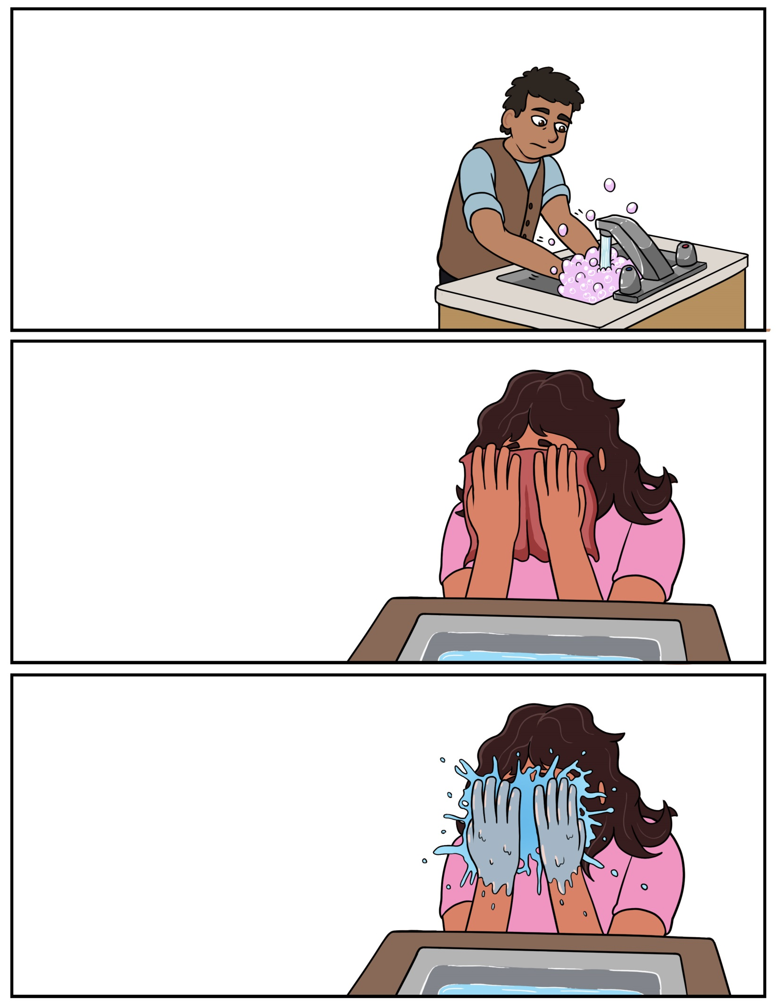

**Giziibiigininjiin – Wash your hands** (Gih-zee-bee-gih-nihn-jeen) **Giziibiigininjiig – Wash your hands (2+)**(Gih-zee-bee-gih-nihn-jeeg) **Giziibiigininjiidaa – Let’s wash our hands (ALL)**(Gih-zee-bee-gih-nihn-jee-daw)

**Giziingwen – Wash your face**(Gih-zeen-gwehn)**Giziingweg – Wash your face (2+)**(Gih-zeen-gwehg)**Giziingwedaa – Let’s wash our face (ALL)**(Gih-zeen-gweh-daw)

**Giziingwe’on – Wipe your face**(Gih-zeen-gweh-ohn)**Giziingwe’og – Wipe your face (2+)**(Gih-zeen-gweh-ohg)**Giziingwe’odaa – Let’s wipe our face (ALL)**(Gih-zeen-gweh-oh-daw)

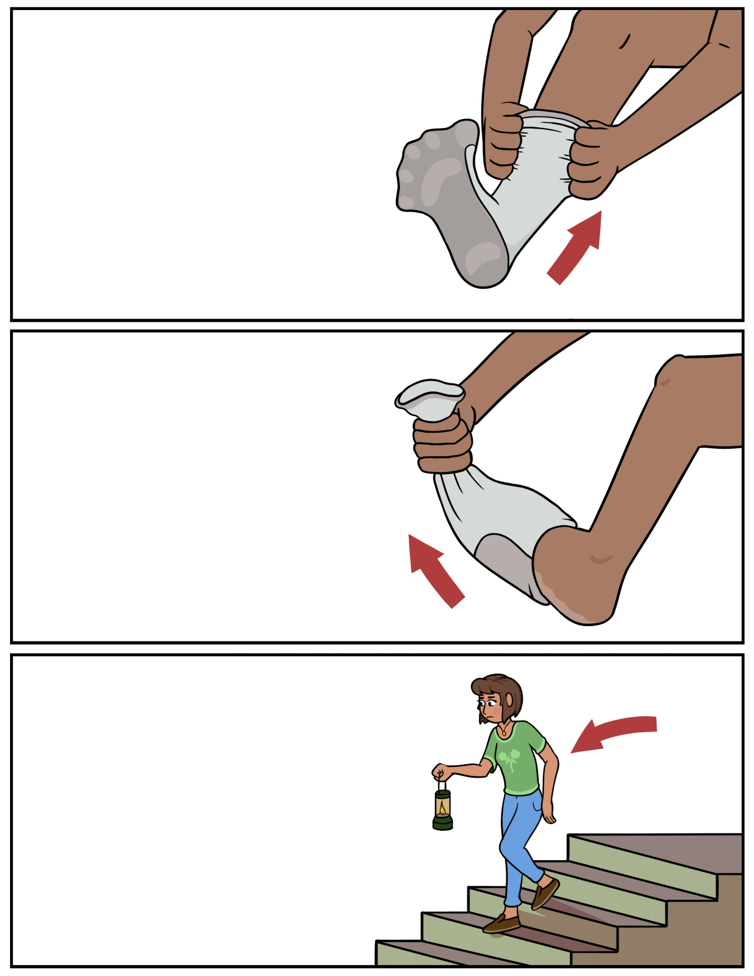

**Biisikan – Put it on** (Bee-sih-kun) **Biisikamok – Put it on (2+)**(Bee-sih-kuh-mohk)**Biisikandaa – Let’s put it on (ALL)**(Bee-sih-kun-daw)

**Niisaandawen – Go downstairs** (Nee-sawn-duh-wehn)**Niisaandaweg – Go downstairs (2+)**(Nee-sawn-duh-wehg)**Niisaandawedaa – Let’s go downstairs (ALL)**(Nee-sawn-duh-weh-daw)

**Giisikan – Take it off**(Gee-sih-kun)**Giisikamok – Take it off (2+)**(Gee-sih-kuh-mohk)**Giisikandaa – Let’s take it off (ALL)**(Gee-sih-kun-daw)

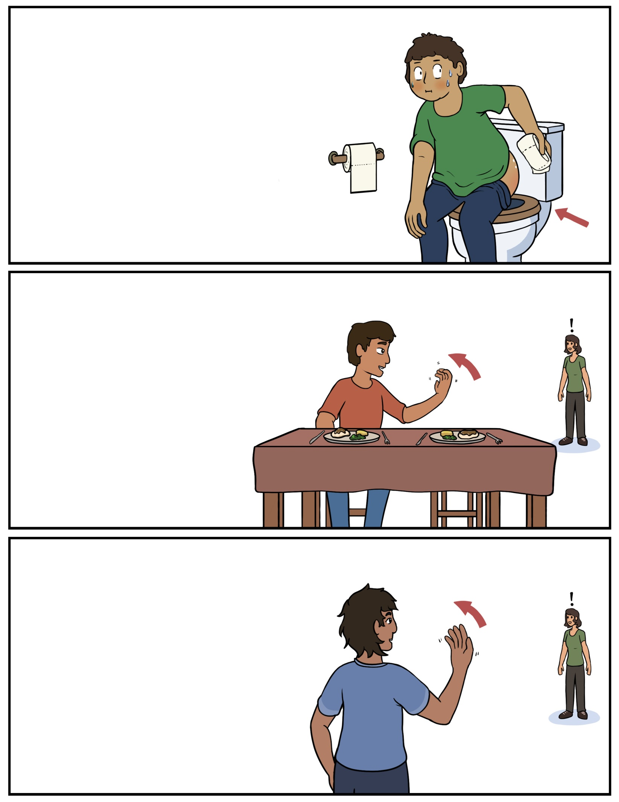

**Giziindime’on – Wipe your bum**(Gih-zeen-dih-meh-ohn) **Giziindime’og – Wipe your bum (2+)**(Gih-zeen-dih-meh-ohg)**Giziindime’odaa – Let’s wipe our bum (ALL)**(Gih-zeen-dih-meh-oh-daw)

**Ambe omaa – Come here** (Uhm-beh oh-maw)**Ambe omaayok- Come here (2+)**(Uhm-beh oh-maw-yohk)**Ambewok omaa – Come here (2+)**(Uhm-beh-wok oh-maw)

**Biwiisinin – Come eat** (Bih-wee-sih-nin)**Biwiisiniyok – Come eat (2+)**(Bih-wee-sih-nih-yohk)**Biwiisinig – Come eat (2+)**(Bih-wee-sih-nihg)**wiisinidaa – Let’s eat (ALL)**(wee-sih-nih-daw)

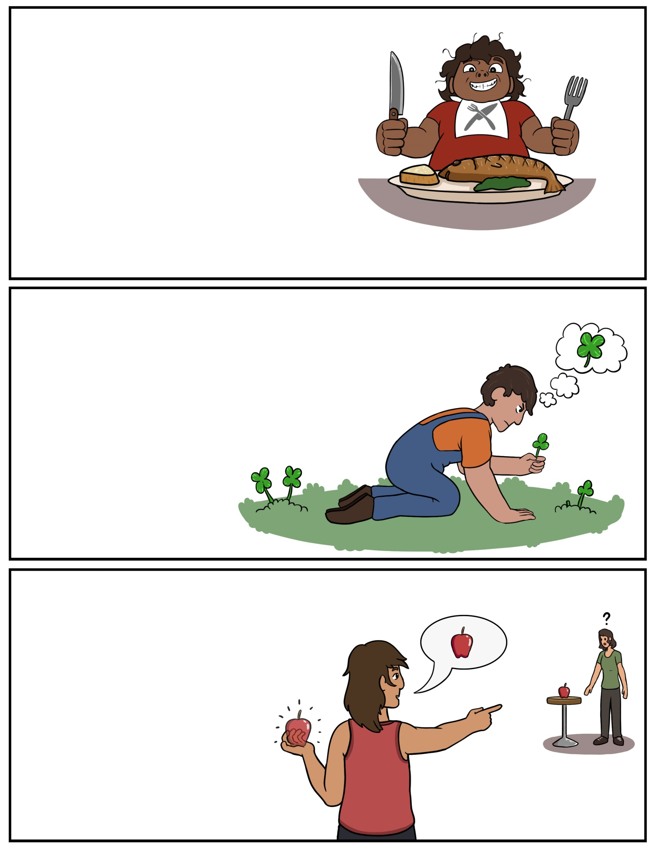

**Amo – Eat it** (Uh-moh) **Amoyok – Eat it (2+)**(Uh-moh-yohk)**Amog – Eat it (2+)**(Uh-mohg)**Amwaadaa /Amwaadaanig - (ALL)**(Uhm-waw-daw / Uhm-waw-daw-nig)

**Biidoon – Bring it** (Bee-doon)**Biidoog- Bring it (2+)**(Bee-doog)**Kina biidoodaa – Let’s bring it (ALL)**(Kih-nuh bee-doo-daw)

**Mikan – Find it** (Mih-kuhn)**Mikamok – Find it (2+)**(Mih-kuh-mohk)**Mikandaa – Let’s find it (ALL)**(Mih-kuhn-daw)

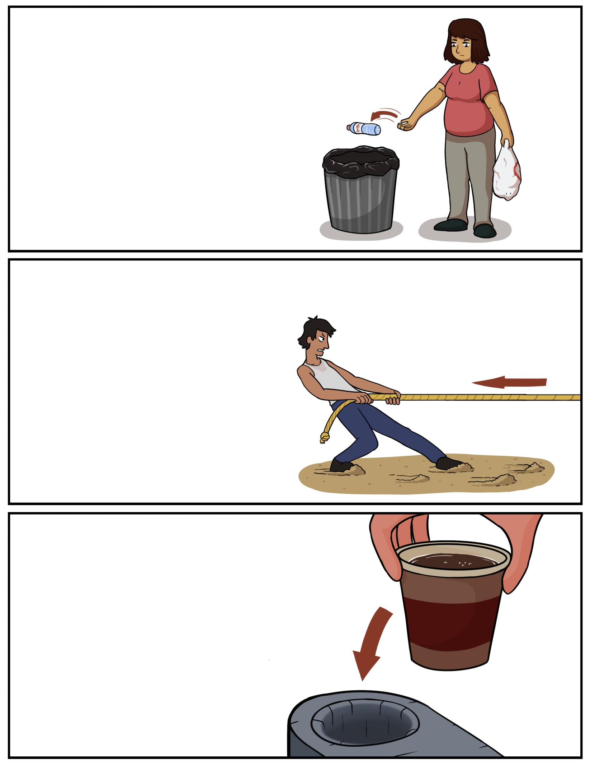

**Webinan – Throw it away** (Weh-bih-nuhn) **Webinamok – Throw it away (2+)**(Weh-bih-nuh-mohk)**Webinandaa – Let’s throw it away (ALL)**(Weh-bih-nuhn-daw)

**Atoon – Put it in a certain place** (Uh-toon)**Atoog – Put it in a certain place (2+)**(Uh-toog)**Atoodaa – Let’s put it in a certain place (ALL)**(Uh-too-daw)

**Wiikobidoon – Pull it**(Wee-koh-bih-doon)**Wiikobidoog – Pull it (2+)**(Wee-koh-bih-doog)**Wiikobidoodaa – Let’s pull it (ALL)**(Wee-koh-bih-doo-daw)