Adik
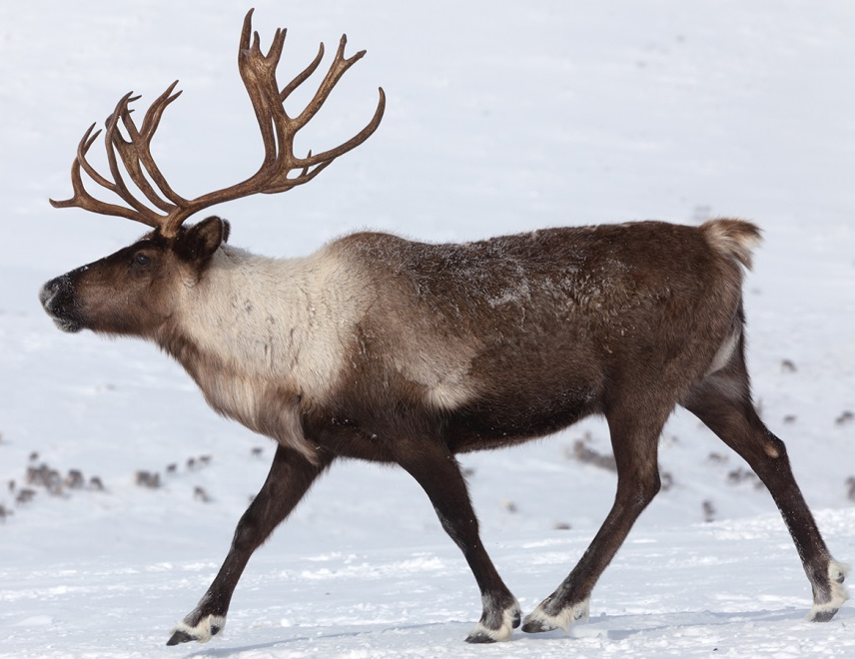

Adik
(Uh-dihk)
Caribou

Andamaakomeshiinh
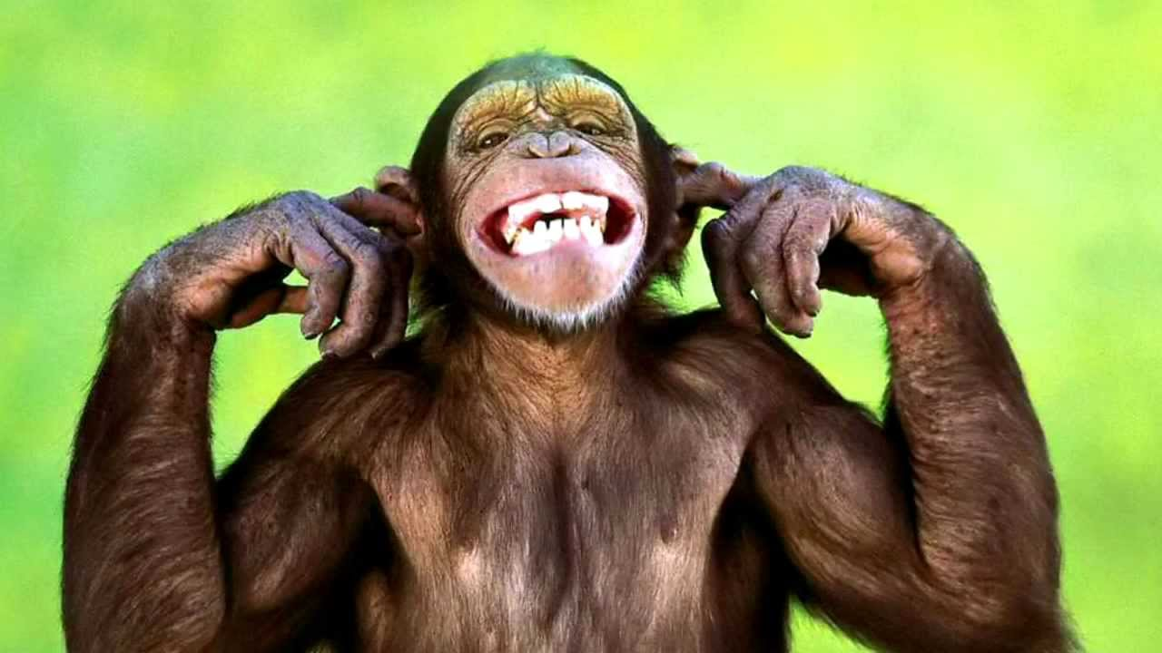

Andamaakomeshiinh
(Uhn-duh-maah-koh-may-shenh)
Monkey

Animosh
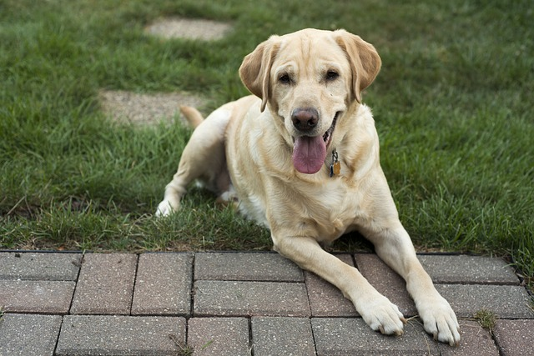

Animosh
(Uh-nih-moush)
Dog

Baakaakwe
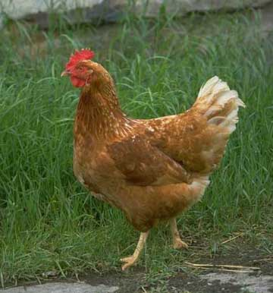

Baakaakwe
(Baah-kaah-kway)
Chicken

Bizhikii
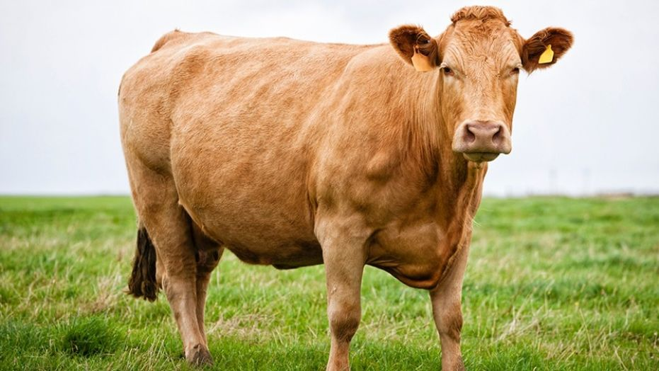

Bizhikii
(Bih-zhih-key)
Cow

Bizhiw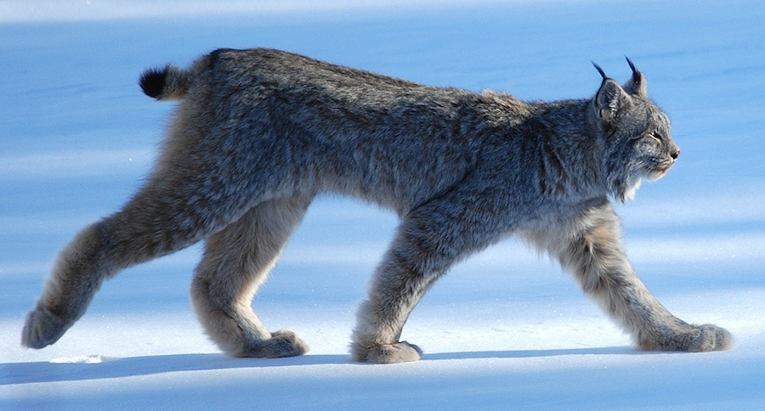

Bizhiw
(Bih-zhew)
Lynx

Gaazhagens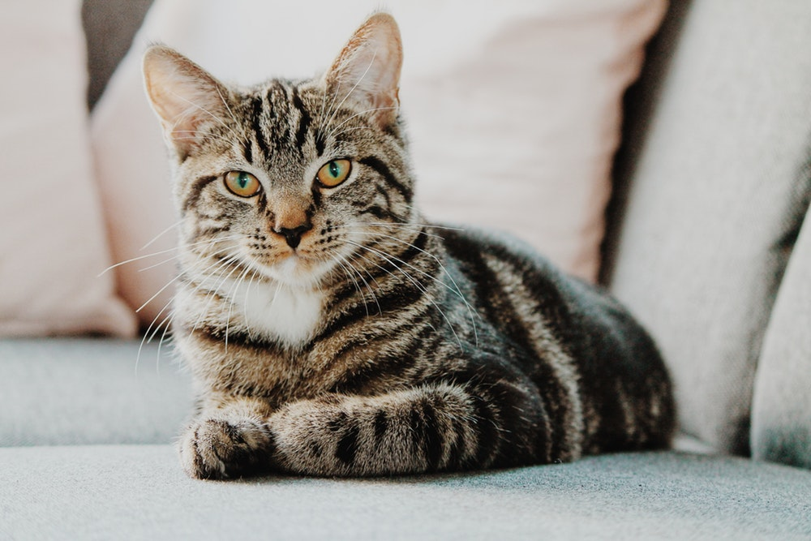

Gaazhagens
(Gaah-zhuh-gayns)
Cat

Ginebig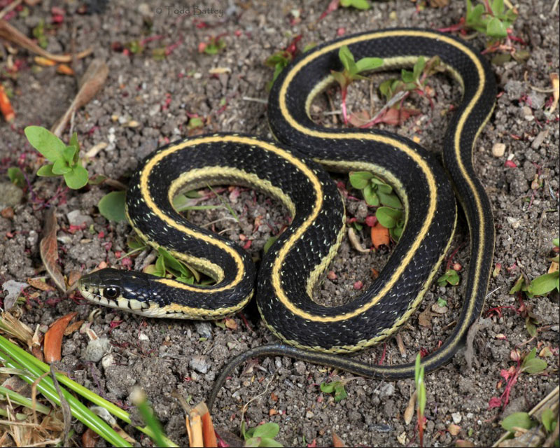

Ginebig
(Gih-nay-big)
Snake

Ginoozhe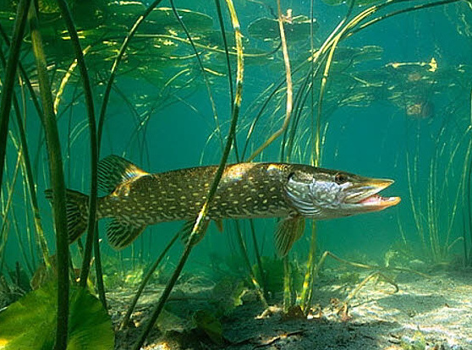

Ginoozhe
(Gih-nooh-zhay)
Northern Pike
Gookookoo’oo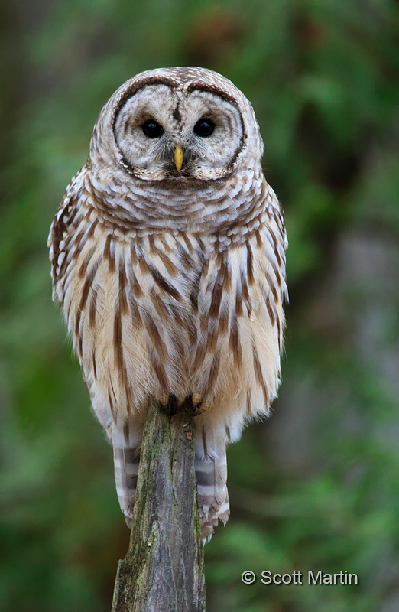

Gookookoo’oo
(Gooh-kooh-kooh’-oouh)
Owl

Gookoosh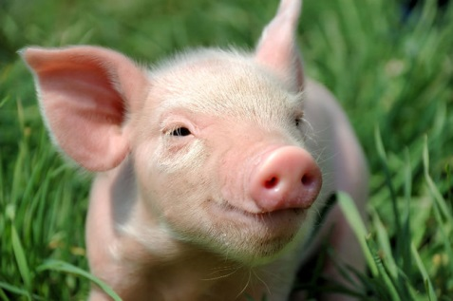

Gookoosh
(Gooh-koush)
Pig

Maanishtaanish

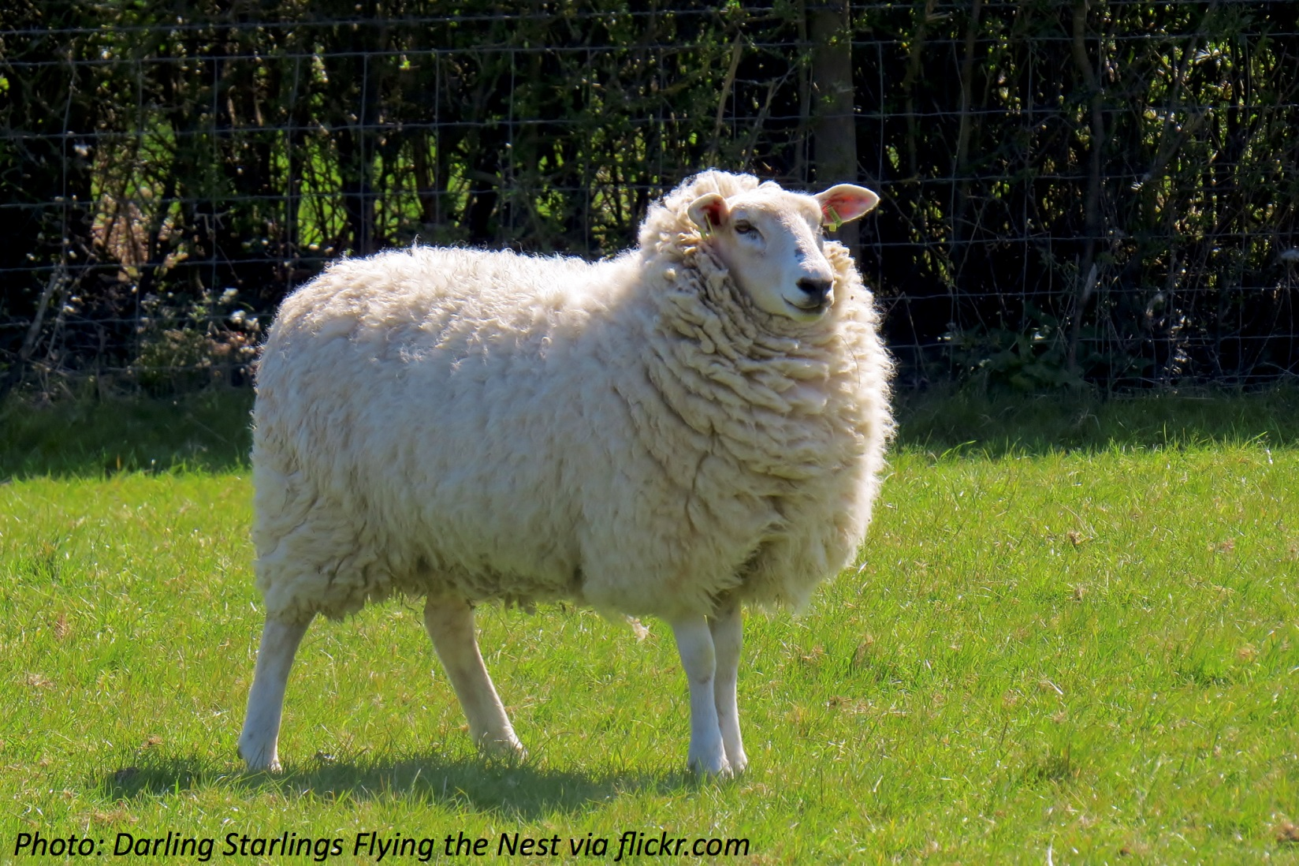

Maanishtaanish
(Maah-nish-taah-nish)
Sheep

Ma’iingan

Ma’iingan
(Muh’-ing-gun)
Wolf

Makwa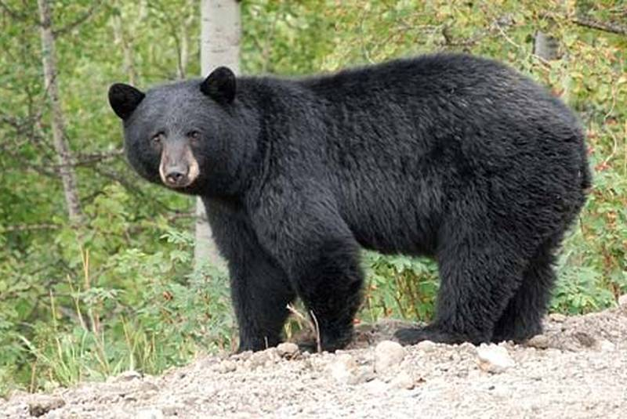

Makwa
(Muh-kwuh)
Bear

Migizi 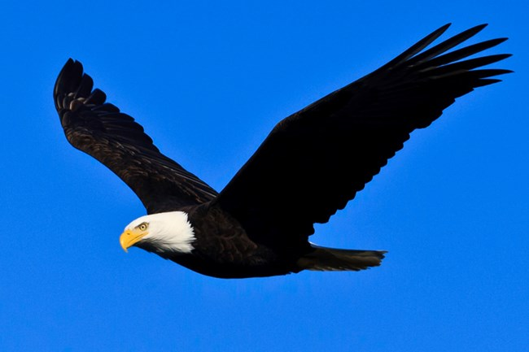

Migizi
(Mih-gih-zih)
Bald Eagle

Mikinaak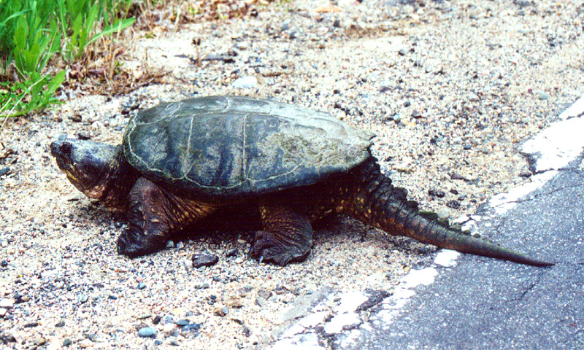

Mikinaak
(Mih-kih-nock)
Snapping Turtle

Mooz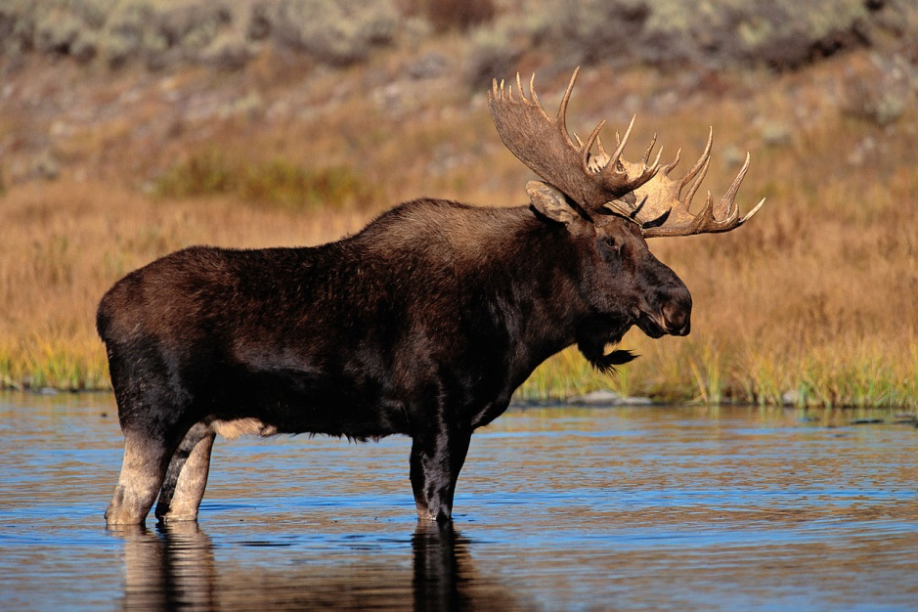

Mooz
(Moohz)
Moose

Name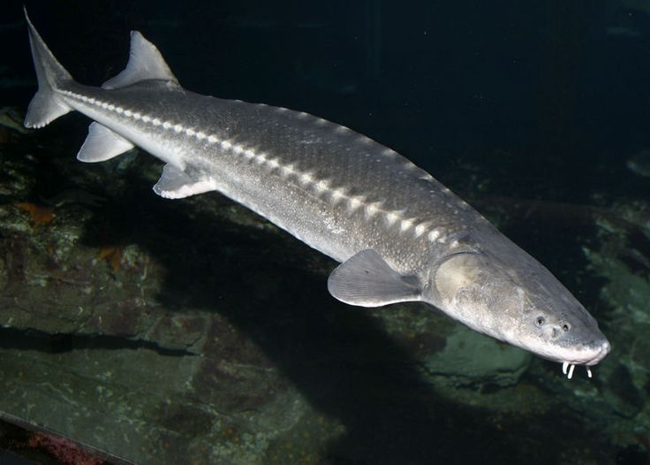

Name
(Nuh-may)
Sturgeon
Nigig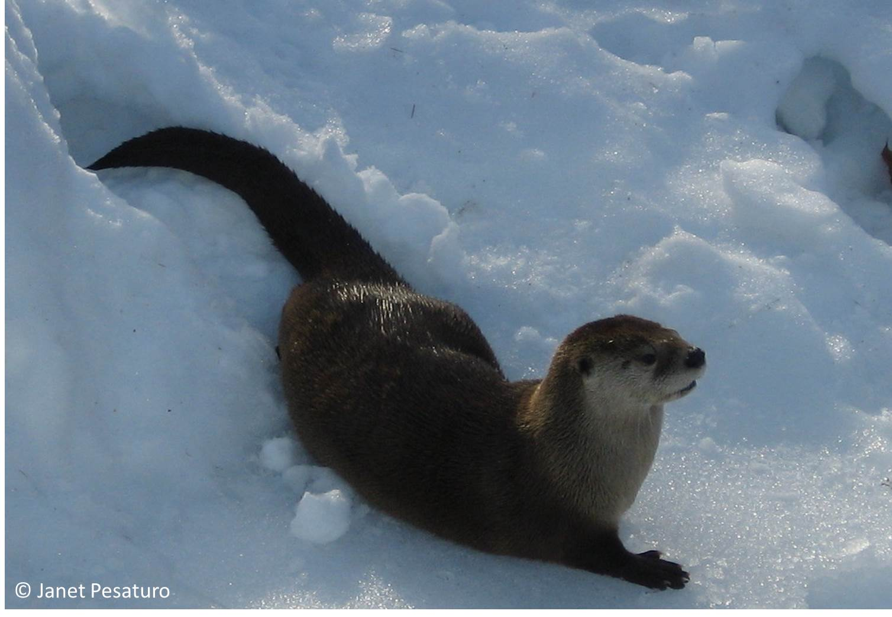

Nigig
(Nih-gihg)
Otter

Omagakii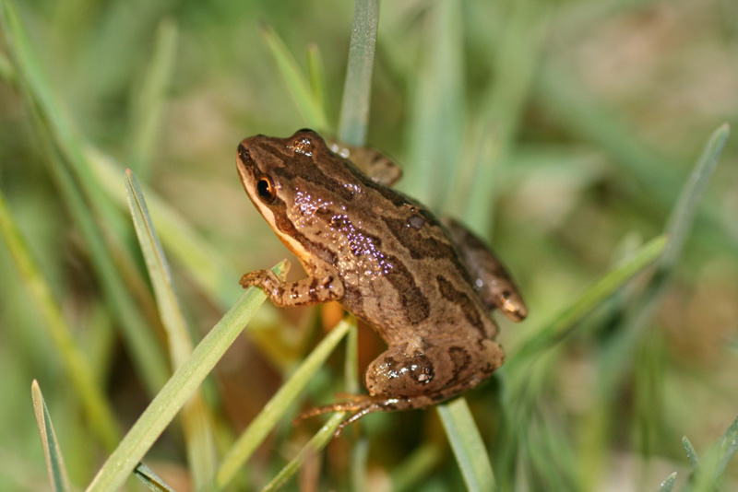

Omagakii
(Oh-muh-guh-key)
Frog

Waabooz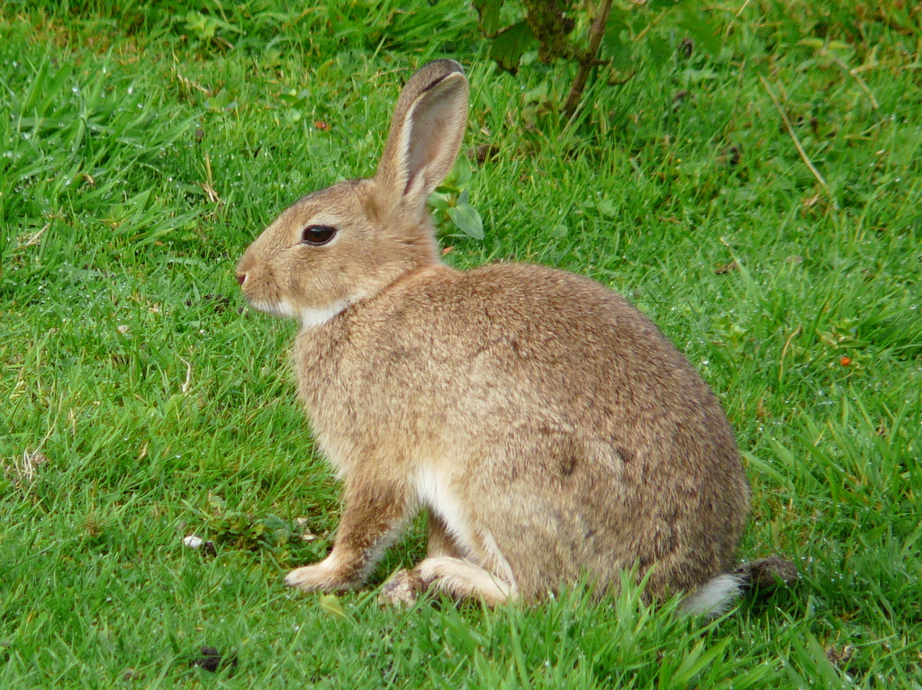

Waabooz
(Waah-boohz)
Rabbit

Waagosh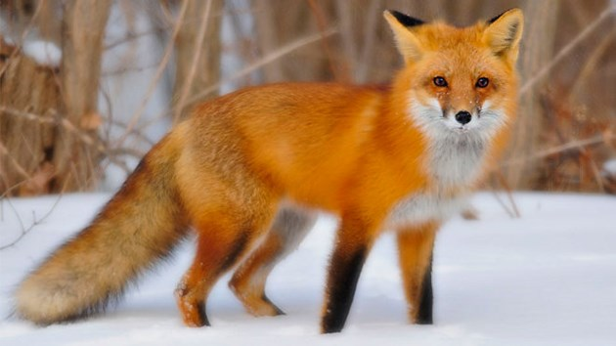

Waagosh
(Waah-goush)
Fox

Waawaashkeshii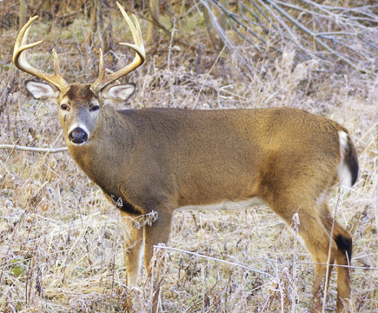

Waawaashkeshii
(Waah-waash-kay-she)
Deer

Zhiishiib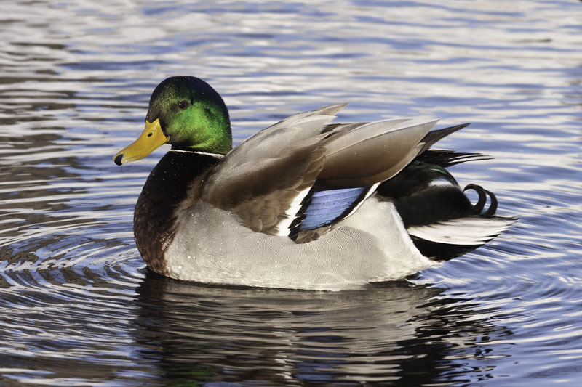

Zhiishiib
(Zhee-sheeb)
Duck

