Awensiinkaazon Odaminowin - Act like an Animal Game
2+ players – all ages
- Insert the animal pictures into the dice.
- A player rolls the dice somewhere the other players cannot see – we recommend a large opaque bin.
- The player then acts like the animal they rolled.
- The other players must guess who the player is pretending to be.
- When a player guesses correctly it is then their turn to roll the dice.
Below is some vocabulary that will help you further your Anishinaabemowin skills the more often you play:

Questions
Awenen enenjikaazowin? Who are you acting like?
Aaniin entaagozit awe? What does s/he sound like?
Awenen awe? Who is that?
Awenen itam? Who’s turn is it?
Commands
Didibiiyebinan Roll it
Gwekiwebinan Flip it over
[Animal]-kaazon Act like a –[animal].
Awe inenjikaazon Pretend to be like this being.
Inenjikaazon Pretend to be like it
Other Sentences
Ingwekiwebinaan I’m flipping it
Ingwekiwebinaan makakoonhs I’m rolling the dice
Niinitam My turn
Giinitam Your turn
Nashke Look

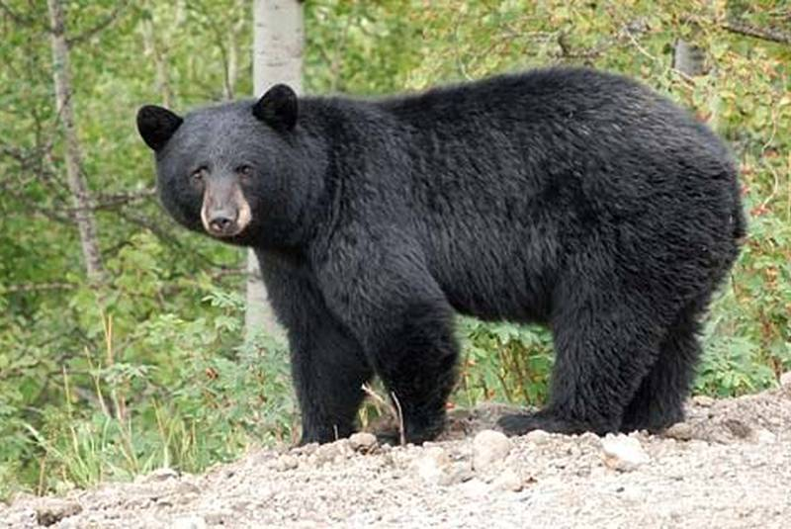  Makwakaazon | 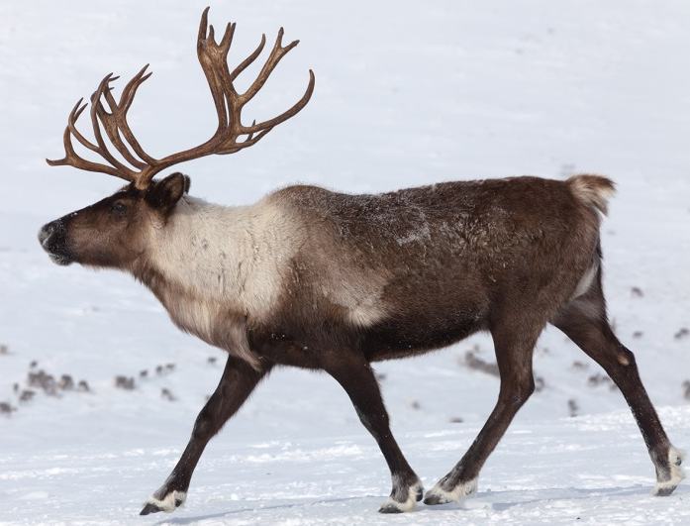  Adikikaazon
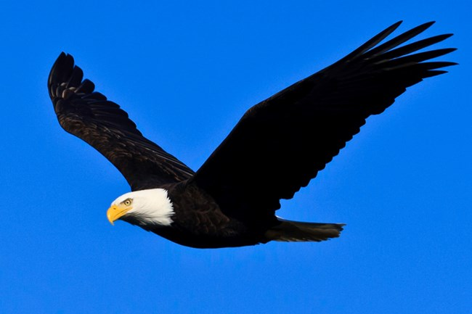  Migizikaazon | 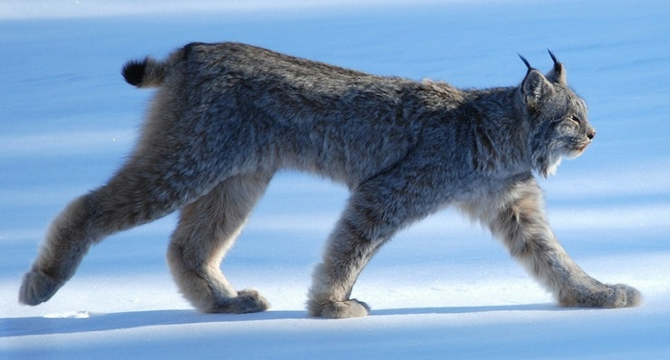  Bizhiwikaazon

Moozookaazon  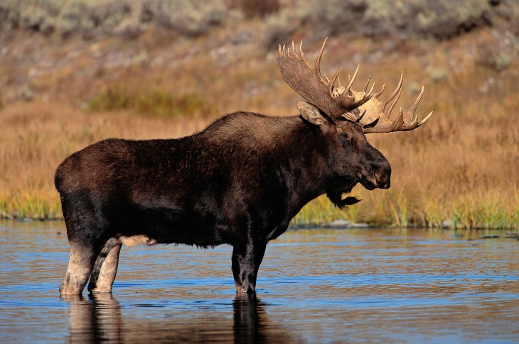 | Mikinaakikaazon  Mikinaakokaazon  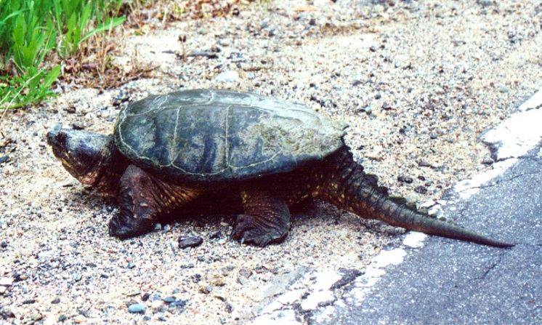
Ma’iinganikaazon | 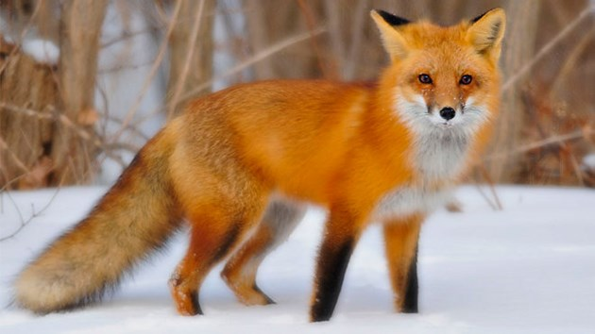  Waagoshikaazon

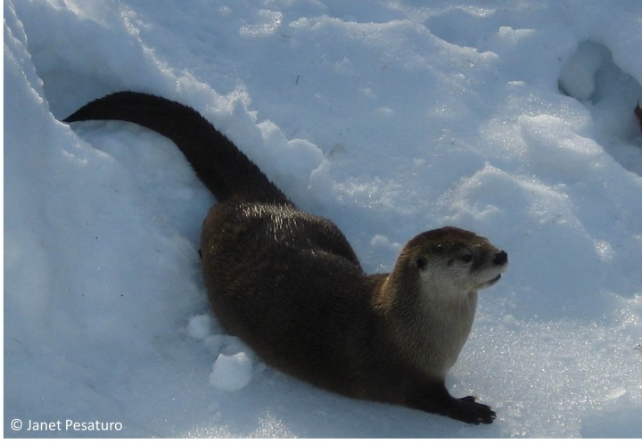  Nigigokaazon | 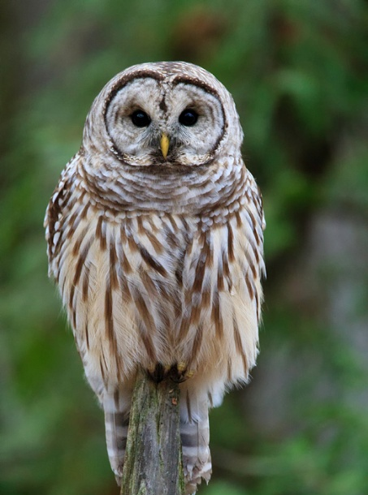  Gookooko’okaazon
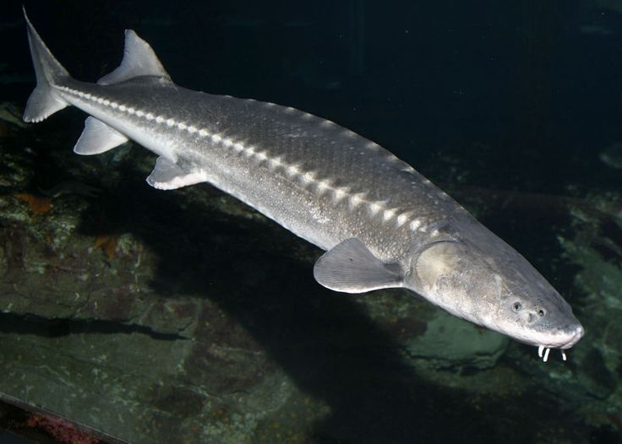  Namekaazon | Animoshikaazon  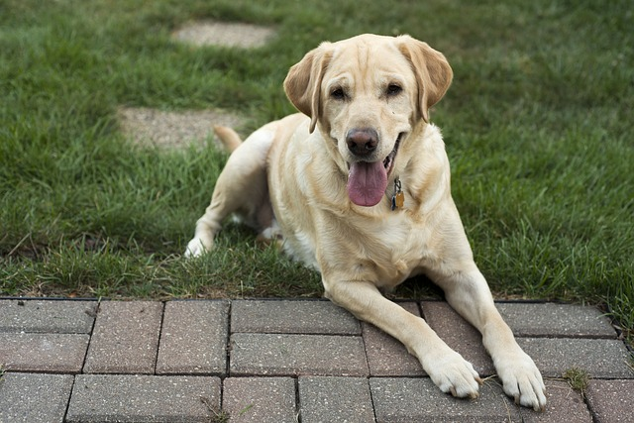

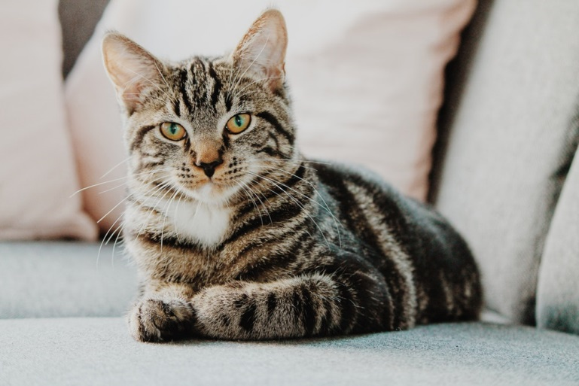  Gaazhagensikaazon | 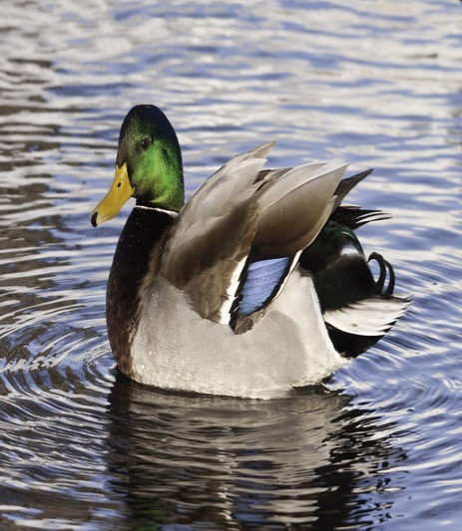  Zhiishiibikaazon
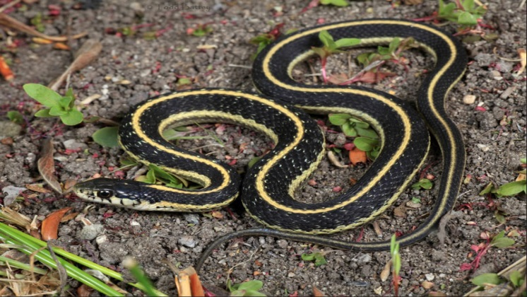  Ginebigokaazon | 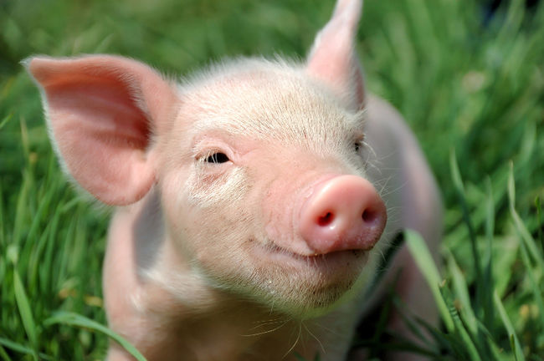  Gookooshiikaazon

Baakaakwekaazon  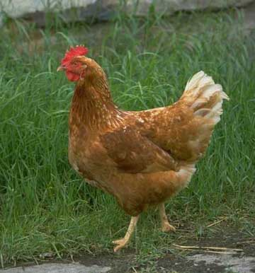  Baakaakwankaazon | 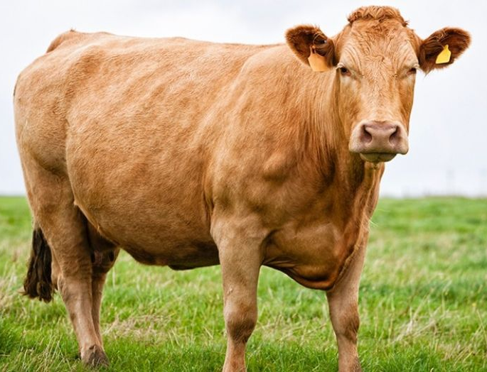  Bizhikiikaazon
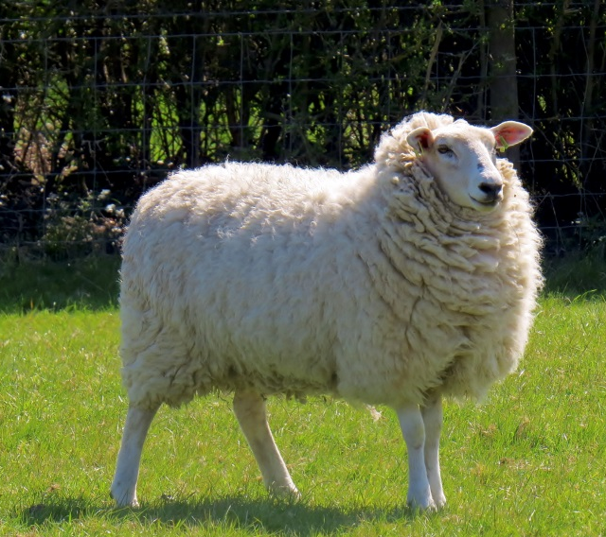  Maanishtaanishikaazon | 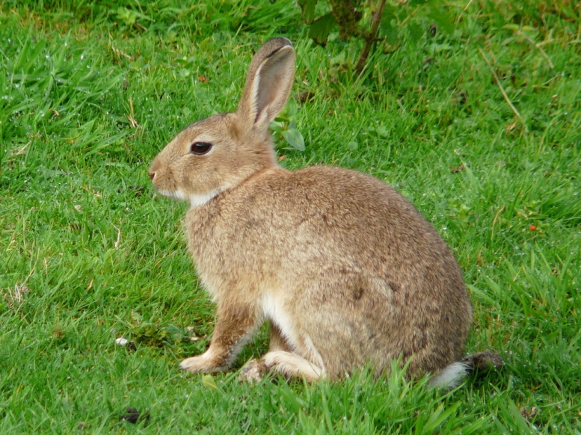  Waaboozookaazon

Andamaakomeshiinhkaazon | 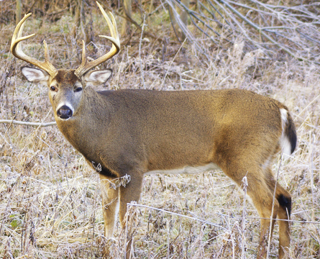  Waawaashkeshiikaazon
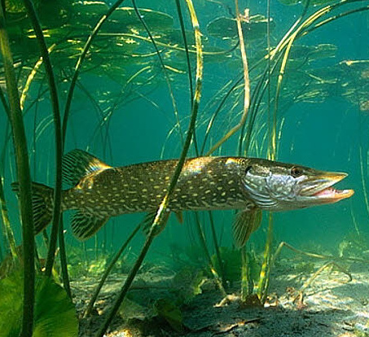  Ginoozhekaazon | Omagakiikaazon  